CE6 “AB_ GB_ RFR” and “AB_ GB_ XB” do not seem to be mentioned. Please check.
Reply CE6: Sorry, I just checked. When we revised the manuscript based on reviewer’s comments, there was one comment that asked us to modify the format of the table 5. During that modification, by mistake, we lost the last two rows. Could you help add these two rows in the pdf version, E8 and E7 after E6 in the current table? Thanks for your help!
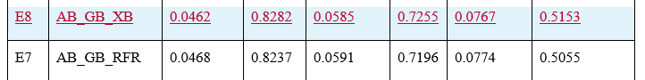

TS1 Please note that changing numbers in the paper at this stage of the publication process requires approval from the handling editor. Please give an explanation of why this needs to be changed, and we will then ask the handling editor for approval. Thank you.
Reply TS1: Sorry for the inconvenience. When I calculated the difference of r² score, by mistake I calculated the difference (0.8985-0.8848=0.0137) between KNR and KNR_RFR_XB, but here we are talking about the difference (0.8985-0.8626=0.0359) between RFR and KNR_RFR_XB.

