The requsted changes are as follows:

Please replace the red rectange part by the red text next to the red rectange
0.103 to 0.1043
0.0025τ^{0.132}i to (0.0025τ^{0.132})i and the same for the next two red rectangle
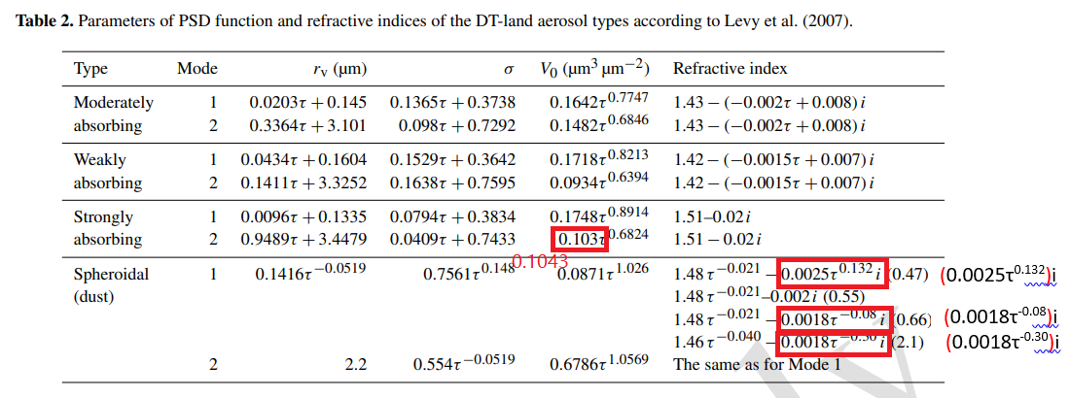

1.45 to 1.43
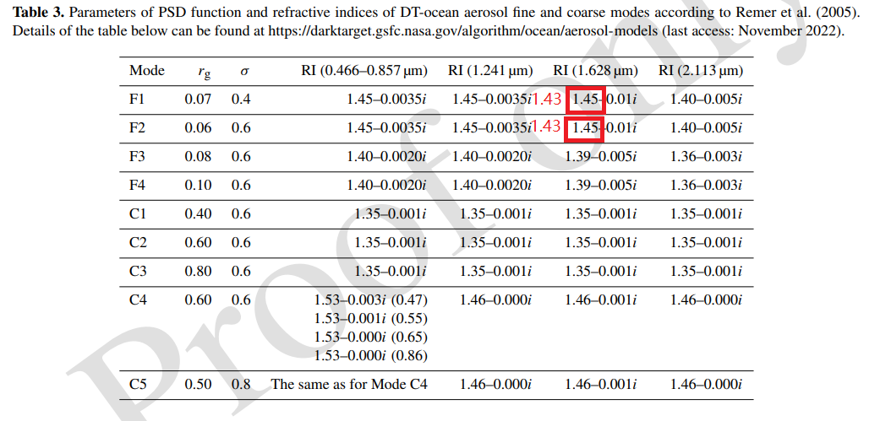

τ_{f} to τ
-0.002 to 0.002
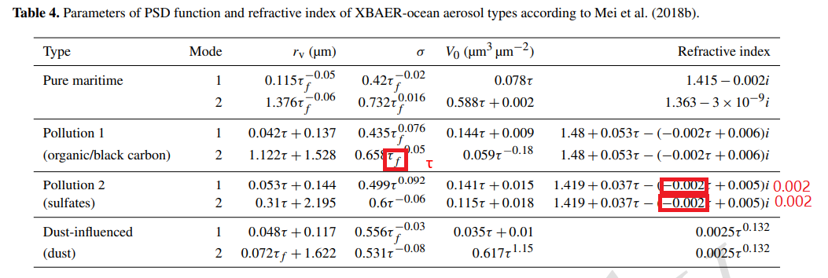

Explanation: The reason that why we need to correct those values is that they are published result from other publications as we cited in the title in each table, and they are just typos. So we have to correct them.

We need to be exactly the same as the original source.

