Dear Editor,  
  
While correcting the proofs for the GMD manuscript *"Simulating barrier island response to sea-level rise with the barrier island and inlet environment (BRIE) model v1.0, doi: 10.5194/gmd-2019-10"* . I discovered an unfortunate mistake in one of the equations.

Equation 19 reads:

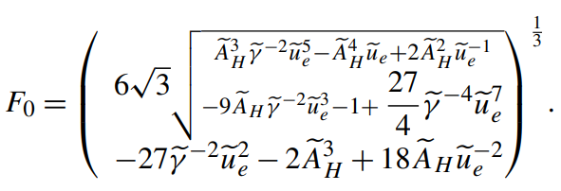

However, I made a mistake in the derivation. The correct equation should be:

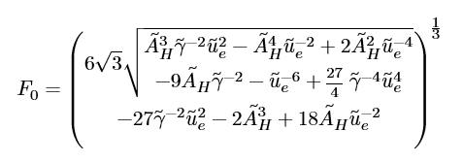

I am requesting permission to change the equation in the final, published, version of the paper.

Best regards,  
  
Jaap Nienhuis