Response to referee comments

Response to Referee #1

Review

Improving climate model accuracy by exploring parameter space with an O(10^5) member ensemble and emulator by Li et al.

The paper describes an approach to identify parameters in the atmosphere and land surface models that control warm and dry biases in summer in the northwestern US with an aim of finding parameter combinations that reduce these regional biases. The authors construct PPEs by perturbing 17 parameters simultaneously using the weather@home modeling framework. They use an ‘iterative refocusing’ approach to find parameter combinations that have satisfactory performance over the NWUS while also maintaining acceptable performance globally.

The PPE approach, in general, is extremely powerful in providing insights into model development and improvements. Parametric uncertainty is also one key area which remains relatively unexplored. So in my opinion, this paper makes an important contribution. The paper is well-structured and clear. The assumptions are clearly stated and the results sufficiently support the interpretations and conclusions. The abstract does provide a concise and complete summary. I also highly appreciated the fact that the authors clearly explain what roles each of the important parameters play in the model. Overall, I strongly feel that the paper is worthy of publication in GMD. I, however, have a few concerns that I would like the authors to address.

General response: Thank you very much for these comments. We feel very encouraged from this review and have made the best attempt to respond to these constructive comments.

General comments:
Item 1: About the parameters perturbed: it is not made clear whether the parameters reside in the global model or the regional model. If the parameters belong to HadAM3P, which I think is the case, then the statement (l.206) “PPEs for parameter refinement with the aim of improving regional climate models (RCMs)” needs to be rephrased. The improvement is in terms of regional biases but the RCM in itself is not improved. If the parameters belong to the RCM, then I don’t fully understand the global TOA flux constraints in Phase 1. The purpose of using a regional model setup is unclear. Assuming that the parameters belong to HadAM3P and since the comparisons with observations are carried out at HadAM3P resolution, what role does the regional model (HadRM3) play here? In a topographically complex region such as the NWUS, model resolution likely plays an important role in model performance, but it’s not discussed in the paper despite using a regional model. It also appears that the nesting is one-way wherein the RCM is nested within the global model, which suggests that any improvements in the RCM are not felt by the global model. These issues need clarification in the main text.
Response: We thank the reviewer for these constructive comments and agree with the assessment that these issues should be clarified in the main text. We have added a few sentences in the main text (lines 373-377 in the revised manuscript) to clarify the parameters perturbed: “The parameters reside in the global model as well as the regional model, and are set to the same values in HadAM3P and HadRM3P in the experiments performed for this study, thus any reduction of regional biases are considered to have been achieved through the improvement of boundary fluxes from the GCM to the RCM, and improvement of the RCM itself”.

The RCM is embedded within the GCM, and nesting is one-way where the GCM provides boundary conditions for the RCM. The purpose of the global TOA flux constraints in Phase 1 was to make sure the large scale boundary conditions for the RCM are realistic. Within weather@home the purpose of the regional model is to provide higher resolution output over the area of interest, rather than to feedback scale dependent features to the GCM. The comparisons with observations are carried out at both HadAM3P resolution and HadRM3P resolution, and the regional model biases are calculated with respect to PRISM datasets. We have changed the wording in the main text (line 333 in the original manuscript), which now reads: “biases of the regional model outputs are calculated with respect to PRISM” (line 408 of the revised manuscript). We agree with the reviewer that, in a topographically complex region such as the NWUS, model resolution does play an important role in model performance, and perhaps the model parameters should be resolution dependent, i.e., they should be set to different values in the GCM and RCM. This is indeed an important issue that needs to be further explored. In follow-on work, we have performed additional PPEs, where the parameter values are set to be different in HadAM3P and HadRM3P, and we will attempt to address the resolution-dependency of parameter values in a following paper using those PPEs.

Item 2: The parameter refocusing is entirely carried out using AMIP-style simulations.
What are the implications of this for using these model variants in coupled model simulations? By perturbing parameters, the model response to future scenarios could be amplified or dampened relative to the standard version of the model, which may lead to differences in behavior between atmosphere-only and coupled model simulations. Is tuning a model in an AMIP mode for better regional performance useful for coupled model simulations?

Response: Thank you for these comments. We agree with the reviewer that by perturbing parameters, the model response to future scenarios could be different from the standard version of the model. As part of our ongoing work, we are looking at the different climate sensitivities of different model variants in future projections. However, it was never the intention of these experiments to come up with model variants to be used in coupled model simulations. Parametric uncertainty exists in the ocean component as well. If an ocean component were to be coupled to the tuned AMIP mode, a systematic parameter refocusing would be required to ensure consistency across the full climate system. It is likely that different atmospheric parameter settings would be selected due to potential interactions with oceanic parameters.

Item 3: I wonder if the phrase ‘perturbed parameter’ should be used here instead of ‘perturbed physics.’ The authors perturb parameters instead of switching between schemes with different physics. For instance, Shiogama et al. (2014) generate multi-parameter, multi-physics PPEs by perturbing parameters in different versions of MIROC. So, while the words ‘physics’ and ‘parameter’ are used interchangeably in the context of PPEs, perhaps it is useful to make that distinction. [Shiogama, H., Watanabe, M., Ogura, T., Yokohata, T. and Kimoto, M., 2014. MultiâA˘ Rparameter multiâ ˇ A˘ R- ˇ physics ensemble (MPMPE): a new approach exploring the uncertainties of climate sensitivity.ÂaAtmospheric Science Letters,Â ˘ a15(2), pp.97-102.]

Response: Thank you for pointing this out. We agree the phrase “perturbed parameter” should be used here instead of “perturbed physics”, since the latter could be interpreted as switching different physics schemes rather than change parameter values. We have changed the main text throughout to only use the phrase “perturbed parameter”.

Item 4: The authors argue that they use ‘history matching’ citing McNeall et al. and Williamson et al. Doesn’t history matching require a formal statistical framework that is based on the definition of Implausibility? My reading of your approach is that it borrows ideas of from history matching (e.g., iterative refocusing) but doesn’t strictly follow it. It would be useful to have a couple of sentences explaining the differences and similarities between your approach and history matching.

Response: We appreciate this comment and have added a couple of sentences at the end of paragraph 10 to explain the differences and similarities between our approach and history matching. In the revised manuscript lines 246-249, it reads: “The method we adopted in this study fits into the third category, borrowing the idea of ‘iterative refocusing’ where parameter values are refined through phases of experiments. Our methodology differs from history matching in that we do not employ a formal statistical framework based on the definition of implausibility”. We believe now it’s much clearer in the main text that the approach adopted in our study does not strictly follow history matching.

Item 5: (l.99) Biases in the regional model are shown in Figure S1, but it would be interesting to show what these biases look like in HadAM3P.

Response: We respectfully point out that the temperature and precipitation biases in HadAM3P are shown in Figure 6 and Figure 7 respectively.

Item 6: Fig. S3 suggests that regional temperature and precipitation metrics are strongly anti-correlated across the PPE. Doesn’t that suggest a physical link between these variables that can be exploited to find parameter combinations acceptable for both variables?

Response: Thank you for these comments. We agree with the reviewer that regional temperature and precipitation are strongly anti-correlated in JJA, and this does suggest a physical link that can be exploited to find parameter combinations acceptable for both variables. Multivariate parameter sensitivity is indeed one of the research questions we will explore with our additional PPEs, which are follow up experiments of our current manuscript.

Item 7: I am a bit surprised that the sensitivity analysis shows very little interaction between the parameters especially at 10-year timescales. My reading of the paragraph starting at l.468 is that the small interaction terms are the property of your emulators. Is that the case? While entrainment coefficient and the ice fall speed are often the dominant parameters, I wonder if inadequate accounting of parameter interactions might prevent you from finding parts of parameters space that might be plausible.

Response: The interaction terms are not the property of emulators. In the extended Fourier Amplitude sensitivity analysis (FAST; Saltelli et al., 1999), the fraction of the total variance due to interactions is computed from the parameter contribution to the residual variance (variance not accounted for by the main effects). The relative importance of the interaction term is dependent on the metrics of interest. For example, the interaction term is non-trivial for the root mean squared error of JJA 850-hPa U (V) wind component in PP simulations over the regional model domain, with respect to SP simulations, as seen in Figure 1 and Figure 2 below.

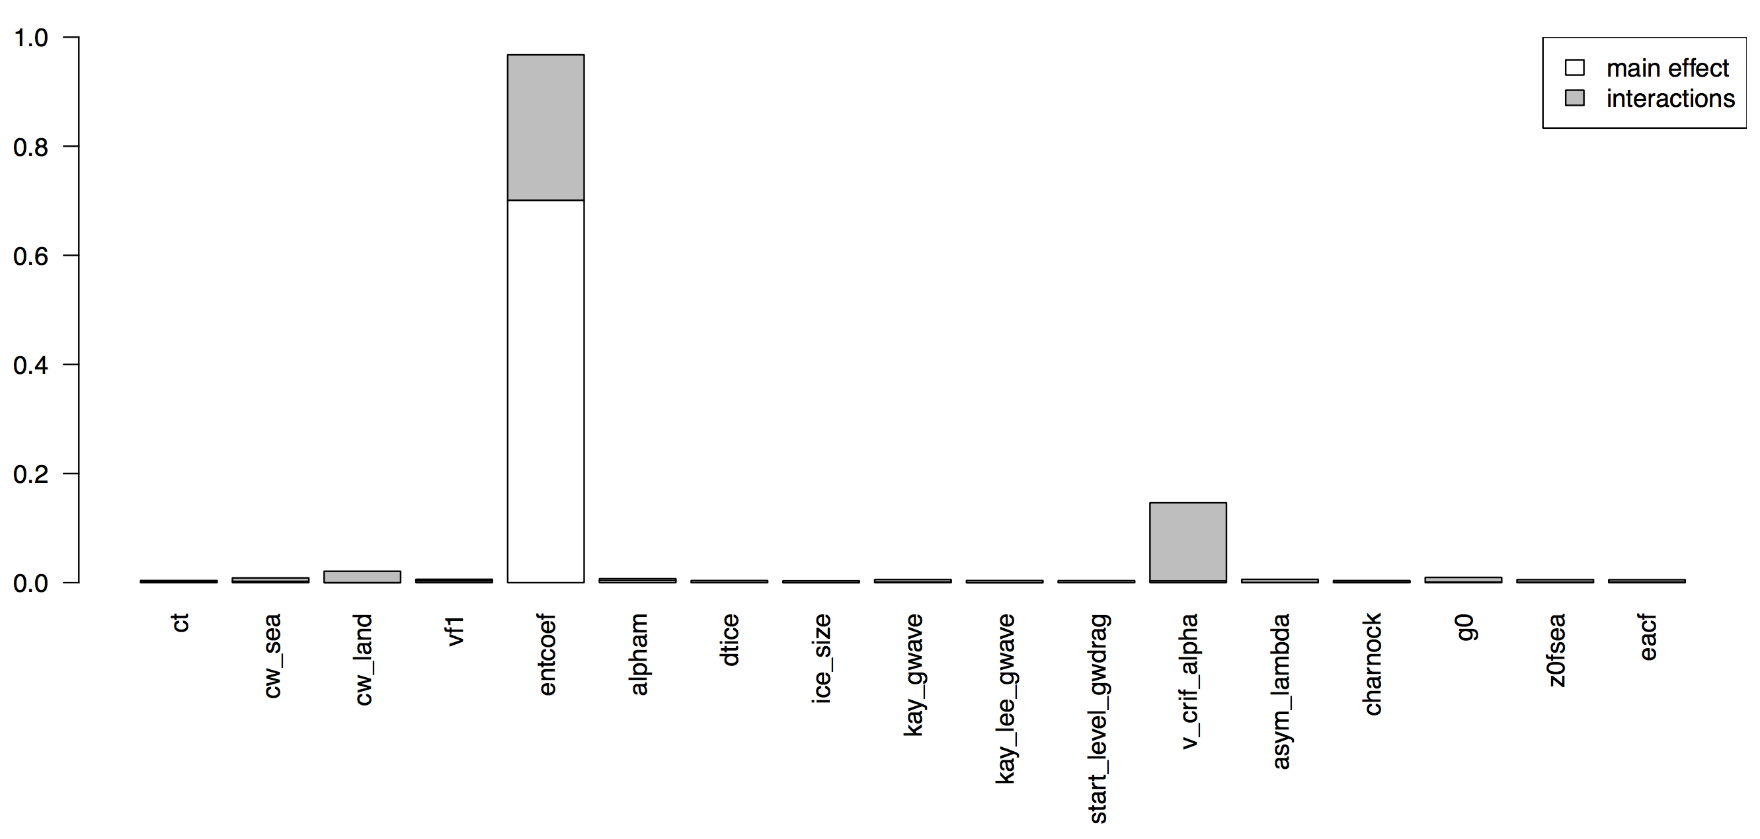
Figure 1. Sensitivity analysis of the root mean squared error of JJA 850-hPa U wind component in PP simulations over the regional model domain, with respect to SP simulations, via the FAST algorithm of Saltelli et al. (1999).
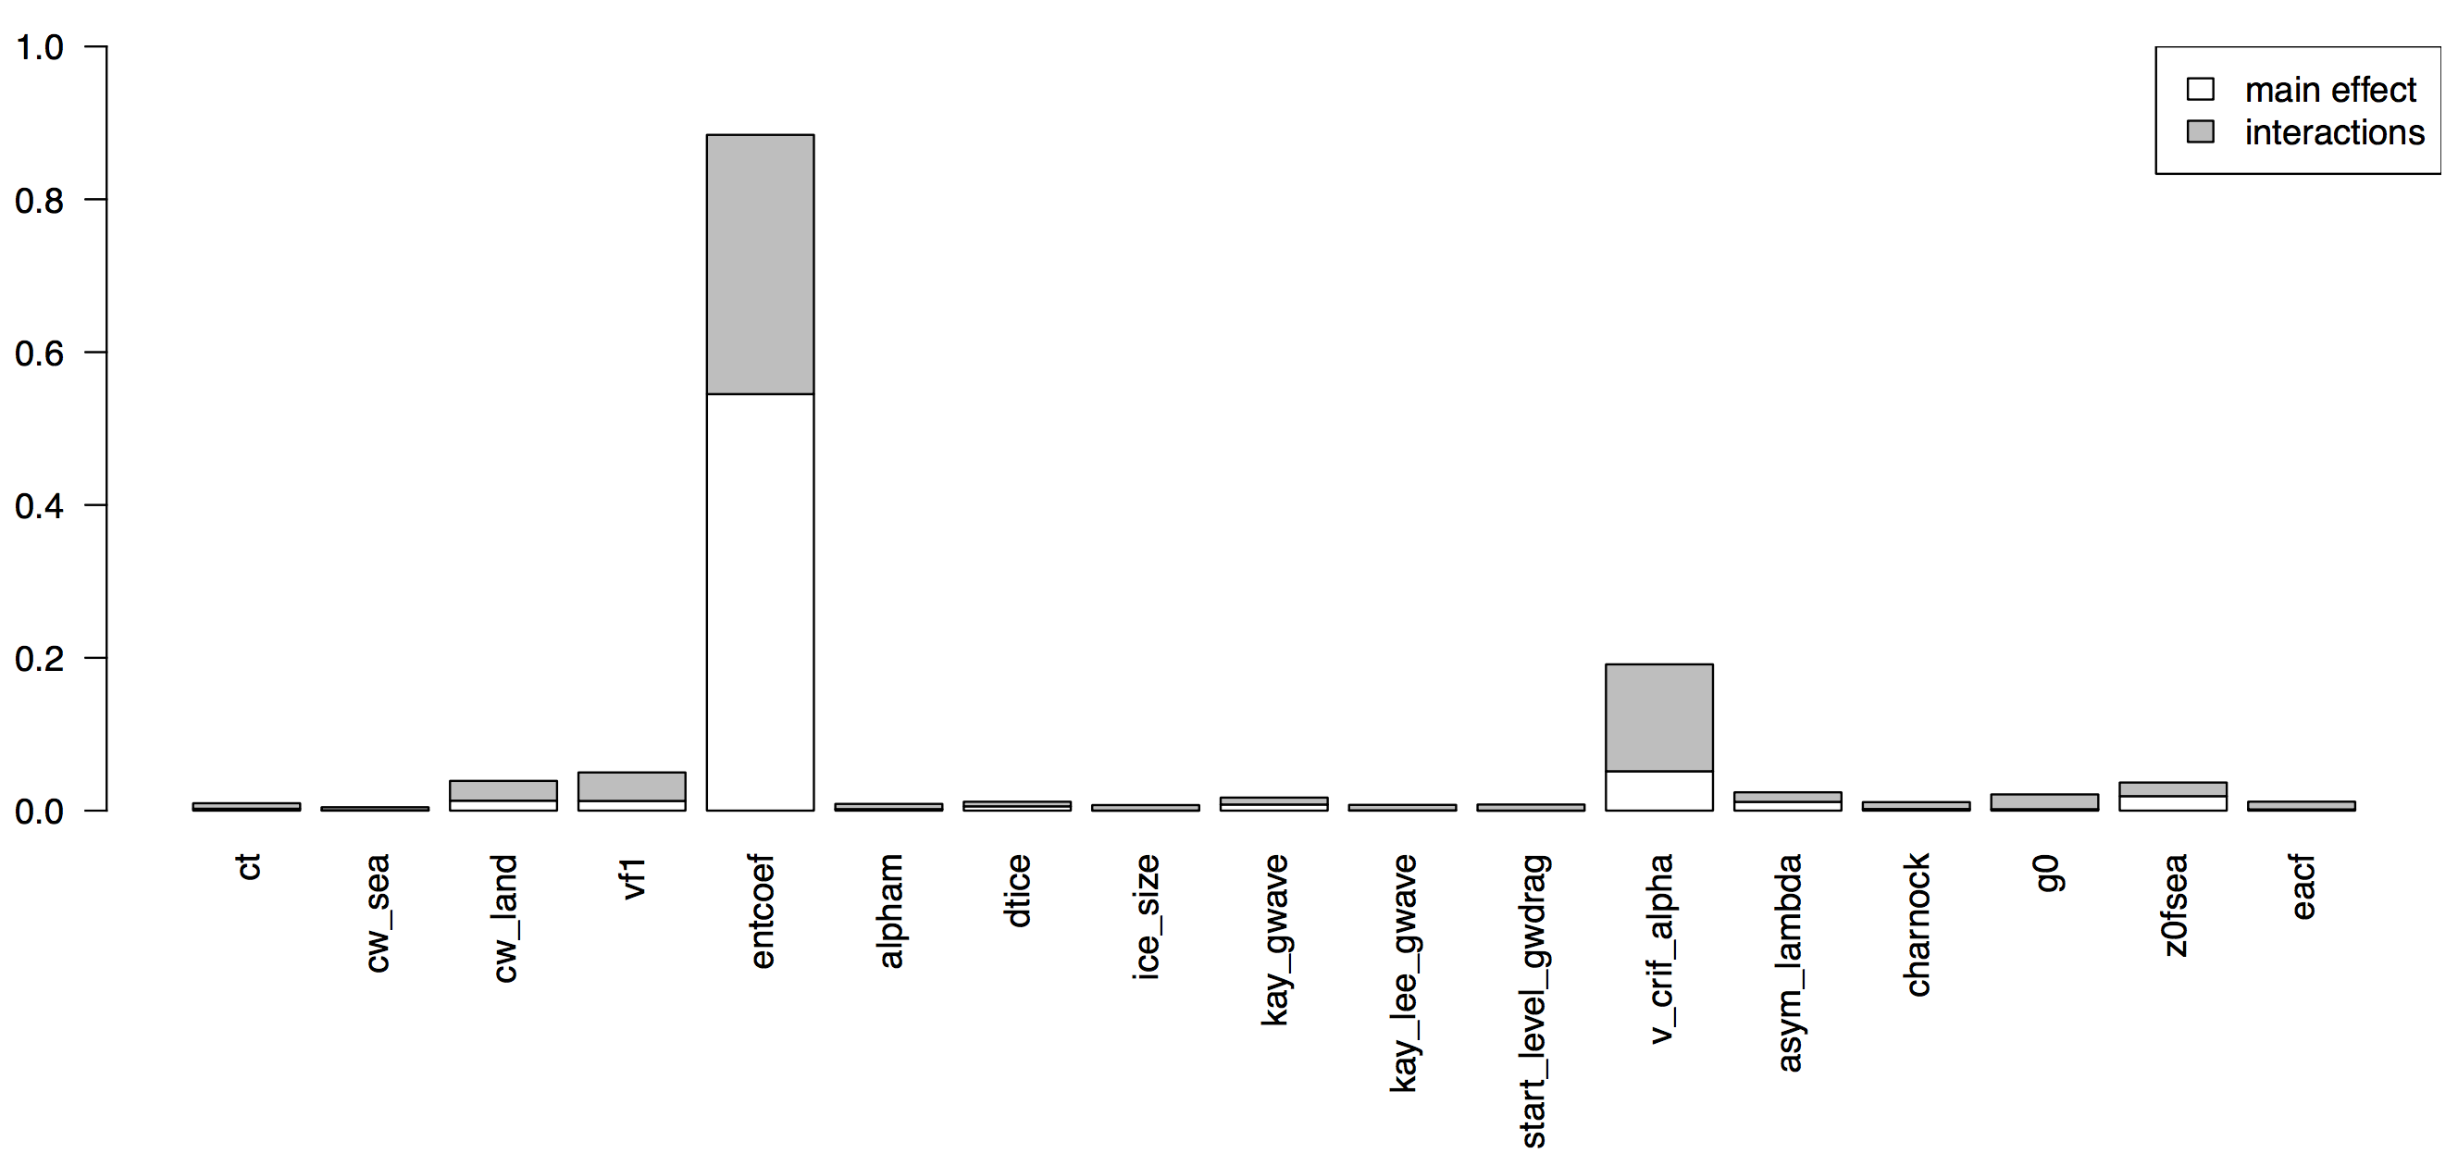
Figure 2. Sensitivity analysis of the root mean squared error of JJA 850-hPa V wind component in PP simulations over the regional model domain, with respect to SP simulations, via the FAST algorithm of Saltelli et al. (1999).

Item 8: Fig. 5 – I am not sure what the purpose of Fig. 5 is since observations are not included in the figure. Yes, the selected 10 models show a substantially smaller spread compared to phases 1 and 2, but in JJA all the selected models show considerably different results compared to the SP and whether that’s an improvement or not is not discussed in the text.

Response: We appreciate this comment and have added a few sentences to clarify about Fig. 5 in the revised manuscript lines 658-662: “The SP simulations have warm and dry biases over NWUS and mid-latitude land in general (as shown in Fig. 4, Fig. 6 and Fig. 7). In JJA all the selected PP model variants show considerably different results compared with the SP-cooler and wetter, i.e. reduced biases and improved model performance”. We have also updated Fig. 5 to include the results from different initial conditions to demonstrate that varying model parameters has more influence on the result than varying initial conditions, which helps clarify item 12 as well.

Item 9: Fig 6i indicates that the cold bias in DJF gets slightly worse in the PP simulations compared to SP even though there are improvements in the other seasons and regions. This needs to be mention in the paper since NWUS is the target region. On l.492, you do mention that the DJF-Pr bias worsens slightly in Phase 3. It suggests that reducing region/season-specific biases is difficult because of its implications for other seasons.

Response: Respectfully, Fig. 6i shows that the PP simulations are warmer than the SP, which indicates the cold biases in DJF gets slightly better in the PP simulations. We agree with the reviewer that reducing region/season-specific biases is difficult because of its implications for other seasons and regions. Parameter refinement exercises like ours are faced with the common dilemma where model revisions yield improvement in one field or regional pattern or season, but degradation in another, or improvement in the model climatology but degradation in the interannual variability representation etc. That is why we feel strongly that any parameter refinement process is and should be tailored to the scientific objectives of the experiments, because there is no one fit for all solution; more importantly, that’s why we are advocating that parameter refinement process should be more explicit and transparent, because choices and compromises made during the refinement process may significantly affect model results and influence evaluations against observed climate, hence should be taken into account in any interpretation of model results, especially in multi-model intercomparison studies to help understanding of model differences.

Item 10: Following on from the point above and the description on lines l.513-529 and l.662, it is clear that a more process-level evaluation is required to find parts of parameter space that truly provide improvements for right physical reasons. The authors should state explicitly (maybe at l.662) that looking at seasonal mean biases in temperature and precipitation is insufficient to fully assess model performance and a more process-based analysis could strengthen the validity of the chosen parameter sets.

Response: We appreciate this comment and have added a few sentences (on lines 780-787 of the revised manuscript) as suggested to explicitly state this point “Furthermore, looking at biases in seasonal mean temperature and precipitation is insufficient to fully assess model performance. As a follow-up step to this study, we recommend a process-based model evaluation and physical explanation of model improvements to further refine the parameter space that provides improvements (e.g., reduce summer biases) through appropriate physical mechanisms. For example, more accurate representation of clouds in the model could lead to better simulated downward solar radiation at the surface, as well as better simulated surface energy and water balance.”

Item 11: (Fig. 8) Why use only reanalysis datasets for precipitation? Aren’t GPCC, CMAP, TRMM better observational precipitation products for model validation?

Response: In the main text, we showed model outputs in comparison with CRU datasets, simply so that temperature and precipitation are compared with the same data source. In the supplementary information, we showed the biases of precipitation compared with other datasets, which includes GPCC (Fig. S16). Now we have added biases of precipitation compared with CMAP and TRMM in the supplementary information of the revised manuscript as Figures. S21&S22.

Item 12: (l.717) The number of initial conditions members, 10 or smaller, seems small especially because the performance is evaluated at regional scales and at climate (∼10-year) timescales. Recent work has demonstrated that large initial conditions ensembles show very different trends on longer timescales. Can the authors please comment on how their parameter refinement might be affected by model’s internal variability characteristics? Is variability in the model strongly coupled to the observed SSTs for the NWUS?

Response: Thank you for these comments regarding initial conditions. Indeed our original intent of having multiple ICs is so that the results would be representative of the parameter perturbations instead of reflecting the influence of any particular IC. Previous work (Bellprat et al., 2012a, Figs. 1-4; Covey et al., 2011, Fig. 4) suggests that varying model parameters has more influence on climate than varying initial conditions. For the metrics we used (e.g. seasonal mean temperature and precipitation), our results show the same in the updated Fig. 5. To answer if internal variability affects different parameter sets differently, we will need to generate identical large initial condition ensembles for each parameter set, which is an interesting research question but beyond the scope of this study.

In previous work (Li et al., 2015) we have compared HadRM3P-HadAM3P results with NARCCAP, and found that that the coupled HadRM3–HadCM3 (HRM3-HadCM3 in NARCCAP convention) demonstrated similar skills in simulating temperature and precipitation as HadRM3P– HadAM3P, even though HadAM3P is an atmosphere only model and SSTs are specified whereas HadCM3 is a coupled ocean–atmosphere model. This similarity between HadRM3P–HadAM3P and HadRM3–HadCM3 suggests that the dynamical coupling between ocean and atmosphere in NARCCAP did not explain most of the difference between HadRM3P–HadAM3P and the various NARCCAP RCM–GCM pairings but that the differences were due mainly to the atmospheric dynamics.

Minor comments:
l.381: It would be useful to have a brief explanation of what the ‘ranges of acceptability’ are for TOA fluxes here. I understand that this has been described in the Appendix and in Fig. 1 caption, but this is critical information and should be concisely described here.

Response: Thank you for pointing this out. Indeed it would be helpful to add some explanation of ‘ranges of acceptability’ in the main text. We have added a brief explanation of what the ‘ranges of acceptability’ at the beginning of Section 3.1 in the revised manuscript lines. 480-484: “The ranges of acceptability for SW and LW (as denoted by the ellipse in Fig. 1) were defined by taking the observational uncertainty ranges given in Stephens et al. (2012), but tripling them (deliberately setting a lenient elimination criteria), and then expanding both the negative and positive thresholds by an additional 1 W m-2 to account for internal variability as estimated from SP (Fig. S5). Please refer to Appendix A for further details.”

l.392: missing ‘a’ in Yamazaki

Response: Apologies for the sloppiness here, this has been fixed.
Fig. S3 caption should read ‘Same as Fig. S2’

Response: Apologies for the sloppiness here, this has been changed.

l.423: should be ‘lead to decreased outgoing . . .’

Response: Apologies for the sloppiness here, this has been changed.

l.577: should ‘increased’ be ‘improved’?

Response: We respectfully point out that in SP, the model has dry biases over northern South America, equatorial Africa, and south Asia in JJA. In PP simulations, the dry biases are stronger compared with SP (Fig. 6k), so the biases are increased in PP simulations.

l.725: Please mention that you use LHS space-filling design earlier in the paper, perhaps at l.241.

Response: Thank you for pointing this out. We have now stated earlier in the paper (line.241 in the original manuscript, line 310 in the revised manuscript) that we used LHS space-filling design.

It would be helpful to have a single document that contains all the supplementary figures and text.

Response: We will upload a single document containing all the supplementary figures and text as revised manuscript.

Response to Referee #2

Review of “Improving climate model accuracy by exploring parameter space with an O(10ˆ5) member ensemble and emulator” by Li et al.

General summary: The manuscript by Li et al applies an iterative, parameter-space refining procedure using perturbed parameter ensembles and statistical emulators to reduce regional biases of temperature and precipitation over the northwestern United States. The paper is well written and thorough, and provides a useful demonstration for reducing biases in the Hadley Centre climate models. I am support publication after the authors address the items below (listed in no particular order).

General response: Thank you very much for these comments. We feel very encouraged from this review and the similar encouraging comments from the other reviewer. We have made the best attempt to respond to these constructive comments.

Item 1: The title seems to suggest that an ensemble of 100,000 forward simulations was used to construct the emulators, which isn’t the case. From Table 2, only a few thousand forward simulations were used. Once the emulators are trained, they can be evaluated very quickly, potentially millions to billions of times. The number of emulator evaluations O(10ˆ5) is therefore somewhat arbitrary and not significant. I recommend that the authors remove the reference to the emulator evaluations in the title because it is misleading. The authors should also consider adding information about the bias reduction goal of the study in the title (e.g. “Reducing climate model biases by exploring . . .”).

Response: Thank you for this suggestion. The title has now been changed to “Reducing climate model biases by exploring parameter space with large ensembles of climate model simulations and statistical emulation”.

Item 2: The first paragraph of the introduction describes the bias reduction goals of the study. On lines 53-54, I recommend that the authors change “simulations cast doubt on the reliability ...” to “simulations reduce the reliability ...”. Later in the paragraph the authors describe prior work that found a relationship between the warm bias and shortwave radiation. This relationship motivates the need for a perturbed parameter approach (i.e. to quantify and reduce the bias). I recommend that the authors introduce PPEs in the first paragraph, rather than wait until the 5th paragraph.

Response: Thank you for these suggestion. Lines 53-54 (line 58 in the revised manuscript) now reads ‘reduce the reliability of’ as suggested. In the revised manuscript we have moved the previous 5th paragraph which introduces parameter perturbation to earlier in the paper (lines 80-99 in the revised manuscript) as suggested.

Item 3: The introduction emphasizes parameter tuning as a major goal of PPEs, but using PPEs to estimate model PDFs and uncertainty is also an important application. I suggest that the authors include a statement about estimating PDFs versus parameter refinement.

Response: Thank you for this suggestion. In the revised manuscript, we have added a few sentences about using PPEs to estimate model PDFs and uncertainty at the end of paragraph 7 (lines 189-198 in the revised manuscript): “Besides parameter refinement, PPEs have also been used in many studies to estimate probability distribution functions (PDFs) of equilibrium climate sensitivity (e.g., Murphy et al., 2004) and transient regional climate change (e.g., Sexton et al., 2012a,b), permitting probabilistic projection of climate change (Murphy et al., 2007, 2009; Harris et al., 2013). PPEs are becoming common as a means to assess the range of uncertainty in climate model projections (Murphy et al., 2004; Stainforth et al., 2005; Collin et al., 2006; Sanderson, 2011; Sexton et al., 2012a,b, 2019; Shiogama et al., 2012; Karmalkar et al., 2019)”.

Item 4: I recommend the following modification on line 146. Change “varied systematically.” to “varied systematically or randomly.”

Response: Thank you for this suggestion. The wording on line 146 (line 183 in the revised manuscript) has been changed to “varied systematically or randomly” as suggested.

Item 5: In the discussion about different types of PPE studies in the introduction, it would be worth pointing out that categories 2 and 3 may not be different from each other if a sufficient number of forward simulations are used to produce an adequate emulator over the full parameter space. With a good enough emulator, it is possible to both rule out parameter space and optimize parameter values. In this case, categories 2 and 3 are simply post-processing steps.

Response: Thank you very much for this suggestion. We have added a few sentences in the main text to point this out at the end of paragraph 10 (lines 241-246 in the revised manuscript): “It is worth pointing out that the second and the third categories may not be different from each other if a sufficient number of model simulations are used to train a statistical emulator over the full parameter space. With a good emulator, it is possible to rule out parameter space and optimize parameter values, in which case categories two and three are post-processing steps”.

Item 6: Bayesian climate model calibration and MCMC are not mentioned or referenced in the introduction (e.g. Jackson et al., J. Clim. 2008), nor is optimization over multiple objectives (e.g. Neelin et al., PNAS, 2010). It would be worth including these references.

Response: Thank you for pointing this out. In the revised manuscript, we have included a few references on Bayesian climate model calibration and MCMC, as well as optimization over multiple objectives in the introduction as suggested on lines 216-220 in the revised manuscript: “Different approaches have been used in optimization, ranging from ensemble Kalman filters (Annan et al., 2005; Annan and Hargreaves, 2007 and the references therein), stochastic Bayesian approach (e.g. Jackson et al., 2004), Markov chain Monte Carlo integrations (Jackson et al., 2008; Järvinen et al., 2010), as well as optimization over multiple objectives (Neelin et al., 2010).”

Item 7: The authors mention that little work has been done using PPEs for parameter refinement to improve RCMs. I agree with this statement, but think that it would be worth referencing prior work using PPEs for parameter refinement to improve regional climate in GCMs.

Response: Thank you for this suggestion. We have added a few references of prior work using PPEs for parameter refinement to improve regional climate over Europe and North America in paragraph 11 (line 207 in the original manuscript, line 263 in the revised manuscript), which now reads: “However, very little (Bellprat et al., 2012b; 2016) has been published on using PPEs for parameter refinement with the aim of improving regional climate models (RCMs).”

Item 8: Toward the end of the introduction, the authors describe how instead of searching for a single optimized parameter set, they consider multiple parameter sets because of the challenges of compensating errors and other effects. Rather than a limited number of parameter sets, it would be better if posterior parameter PDFs were estimated in a Bayesian sense. Doing so would understandably be outside the scope of the manuscript, though the authors should comment about the potential benefits of using parameter PDFs in their analysis.

Response: Thank you for this suggestion. We have added a few sentences commenting on the potential benefits of using posterior parameter PDFs toward the end of the introduction on lines 286-292 in the revised manuscript: “An alternative approach would be to interpolate between the sampled points in the parameter space, and estimate a posterior parameter probability density function (PDF), which could then be used to produce a PDF of model outputs of interests (e.g., Murphy et al., 2004; Sexton et al., 2012a,b). We chose to select multiple parameter sets instead of using parameter PDFs because the intended use is to make projections with a small ensemble of parameter sets with reduced biases in summer temperature and precipitation.”

Item 9: I would like the authors to comment about how they expect their results would differ if they swapped the order of phases 1 and 2 (i.e. first reduce biases in NWUS and then rule out regions that don’t preserve energy balance).

Response: If we were to swap the order of phases 1 and 2, we could possibly get rid of the regional temperature biases, seeing the reduction in temperature biases is accompanied by increased TOA reflected SW radiation (Fig. 4), implying there are more clouds in those PPE simulations with reduced JJA temperature biases. Then we could end up in a corner of the parameter space where there are minimal JJA temperature biases, but out of balance TOA energy fluxes. Our premises was that TOA radiation balance is an emergent property in GCMs (Solomon et al., 2007), so we chose to carry out the parameter refining process following phases 1 and 2, preserving energy balance first, then reducing biases in NWUS.

Item 10: The authors use the so-called standard physics set (SP) as a reference point for gauging improvements from the PPE. Are the parameter values in the SP the same between the global and regional versions of the model? If so, there would appear to be a mismatch because the parameters represent unresolved processes and the standard values should be adjusted to account for differences in scale between the HadAM3P and HadRM3P. Following similar reasoning, it is difficult to see how parameter perturbations applied to the global model can be directly applied to the regional model without adjusting for scale differences. The authors should comment on and describe the implications of this potential mismatch.

Response: Thank you for these comments. Some model parameters are different between the global and regional model (adjusted for scale) but these are not among the parameters that were perturbed in this study. We are mindful of the possibility that among the parameters that were perturbed here, for some parameters the parameter values may be resolution-dependent, especially in a topographically complex region such as the NWUS. This is an important issue that needs to be further explored. However, currently there is no clear guidance on how the parameters should scale with changes in resolution between the global and regional model. Without information on how these should be adjusted or performing a further nested parameter sweep (which is beyond the scope of this study), it would be hard to know which parameters to adjust, to what extent are they resolution dependent, and how to adjust them. Therefore, the same values are applied in HadAM3P and HadRM3P as a first estimation, without adjustment to account for differences in scale. But it would be an interesting and useful follow-on study to look at setting parameters differently in the global and regional model. As part of our ongoing work, we have performed additional PPEs, where the parameter values are set to be different in HadAM3P and HadRM3P, and we will attempt to address the resolution-dependency of parameter values in a following paper using those PPEs.

Item 11: Observational uncertainty is assessed by using multiple observational datasets. For the regional bias analysis, how large are the datasets differences relative to the upscaling variability in regridding PRISM to HadRM3P?

Response: We are not quite sure what the reviewer means by ‘upscaling variability’. Assuming that means variability in upscaling methods in regridding PRISM to HadRM3P, to clarify, we chose the method where for each HadRM3P grid point, an average was taken over all the PRISM points that fall in the bounds of that HadRM3P grid point, and the averaged value was assigned to that HadRM3P grid point.

Item 12: Presumably emulators are used for the sensitivity analysis, though this is not clear from the discussion in section 2.5. I recommend including a short summary of the emulators before the sensitivity analysis, rather than keeping all of the emulator discussion in the appendix. If emulators were used for the sensitivity analysis and are efficient to evaluate, so why not use a quantitative Sobol analysis instead of the qualitative FAST method?

Response: Thank you for these comments and suggestions. Yes, emulators are used for sensitivity analysis. Apologies for not being clear about this. We have added a sentence in the sensitivity analysis section to clarify this on lines 462-463 in the revised manuscript “Emulators are used for the sensitivity analysis”.

As suggested, we have included a brief summary of the emulators (the new section 2.5. Emulators in the revised manuscript on lines 429-444 in the revised manuscript) before the sensitivity analysis (the previous section 2.5, which is now section 2.6), which reads: “In Phase 1, a 2-layer feed-forward Artificial Neural Network (ANN, Knutti et al., 2003; Sanderson et al., 2008; Mulholland et al., 2016) was used. Although other machine-learning algorithms could be suitable (Rougier et al., 2009; Neelin et al., 2010; Bellprat et al., 2011, 2012, 2016), we chose ANN because it permits multiple simultaneous emulator targets (i.e., TOA SW and LW at the same time). Although ANN has the advantage of using multiple metrics as targets simultaneously, the underlying emulator structure remains obscure. From Phase 2, for the sake of simplicity and transparency, we used kriging - which is similar to a Gaussian process regression emulator - following McNeall et al. (2016) as coded in the package DiceKriging (Roustant et al., 2012) in the statistical programming environment R. We used universal kriging, with no ‘nugget’ term, meaning that the uncertainty on model outputs shrinks to zero at the parameter input points that have already been simulated by the climate model (Roustant et al., 2012). Please refer to Appendix A for further details.”

FAST is also a variance-based quantitative sensitivity analysis method. The fraction of the variance due to an input parameter (main effect) is calculated as the sum of the Fourier coefficients for the frequency assigned to the input parameter and it’s harmonics. The total contribution of each parameter, xi, to the output variance includes main effects and interactions with all other parameters and can be calculated by summing Fourier coefficients for the set of frequencies complementary to the frequency assigned to input the parameter xi. The residual variance, not accounted for by the main effect, is therefore attributable to interactions between the parameter xi and any of the other parameters. We agree with the reviewer that Sobol analysis could be used, but FAST is a quantitative method that can be used to identify the dominant parameters as well.

Item 13: When I first read section 3.1 and interpreted the results in figure 1, I thought that the phase 2 emulator errors for SW were significant. Only later, after seeing the quality of the emulators in appendix B, did I realize that the errors were smaller than I thought. I recommend that the authors summarize the quality of the emulators earlier in the manuscript. Referring to figure 1, can the authors also comment about why there does not appear to be a very strong relationship between the LW and SW points (correlation looks like 0) and why there are no simulations in the blue ellipse with high LW?

Response: Thank you for these comments and suggestions. We have added a few sentences (on lines 493-498 in the revised manuscript) to summarize the quality of the emulators earlier in the manuscript (section 3.1) as suggested: “Fig. B1 and B2 (in Appendix B) show predictions from emulators against model-simulated values for model output metrics as validations of the emulators. The linear relationships between the emulated and simulated are very strong (regression coefficient regcoef>0.9 for both LW and SW), while the emulated results can predict the simulated results relative well, with coefficient of determination R2 > 0.9 for both LW and SW. Please refer to Appendix B for further details on emulator validations”.

Regarding the relationship between the LW and SW, the bias reduction is accompanied by reduced TOA reflected SW, suggesting changes in clouds, but given different cloud types have different radiative effects on SW and LW (Zelinka et al., 2012, Fig. 8), we do not expect a clear positive or negative correlation between SW and LW by increased clouds, without knowing if the increased clouds are high, medium, low, thin, medium, thick, or any combination of these cloud types. We suspect the reason why there are no simulations in the blue ellipse with high LW is because the net effects of changes in clouds in these PP experiments are so that they do not lead to too much infrared radiation emitting to space. To answer this in further detail, we would need to run additional experiments where detailed could covers (low, medium and high) and cloud properties (e.g., optical depth) are saved as outputs, which is beyond the scope of this study.

Item 14: The OAAT relationships in figure 2 are useful as qualitative indicators of the dependence of the outputs on the inputs. While it reasonable to hold other inputs at their mean values, it would probably be more informative to use the default SP values. Can the authors regenerate the plots using SP values instead? Moreover, instead of conditioning on the values of the other inputs, it may be more useful to compute partial dependence plots that integrate over the other inputs. Unlike the OAAT plots, partial dependence plots account for interactions.

Response: Thank you for these comments and suggestions. We have regenerated the OAAT plot using SP values as suggested (please see Figure 1). The results are very similar to those shown in the main Figure 2 holding other inputs at their mean values. We have added a sentence on lines 555-556 of the revised manuscript to state this: “OAAT results while holding all other parameters at their SP values are very similar to those shown in Fig. 2 (results not shown here).”

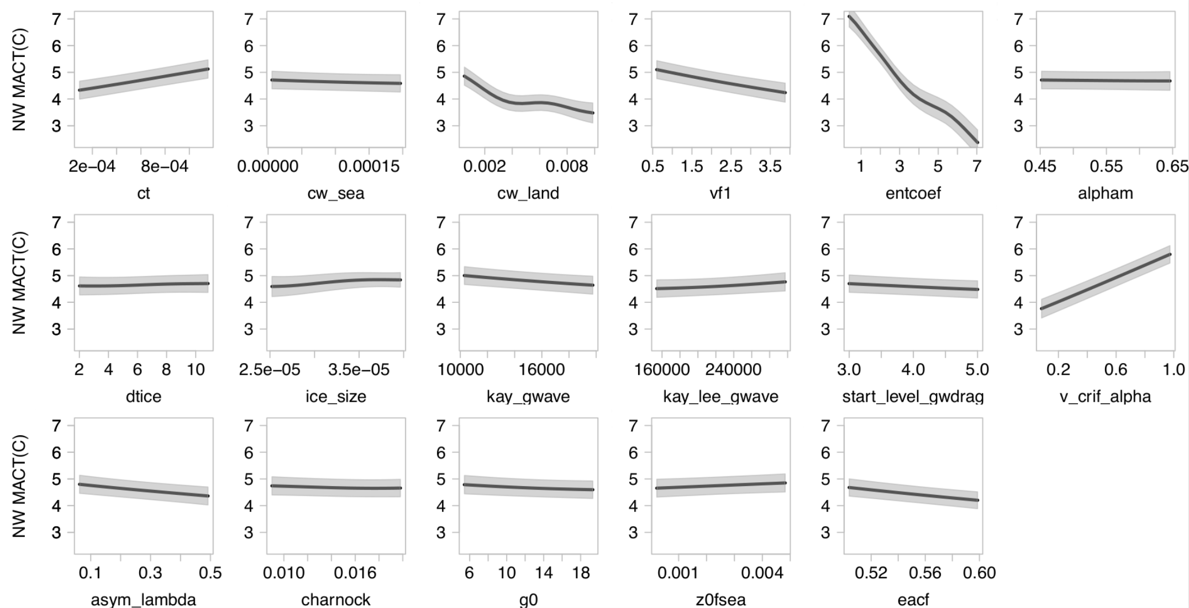
Figure 1. One-at-a-time sensitivity analysis of magnitude of MAC-T over Northwest to each input parameter in turn, with all other parameter held at SP values. Heavy lines represent the emulator mean, and shaded areas represent the estimate of emulator uncertainty, at the ±1 SD level.

Thank you for suggesting to use partial dependence plots. We have attempted to compute and plot partial dependence plots (using scikit-learn in python https://scikit-learn.org/stable/). Figure 2 below shows the results for the four most important parameters - cw_land, vf1, entcoef, and v_crit_alpha. The results are very similar to those shown in the OAAT plots, and the results for the other parameters are very similar as well (not shown here). Since the interaction terms are quite small (from the sensitivity analysis shown in Figure 3 in the main text), it is not that surprising that the OAAT plots and the partial dependence plots are similar.

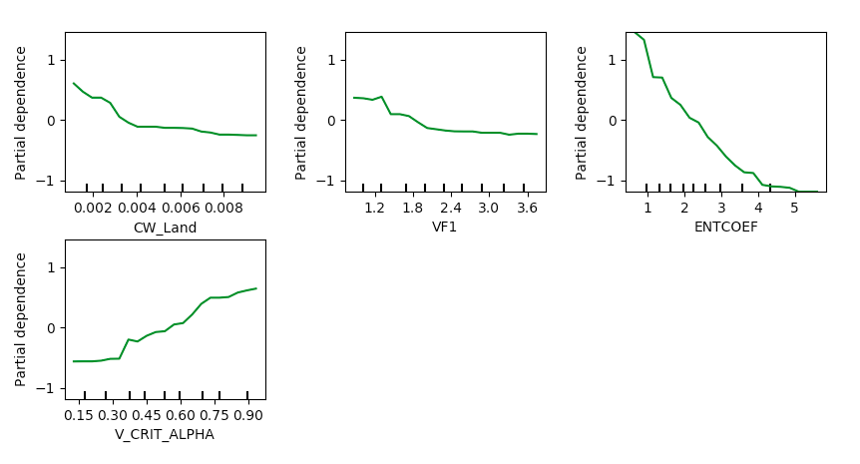
Figure 2. Partial dependence plots of magnitude of MAC-T over Northwest to CW_LAND, VF1, ENTCOEF, and V_CRIT_ALPHA.

Item 15: Global sensitivity indices are presented in figure 3 using the FAST method. The text mentions that total and main effects are both computed, and that the maximum sensitivity value is 1. For nonlinear models, the sum of the total effects can be greater than 1 because interactions are counted more than once. Can the authors clarify their statement? Also, I am wondering about the robustness of some of the differences between the sensitivity indices (e.g. for JJA-Pr). If emulators were used, can the authors estimate and include emulator uncertainty in figure 3?

Response: We agree with the reviewer that non-linear models can have coefficients that sum to greater than one. However, in the extended Fourier Amplitude sensitivity analysis (FAST; Saltelli et al., 1999), the fraction of the variance due to an input parameter (main effect) is calculated as the sum of the Fourier coefficients for the frequency assigned to the input parameter and it’s harmonics. The total contribution of each parameter, xi, to the output variance includes main effects and interactions with all other parameters and can be calculated by summing Fourier coefficients for the set of frequencies complementary to the frequency assigned to input the parameter xi. The residual variance, not accounted for by the main effect, is therefore attributable to interactions between the parameter xi and any of the other parameters. The fraction of the total variance due to interactions is not resolved as the sum of individual effects and will never sum to a value other than 1. For further information please refer to Saltelli et al. (1999).

We have added a few sentences in ‘Sensitivity Analysis’ section (lines 457-461 in the revised manuscript) to clarify this “In the FAST method, the fraction of the total variance due to the interactions is not resolved as the sum of individual interactions, but is computed from the parameter contribution to the residual variance , i.e., variance not accounted for by the main effects.”

Regarding the emulator uncertainty, Figure 2, which shows the emulator uncertainty as the shaded area in each panel, illustrates that the contribution of the emulator uncertainty to the variance of the emulated output is small.

Item 16: Figure 4 is highly useful, but contains a lot of information. It might be easier to digest in three separate figures (input-input, input-output, and output-output). I am also wondering about some of the differences between the phase 3 and SP values. For the input-input plots, the SP red dots tend to lie near or within the phase 3 set of points (there are exceptions for CW_land, ENTCOEF and V_CRIT_ALPHA). In the MAC-T-input and JJA-T-input plots, however, the SP and phase 3 points are completely separated from each other. It looks like the separation can be explained by ENTCOEF and V_CRIT_ALPHA, but the magnitude of the separation seems too large. For MAC-T it looks like the average difference is about 2 degrees C. But the temperature change in figure 1 is about 1 degree C when ENTCOEF is varied between 3 and 5. Can the authors explain why small changes in ENTCOEF and V_CRIT_ALPHA lead to such large (and discrete) changes in temperature? Understandably, one of the goals of the study is to reduce the temperature bias, so large changes might be expected. But the authors use an iterative and refinement strategy that I would expect to reduce the bias in small continuous steps, not the large, discrete changes that are shown.

Response: Thank you for these comments. We agree with the reviewer that Figure 4 contains a lot of information. In the original figure, we added the horizontal and vertical red lines to mark the transition from parameter inputs to model output metrics, hoping that would make digesting the figure easier. In the updated Fig 4 (which is shown in Figure 3 below), we have added additional labels in the figure to mark the three quadrants of the figure as a) input-input, b) input-output, and c) output-output.

Regarding the changes in MAC-T and JJA-T from Phase 2 to Phase 3, we are not surprised by the large reductions in temperature biases. Multiple individual parameters demonstrated the capacity to reduce the MAC-T bias by several degrees (ENTCOEF, V_CRIT_ALPHA) in the one-at-a-time sensitivity analysis (Figure 2). The additive effects of ENTCOEF and V_CRIT_ALPHA adjustments made between Phase 2 and Phase 3, in addition to the effects of other influential parameters (CW_LAND and VF1) are expected to be quite large (several degrees in MAC-T). The temperature changes are not discrete, and no results from the Phase3 PPE overlap results from SP. This is attributable to the changes in parameter ranges between Phase2 and Phase3, i.e., parameters were constrained after Phase 2. In Phase 3 the default parameterization is not a plausible parameter combination in the newly refined plausible parameter space.
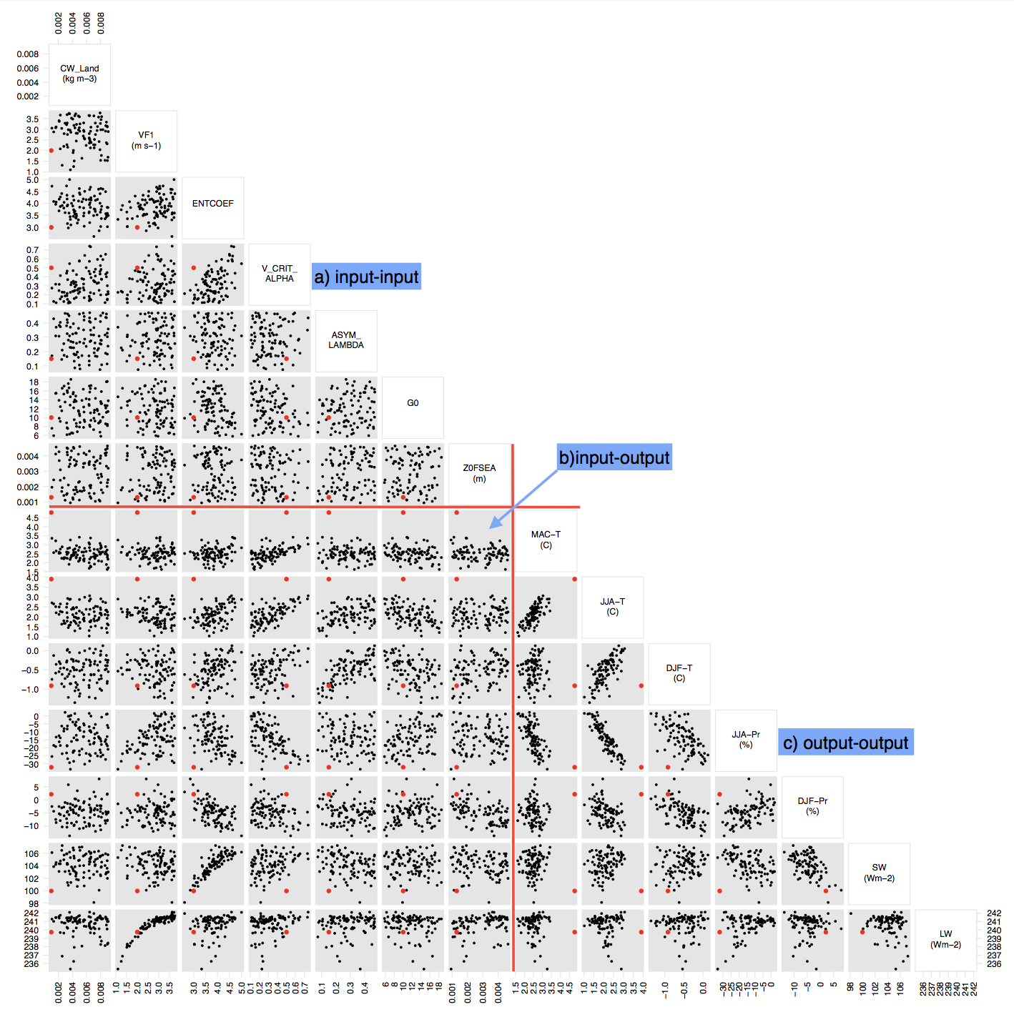
Figure 3. Updated Figure 4 of the main text.

Item 17: Given that ENTCOEF and V_CRIT_ALPHA are dominant parameters affecting temperature, it might be useful to use the emulators to further analyze and display the temperature surfaces as a function of the inputs.

Response: Thank you for this suggestion. We have plotted the temperature surfaces (MAC-T, JJA-T, and DJF-T) as a function of each pair of parameter inputs using the emulators (please see Figures 4-6, which have been added into supplementary information as Figures. S23-S25).
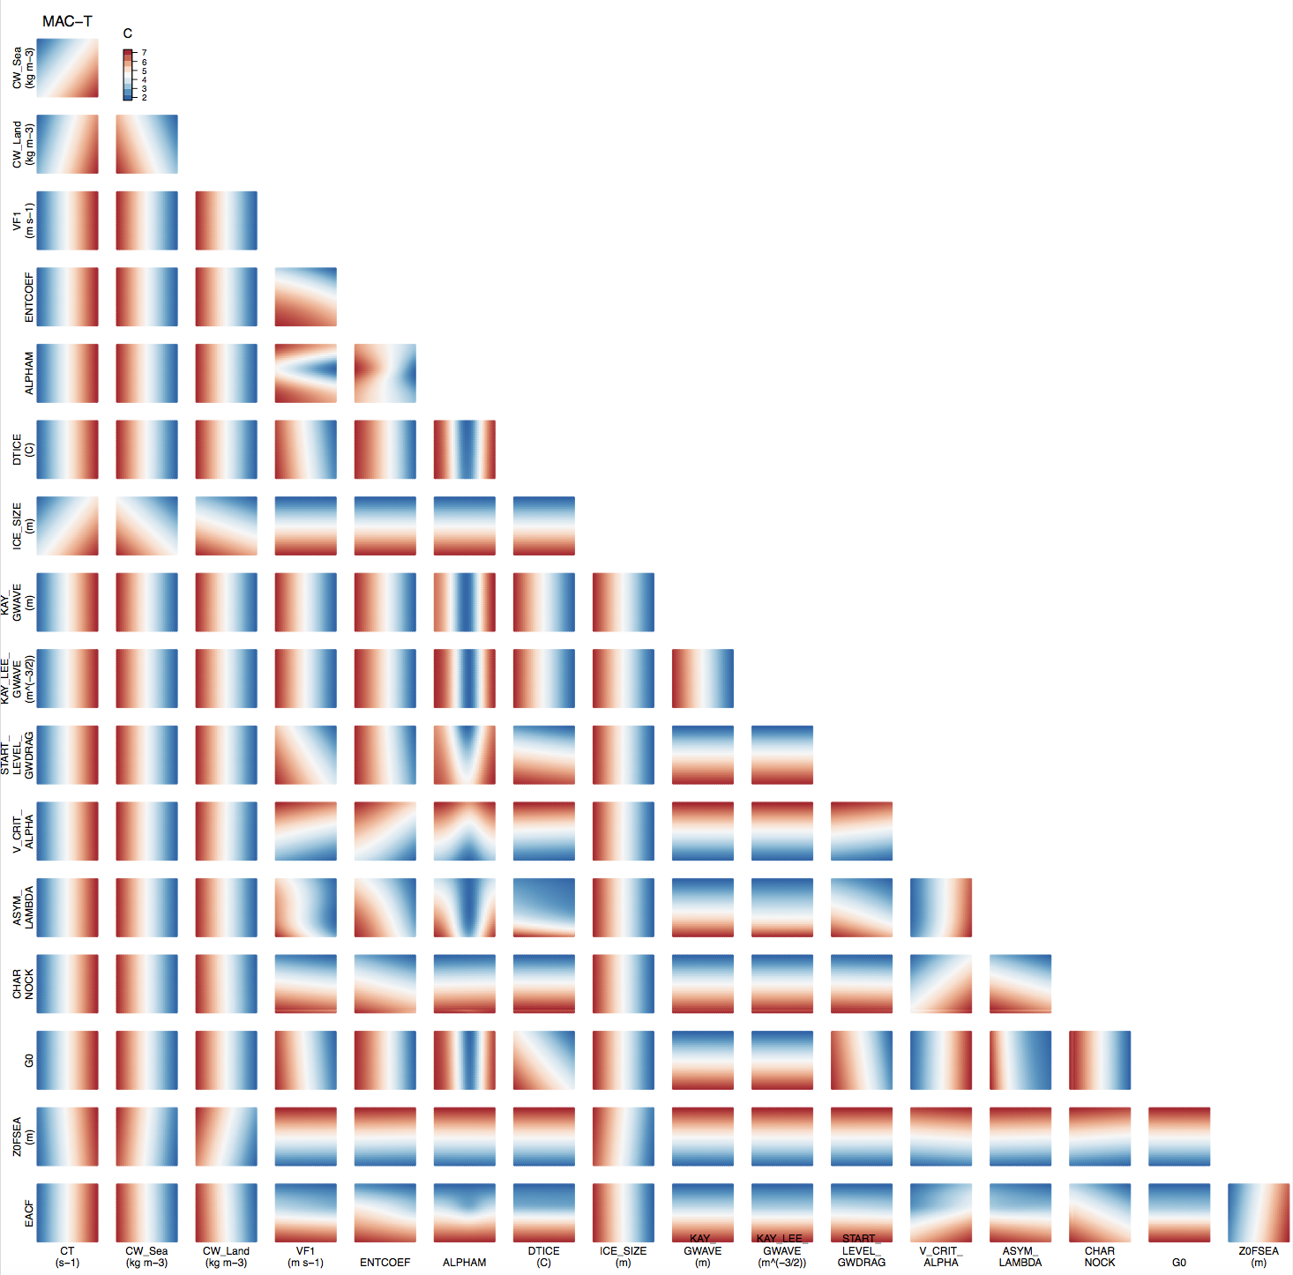
Figure 4. MAC-T biases projected into the two-dimensional spaces of each pair of input parameters using the emulator.

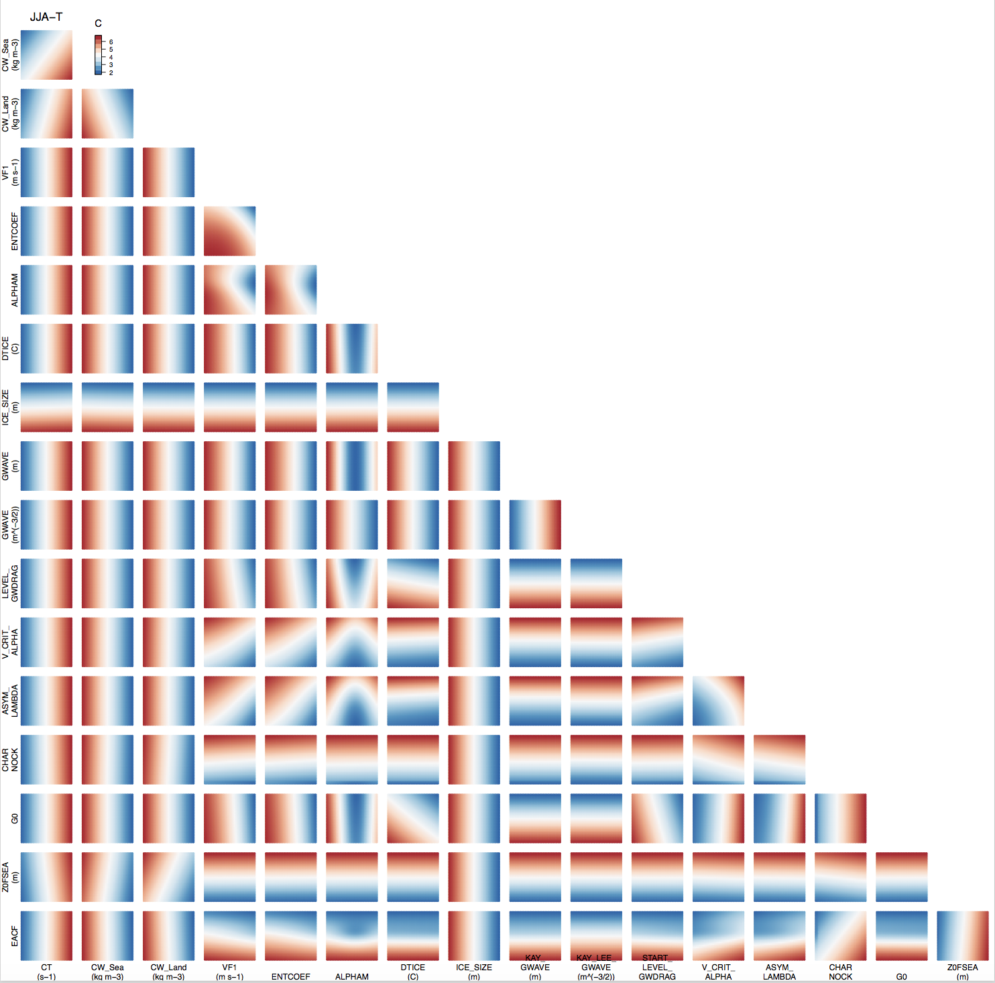
Figure 5. JJA-T biases projected into the two-dimensional spaces of each pair of input parameters using the emulator.

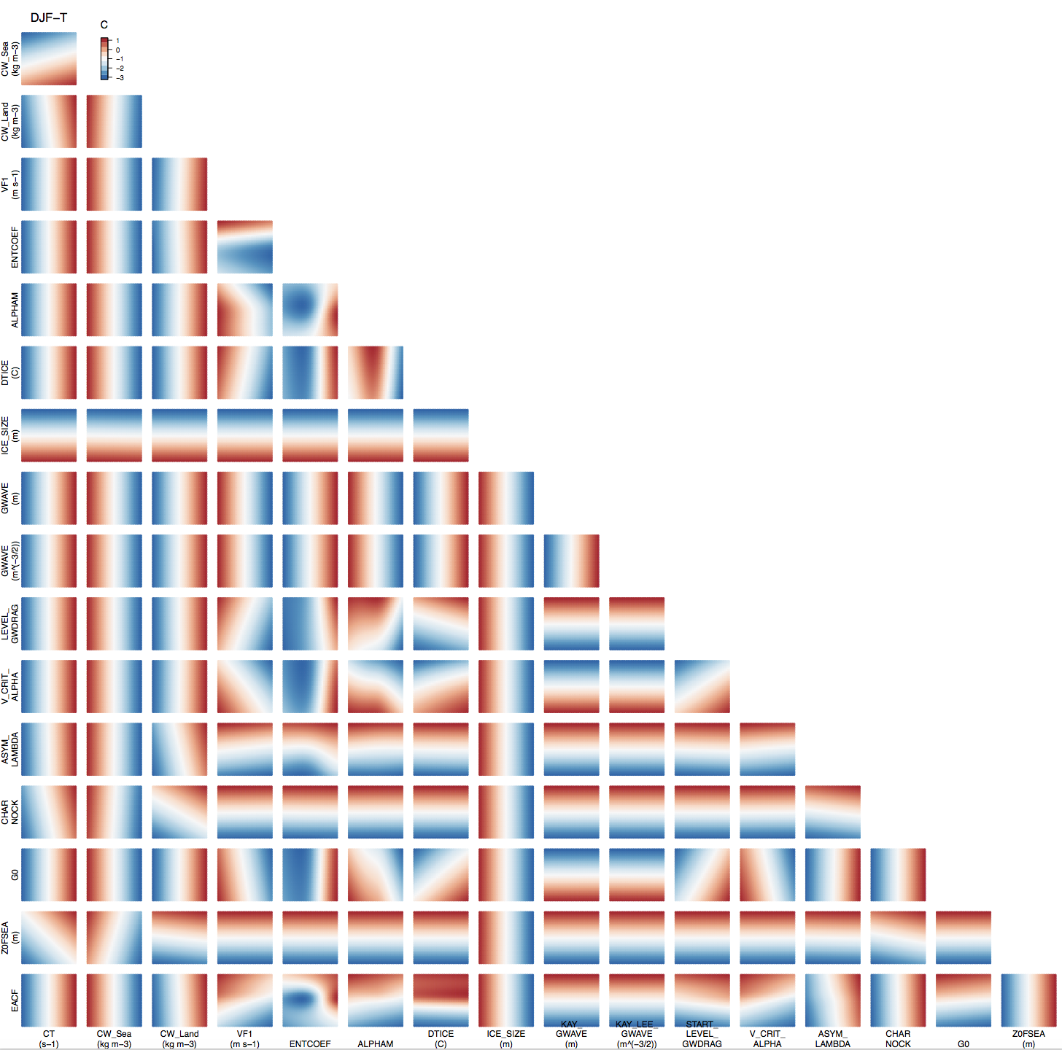
Figure 6. DJF-T biases projected into the two-dimensional spaces of each pair of input parameters using the emulator.

Item 18: On the copy of the manuscript that I reviewed, there appears to be an artifact (i.e. a white line) at longitude 0 on all of the spatial maps (e.g. see figure 6k over Eastern Africa).

Response: Thank you for point this out. This seems like an artifact from the original plotting. We have updated the spatial maps to in the revised manuscript (both the main text figures and supplemental figures), which do not have these white lines anymore.

Item 19: After refining the parameter space between phases 2 and 3, the parameters that were dominant in figure 3 may no longer be dominant. Can the authors recompute the sensitivity indices for the refined parameter space after the bias reduction?

Response: Thank you for these comments. We have recomputed and replotted the sensitivity indices for the refined parameter space in phase 3 as suggested (please see Figure 7 below, and this figure has been added to the supplementary information of the revised manuscript as Figure. S26). The dominant parameters for SW, LW, and DJF-Pr are still the same, whereas the dominant parameters for the other output metrics are different. V_CRIT_ALPHA becomes the most important parameter for MAC-T, JJA-T and JJA-Pr, and ASYM_LAMBDA becomes the most important parameter for DJF-T. The dominant parameter is partially a function of the plausible range set for that parameter. We agree with the reviewer that the parameters that were well constrained after phase 2 may not be dominant in phase 3 simply because the perturbation range was reduced after phase 2. We consider this result to demonstrate the effectiveness of iterative refocusing in constraining the plausible parameter space.

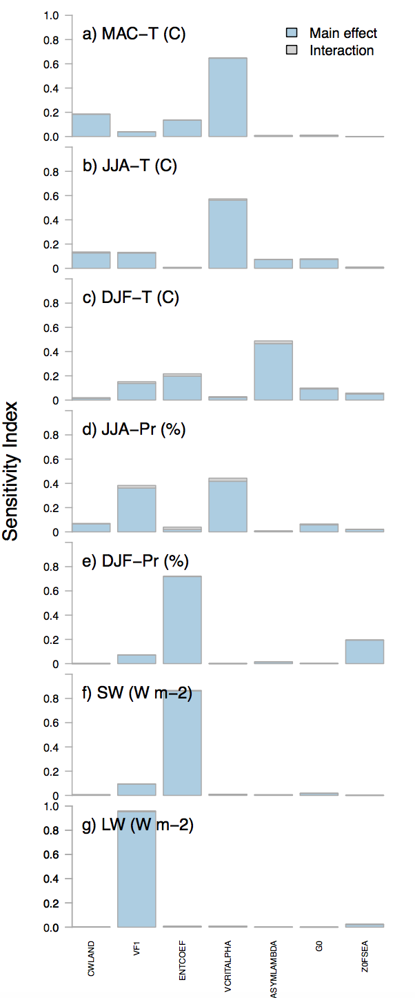
Figure 7. The sensitivity indices for the refined parameter space in Phase 3.

References:
Annan, J.D. and Hargreaves, J.C.: Efficient estimation and ensemble generation in climate modelling. Philosophical Transactions of the Royal Society A: Mathematical, Physical and Engineering Sciences, 365(1857), pp.2077-2088, 2007.
Annan, J.D., Lunt, D.J., Hargreaves, J.C. and Valdes, P.J.: Parameter estimation in an atmospheric GCM using the Ensemble Kalman Filter. Nonlinear processes in geophysics, 12(3), pp.363-371, 2005.
Bellprat, O., Kotlarski, S., Lüthi, D., and Schär, C.: Exploring perturbed physics ensembles in a regional climate model, Journal of Climate, 25(13), 4582-4599, https://doi.org/10.1175/JCLI-D-11-00275.1, 2002a.
Bellprat, O., Kotlarski, S., Lüthi, D., and Schär, C.: Objective calibration of regional climate models, Journal of Geophysical Research: Atmospheres, 117(D23), https://doi.org/10.1029/2012JD018262, 2012b.
Bellprat, O., Kotlarski, S., Lüthi, D., De Elía, R., Frigon, A., Laprise, R., and Schär, C.:
Objective calibration of regional climate models: application over Europe and North
America, Journal of Climate, 29(2), 819-838, https://doi.org/10.1175/JCLI-D-15-0302.1,
2016.
Collins, M., Booth, B.B., Harris, G.R., Murphy, J.M., Sexton, D.M. and Webb, M.J.: Towards quantifying uncertainty in transient climate change. Climate Dynamics, 27(2-3), pp.127-147, 2006.
Covey, C., Brandon, S., Bremer, P.T., Domyancis, D., Garaizar, X., Johannesson, G., Klein, R., Klein, S.A., Lucas, D.D., Tannahill, J. and Zhang, Y., 2011 A new ensemble of perturbed-input-parameter simulations by the Community Atmosphere Model. Technical report, Lawrence Livermore National Laboratory, Livermore, CA.
Harris, G.R., Kendon, E.J., Betts, R.A. and Brown, S.J.: UK climate projections science report: climate change projections, 2009.
Harris, G.R., Sexton, D.M., Booth, B.B., Collins, M. and Murphy, J.M.: Probabilistic projections of transient climate change. Climate dynamics, 40(11-12), pp.2937-2972, 2013.
Jackson, C., Sen, M.K. and Stoffa, P.L.: An efficient stochastic Bayesian approach to optimal parameter and uncertainty estimation for climate model predictions. Journal of Climate, 17(14), pp.2828-2841, 2004.
Jackson, C.S., Sen, M.K., Huerta, G., Deng, Y. and Bowman, K.P.: Error reduction and convergence in climate prediction. Journal of Climate, 21(24), pp.6698-6709, 2008.
Järvinen, H., Räisänen, P., Laine, M., Tamminen, J., Ilin, A., Oja, E., Solonen, A. and Haario, H.: Estimation of ECHAM5 climate model closure parameters with adaptive MCMC. Atmospheric Chemistry and Physics, 10(20), pp.9993-10002, 2010.
Karmalkar, A.V., Sexton, D.M., Murphy, J.M., Booth, B.B., Rostron, J.W. and McNeall, D.J.: Finding plausible and diverse variants of a climate model. Part II: development and validation of methodology. Climate Dynamics, pp.1-31, 2019.
Li, S., Mote, P.W., Rupp, D.E., Vickers, D., Mera, R. and Allen, M., 2015. Evaluation of a regional climate modeling effort for the western United States using a superensemble from weather@ home. Journal of Climate, 28(19), pp.7470-7488.
Murphy, J.M., Sexton, D.M., Barnett, D.N., Jones, G.S., Webb, M.J., Collins, M. and Stainforth, D.A.: Quantification of modelling uncertainties in a large ensemble of climate change simulations. Nature, 430(7001), p.768, 2004.
Murphy, J.M., Booth, B.B., Collins, M., Harris, G.R., Sexton, D.M. and Webb, M.J.: A methodology for probabilistic predictions of regional climate change from perturbed physics ensembles. Philosophical Transactions of the Royal Society A: Mathematical, Physical and Engineering Sciences, 365(1857), pp.1993-2028, 2007.
Murphy, J.M., Sexton, D.M., Jenkins, G.J., Booth, B.B., Brown, C.C., Clark, R.T., Collins, M., Harris, G.R., Kendon, E.J., Betts, R.A. and Brown, S.J.: UK climate projections science report: climate change projections, 2009.
Neelin, J. D., Bracco, A., Luo, H., McWilliams, J.C., and Meyerson, J. E.: Considerations for parameter optimization and sensitivity in climate models. Proc. Natl. Acad. Sci. USA, 107(50), 21349–21354, doi:10.1073/pnas.1015473107, 2010.
Sanderson, B.M.: A multimodel study of parametric uncertainty in predictions of climate response to rising greenhouse gas concentrations. Journal of Climate, 24(5), pp.1362-1377, 2011.
Sexton, D.M. and Murphy, J.M.: Multivariate probabilistic projections using imperfect climate models. Part II: robustness of methodological choices and consequences for climate sensitivity. Climate Dynamics, 38(11-12), pp.2543-2558, 2012.
Sexton, D.M.H., Karmalkar, A.V., Murphy, J.M., Williams, K.D., Boutle, I.A., Morcrette, C.J., Stirling, A.J. and Vosper, S.B.: Finding plausible and diverse variants of a climate model. Part 1: establishing the relationship between errors at weather and climate time scales. Climate Dynamics, pp.1-34, 2019.
Shiogama, H., Watanabe, M., Yoshimori, M., Yokohata, T., Ogura, T., Annan, J.D., Hargreaves, J.C., Abe, M., Kamae, Y., O’ishi, R. and Nobui, R.: Perturbed physics ensemble using the MIROC5 coupled atmosphere–ocean GCM without flux corrections: experimental design and results. Climate dynamics, 39(12), pp.3041-3056, 2012.
Solomon, S., Qin, D., Manning, M., Averyt, K. and Marquis, M. eds.: Climate change 2007-the physical science basis: Working group I contribution to the fourth assessment report of the IPCC (Vol. 4). Cambridge university press, 2007.
Stainforth, D.A., Aina, T., Christensen, C., Collins, M., Faull, N., Frame, D.J., Kettleborough, J.A., Knight, S., Martin, A., Murphy, J.M. and Piani, C.:. Uncertainty in predictions of the climate response to rising levels of greenhouse gases. Nature, 433(7024), p.403, 2005.
Zelinka, M.D., Klein, S.A. and Hartmann, D.L.: Computing and partitioning cloud feedbacks using cloud property histograms. Part I: Cloud radiative kernels. Journal of Climate, 25(11), pp.3715-3735, 2012.

Reducing climate model biases by exploring parameter space with large ensembles of climate model simulations and statistical emulation

Sihan Li^{1,2}, David E. Rupp³, Linnia Hawkins^{3,6}, Philip W. Mote^{3,6}, Doug McNeall⁴, Sarah N. Sparrow², David C. H. Wallom², Richard A. Betts^{4,5}, Justin J. Wettstein^{6,7,8}
¹Environmental Change Institute, School of Geography and the Environment, University of Oxford, Oxford, United Kingdom
²Oxford e-Research Centre, University of Oxford, Oxford, United Kingdom
³Oregon Climate Change Research Institute, College of Earth, Ocean, and Atmospheric Science, Oregon State University, Corvallis, Oregon

⁴Met Office Hadley Centre, FitzRoy Road, Exeter, United Kingdom
⁵College of Life and Environmental Sciences, University of Exeter, Exeter, UK
⁶College of Earth, Ocean, and Atmospheric Science, Oregon State University, Corvallis, Oregon
⁷Geophysical Institute, University of Bergen, Bergen, Norway
⁸Bjerknes Centre for Climate Change Research, Bergen, Norway
Correspondence to: Sihan Li (sihan.li@ouce.ox.ac.uk)

Abstract
Understanding the unfolding challenges of climate change relies on climate models, many of which have large summer warm and dry biases over Northern Hemisphere continental mid-latitudes. This work, using the example of the model used in the updated version of the weather@home distributed climate model framework, shows the potential for improving climate model simulations through a multi-phased parameter refinement approach, particularly over northwestern United States (NWUS). Each phase consists of 1) creating a perturbed parameter ensemble with the coupled global - regional atmospheric model, 2) building statistical emulators that estimate climate metrics as functions of parameter values, 3) and using the emulators to further refine the parameter space. The refinement process includes sensitivity analyses to identify the most influential parameters for various model output metrics; results are then used to cull parameters with little influence. Three phases of this iterative process are carried out before the results are considered to be satisfactory; that is, a handful of parameter sets are identified that meet acceptable bias reduction criteria. Results not only indicate that 74% of the NWUS regional warm biases can be reduced by refining global atmospheric parameters that control convection and hydrometeor transport, and land surface parameters that affect plant photosynthesis, transpiration and evaporation, but also suggest that this iterative approach to perturbed parameters has an important role to play in the evolution of physical parameterizations.

Introduction
Boreal summer (June-July-August, JJA) warm and dry biases over North Hemisphere (NH) continental midlatitudes are common in many global and regional climate models (e.g., Boberg and Christensen, 2012; Mearns et al., 2012; Mueller and Seneviratne, 2014; Kotlarski et al., 2014; Cheruy et al., 2014; Merrifield and Xie, 2016), including very high resolution convection-permitting models (e.g. Liu et al., 2017). These biases can have non-negligible impacts on climate change studies, particularly where relationships are non-linear, such as is the case of surface latent heat flux as a function of water storage (e.g. Rupp et al., 2017). Biases in present-day climate model simulations reduce the reliability of the future climate projections from those models. As shown by Boberg and Christensen (2012), after applying a bias correction conditioned on temperature to account for model deficiencies, the Mediterranean summer temperature projections were reduced by up to 1°C. Cheruy et al. (2014) demonstrated that of the climate models contributing to the Coupled Model Intercomparison Project Phase5 (CMIP5), the models that simulate a higher‐than‐average warming overestimated the present climate net shortwave radiation which increased more than multi-model average in the future; those models also showed a higher‐than‐average reduction of evaporative faction in areas with soil moisture‐limited evaporation regimes. Both studies suggested that models with a larger warm bias in surface temperature tend to overestimate the projected warming. The implication of the warm bias goes beyond climate model simulations, as many impact modeling (e.g. hydrological, fire, crop modeling) studies (e.g. Brown et al., 2004; Fowler et al., 2007; Hawkins et al., 2013; Rosenzweig et al., 2014) use climate model simulation results as driving data. Recently, there have been coordinated research efforts (Morcrette et al., 2018; van Weverberg et al., 2018; Ma et al., 2018; Zhang et al., 2018) to better understand the causes of the near-surface atmospheric temperature biases through process level understanding and to identify the model deficiencies that generate the bias. These studies suggest that biases in the net shortwave and downward longwave fluxes as well as surface evaporative fraction are contributors to surface temperature bias.

In the aforementioned climate models, many small-scale atmospheric processes have significant impacts on large-scale climate states. Processes such as precipitation formation, radiative balance, and convection, occur at scales smaller than the spatial resolution explicitly resolved by climate models, though very high resolution regional climate models are able to resolve or partially resolve some of these processes (e.g., convection). These processes must be represented by parameterizations that include parameters whose uncertainty are often high because: 1) there are insufficient observations with which to constrain the parameters, 2) a single parameter is inadequate to represent the different ways a process behaves across the globe, and/or 3) there is incomplete understanding of the physical process (Hourdin et al., 2013). Many studies have demonstrated the importance of considering parameterization uncertainty in the simulation of present and future climates by perturbing single and multiple model parameters within plausible parameter ranges usually established by expert judgment (e.g., Murphy et al., 2004; Stainforth et al., 2005; Sanderson et al., 2008a, b, 2010, 2011; Collins et al., 2011; Bellprat et al., 2012a,b, 2016). These studies have argued for careful tuning of models not only to reduce model parameter uncertainties by selecting parameter values that result in a better match between model simulation results with observations, but also to better understand relationships among physical processes within the climate system via systematic experiments that alter individual parameter values or combinations thereof, in order to assess model responses to perturbing parameters.

Older generation Hadley Centre coupled models (HadCM2 and HadCM3), and atmospherere-only global (HadAM) and regional (HadRM) models have been used in numerous attribution studies (e.g., Tett et al., 1996; Stott et al., 2004; Otto et al., 2012; Rupp et al., 2017a; van Oldenborgh et al., 2016; Schaller et al., 2016; van Oldenborgh et al., 2017; Uhe et al., 2018), and the same models have been used for future projections (e.g., Rupp and Li, 2017; Rupp et al., 2017b; Guillod et al., 2018). These model families exhibit warm and dry biases during JJA over continental midlatitudes, biases that have persisted over model generations and enhancements (e.g., Massey et al., 2015; Li et al., 2015; Guillod et al., 2017). The more recent generations of Hadley Centre models – HadGEMx (HadGEM1, Johns et al, 2016; HadGEM2, Collins et al., 2008 ) also have the same biases to some extent.

Many of the aforementioned studies using HadAM and HadRM generated simulations through a distributed computing system known as climateprediction.net (CPDN, Allen et al., 1999), within which a system called weather@home is used to dynamically downscale global simulations using regional climate models (Massey et al., 2015; Mote et al., 2016; Guillod et al., 2017). As with the previous version of weather@home, the current operational version of weather@home (version 2: weather@home2) uses the coupled HadAM3P/HadRM3P with the atmosphere component based on HadCM3 (Gordon et al., 2000), but updates the land surface scheme from the Met Office Surface Exchange Scheme version 1 (MOSES1, Cox et al., 1999) to version 2(MOSES2, Essery et al., 2003).

Although the current model version in weather@home2 produces some global-scale improvements in the global model’s simulation of the seasonal mean climate, warm biases in JJA increase over North America north of roughly 40° compared with the previous version in weather@home1 (Fig. 2 in Guillod et al., 2017). The warm and dry JJA biases appear clearly in the regional model simulations over the northwestern US region (NWUS, defined here as all the continental US land points west of 110° and between 40°N-49°N - the grey bounding box in Fig.S1). These biases may be related to, among other things, an imperfect parameterization of certain cloud processes, leading to excess downward solar radiation at the surface, which in turn triggers warm and dry summer conditions that are further amplified by biases in the surface energy and water balance in the land surface model (Sippel et al., 2016; Guillod et al., 2017). The fact that recent model enhancements did not reduce biases over most of the northwest US motivates the present study, which aims at reducing these warm/dry biases by way of adjusting parameter values, herein referred to as ‘parameter refinement’.

Improving a model by parameter refinement can be an iterative process of modifying parameter values, running a climate simulation, comparing model output to observations, and refining the parameter values again (Mauritsen et al., 2012; Schirber et al., 2013). This iterative process can be both computationally expensive and labor-intensive. Any parameter refinement process performed with the intent of improving the model also involves unavoidably arbitrary decisions - though guided by expert judgement - about which parameter(s) to adjust, which metric(s) to evaluate (i.e., which feature(s) of the climate system to simulate at some level of accuracy), and which observational dataset(s) to use as the basis for the evaluation metric(s). Nonetheless, model tuning through parameter refinement is invariably needed to better match model simulations with observations (Schirber et al., 2013).

One systematic, yet computationally demanding, approach to model tuning is through perturbed parameter experiments (Allen et al., 1999; Murphy et al., 2004). These experiments use a perturbed parameter ensemble (PPE) of simulations from a single model where a handful of uncertain model parameters are varied systematically or randomly. Each set of perturbed parameter (PP) values is considered to be a different model variant - a PP set refers to a combination of parameter values from herein on. PPEs can be treated as a sparse sample of behaviours from a vast, high-dimensional parameter space (Williamson et al., 2013). A PPE directly informs us about model behaviour at those points in parameter space where the model is run (the PP sets), and helps us infer model behavior in nearby parameter space where the model has not been run. Besides parameter refinement, PPEs have also been used in many studies to estimate probability distribution functions (PDFs) of equilibrium climate sensitivity (e.g., Murphy et al., 2004) and transient regional climate change (e.g., Sexton et al., 2012a,b), permitting probabilistic projection of climate change (Murphy et al., 2007, 2009; Harris et al., 2013). PPEs are becoming common as a means to assess the range of uncertainty in climate model projections (Murphy et al., 2004; Stainforth et al., 2005; Collin et al., 2006; Sanderson, 2011; Sexton et al., 2012a,b2019; Shiogama et al., 2012; Karmalkar et al., 2019).

Studies of climate model tuning using PPEs generally fall into three categories. The first category makes only direct use of the ensemble itself (e.g., Murphy et al., 2004; Rowlands et al., 2012) by screening out ensemble members that are deemed too far from the observed target metrics. This is often referred to as ensemble filtering. However, this approach can overlook certain critical parts of the parameter space not sampled by the PPE. One promising improvement of this approach is to estimate the response of metric(s) in a geophysical (e.g., atmospheric) model to parameter perturbations using a computationally efficient statistical model (i.e. emulator) that is trained from the PPE results. The emulator’s skill is evaluated based on its metric prediction accuracy using independent simulations of the model and, if deemed sufficiently skilful, can be used to estimate the model’s output metrics as a function of the model parameters in the parameter space not sampled by the PPE.

The second category uses a PPE to train a statistical emulator, or establish some cost function, which is then used to automatically search for optimal parameter values that produce simulations closest to observations (e.g., Bellprat et al., 2012a, 2016; Zhang et al., 2015; Tett et al., 2017). Different approaches have been used in optimization, ranging from ensemble Kalman filters (Annan et al., 2005; Annan and Hargreaves, 2007 and the references therein), stochastic Bayesian approach (e.g. Jackson et al., 2004), Markov chain Monte Carlo integrations (Jackson et al., 2008; Järvinen et al., 2010), as well as optimization over multiple objectives (Neelin et al., 2010). These studies advocated for this approach particularly because of the efficiency and automation of available searching algorithms. However, as with any model evaluation effort, the use of a cost function with multiple target metrics means that optima for different metrics may occur at different parameter values. This approach (automatically searching for optimal parameters) also runs the risk of being trapped into local minima in the associated cost function; thus, searching results are heavily dependent on the initial parameter values. Admittedly, the idea of automatic searching to obtain optimal combinations of model parameters is appealing, but in reality there is still a high level of subjectivity, e.g. selecting which model performance metrics and observation(s) to use in evaluating the model, and the methods of optimization and searching algorithm.

Unlike the second category, which searches for the optimal parameter values that result in the closest match to observations, the third category, named ‘history matching’ (McNeall et al., 2013, 2016; Williamson et al., 2013, 2015, 2017), seeks to rule out parameter choices that do not adequately reproduce observations. History matching uses PPEs to train statistical emulators that predict key metrics from the model output, and then uses the emulators to rule out parameter space that is implausible. Williamson et al. (2017) demonstrated that this method is more powerful when iterative steps are taken to rule out implausible parameter space, where each step helps refine the parameter space containing potentially better performing model variants. A drawback is that iterative history matching requires more model runs in the not-ruled-out-yet parameter space for later iterations. It is worth pointing out that the second and the third categories may not be different from each other if a sufficient number of model simulations are used to train a statistical emulator over the full parameter space. With a good emulator, it is possible to rule out parameter space and optimize parameter values, in which case categories two and three are post-processing steps. The method we adopted in this study fits into the third category, borrowing the idea of ‘iterative refocusing’ where parameter values are refined through phases of experiments. Our methodology differs from history matching in that we do not employ a formal statistical framework based on the definition of implausibility.

All three approaches begin with an initial PPE, which can be computationally expensive even with a modest number of free parameters. To cope with the computational demand, many previous studies have generated PPEs from a global climate model (GCM) using CPDN. The studies span a range of topics, from the earlier studies focusing on climate sensitivity (e.g., Murphy et al., 2004; Stainforth et al., 2005; Sanderson et al., 2008a,b, 2010, 2011), to later ones attempting to generate plausible representations of the climate without flux adjustments (e.g. Irvine et al., 2013; Yamazaki et al., 2013) and using history matching to reduce parameter space uncertainty (Williamson et al., 2013). More recently, Mulholland et al. (2016) demonstrated the potential of using PPEs to improve the skill of initialized climate model forecasts of 1 month lead time, and Sparrow et al. (2018) showed that large PPE can be used to identify subgrid scale parameter settings that are capable of best simulating the ocean state over the recent past (1980-2010). However, very little (Bellprat et al., 2012b; 2016) has been published on using PPEs for parameter refinement with the aim of improving regional climate models (RCMs).

The goals of this study were to: 1) identify model parameters that most strongly control the annual cycle of near-surface temperature and precipitation over the NWUS in weather@home2, and 2) select model parameterizations that reduce the warm/dry summer biases without introducing or unduly increasing other biases. We acknowledge that changing a model in any way inevitably involves making sequences of choices that influence the behaviour of the model. Some of the model behavioural changes are targeted and desirable, but parameter refinement may have unintended negative consequences. There is a general concern that ‘improved’ performance arises because of compensation among model errors, and an ‘accurate’ climate simulation may very well be achieved by compensating errors in different processes, rather than by best simulating every physical process. This concern motivated us to select multiple parameter sets from the tuning exercise rather than seek an “optimal” set. Though having multiple parameter sets does not eliminate the problem, to the degree that each parameter set compensates for errors uniquely, obtaining a similar model response to some change in forcing across parameter sets may provide more confidence in that response. An alternative approach would be to interpolate between the sampled points in the parameter space, and estimate a posterior parameter probability density function (PDF), which could then be used to produce a PDF of model outputs of interests (e.g., Murphy et al., 2004; Sexton et al., 2012a,b). We chose to select multiple parameter sets instead of using parameter PDFs because the intended use is to make projections with a small ensemble of parameter sets with reduced biases in summer temperature and precipitation.

It is worth noting that this study looks mainly at atmospheric parameters because we intended to focus this study on larger-scale atmospherics dynamics that influence the boundary conditions of the regional model, especially how much moisture and heat is advected to the regional model, while local land surface/atmosphere interactions are being examined in a subsequent study that perturbs a suite of atmospheric and land surface parameters in the regional model.

2. Methodology

Throughout this paper we use ‘simulated’ to refer to outputs from climate models, and ‘emulated’ results to refer to estimated/predicted outputs from statistical emulators.

2.1. Overview of the parameter refinement process
This study carried out an iterative parameter refinement exercise, or an ‘iterative refocusing’ procedure to use a term coined in Williamson et al. (2017). The multi-dimensional parameter space is reduced in phases, where each phase includes the following steps:
1) Using space-filling Latin hypercube sampling (McKay et al., 1979) to randomly sample the initially defined parameter space (defined by the bounds of the 17 parameters listed in Table1) to generate sets of parameter combinations;
2) generate a PPE with the parameters sets from step (1) through weather@home;
3) train statistical emulators for multiple climate metrics using the PPE from step (2);
4) reduce the parameter space (i.e., narrow the ranges of acceptable values for parameters) such that the space excludes ensemble parameter sets that are ‘too far away’ from target metrics;
5) randomly sample the reduced parameter space to design a new set of parameter combinations;
6) use the trained emulators to filter the sample from step (5), and reject a parameter set if the emulator prediction is too far away from a target value;
7) repeat steps (2) through (6) until the desired outcome is achieved.
Detailed descriptions of the parameter refinement process throughout three phases is presented in Appendix A, including decisions on what key climate metrics to use in each phase, and the stopping point of this iterative exercise - after three phases.

Here we briefly summarize the objective of each phase. The objective of Phase 1 was to eliminate regions of parameter space that led to top-of-atmosphere (TOA) radiative fluxes that are too far out of balance. The objective of Phase 2 was to reduce biases in the simulated regional climate of NWUS, while not straying too far away from TOA radiative (near-) balance. Lastly, the objective of Phase 3 was to further refine parameter space, specifically to reduce the JJA warm and dry bias over the NWUS.

The principle climate metrics used to access the effect of parameter perturbation are: Phase 1) TOA radiative fluxes, where we considered outgoing (reflected) shortwave radiation (SW) and outgoing longwave radiation (LW) separately; Phase 2) NWUS regional surface metrics - the mean magnitude of the annual cycle of temperature (MAC-T), and mean temperature (T) and precipitation (Pr) in December-January-February (DJF) and (JJA), while still being mindful of SW and LW; and Phase 3) same as Phase 2, except for selecting model parameterizations that reduce the JJA warm and dry biases over the NWUS.

2.2. Climate simulations with weather@home
The climate simulations used in this study were generated through the weather@home climate modelling system (Massey et al., 2015; Mote et al., 2016) with updates (Guillod et al., 2017) that includes MOSES2. MOSES2 simulates the fluxes of CO₂, water, heat, and momentum at the interface of the land and atmospheric boundary layer, and is capable of representing a number of sub-grid tiles within each grid box, allowing a degree of sub-grid heterogeneity in surface characteristics to be modeled (Williams et al., 2012).

The western North America application of weather@home (weather@home-WNA) consists of HadRM3P (0.22° × 0.22°) nested within HadAM3P (1.875° longitude ×1.25° latitude). Weather@home-WNA prior to recent enhancements was evaluated for how well it reproduced various aspects of the recent historical climate of the western US by Li et al. (2015), Mote et al. (2016), Rupp and Li (2016), and Rupp et al. (2017). Notable warm/dry biases in JJA were present over the NWUS and these biases persist with MOSES2 (Fig. S1), with a temperature bias of 3.9 °C and a precipitation biases of -8.5 mm/month (-32%) in JJA over Washington, Oregon, Idaho and western Montana, as compared with the PRISM gridded observational dataset (Daly et al., 2008). Note these were biases using default, i.e. standard physics (SP), model parameter values.

Each simulation in the PPE spanned 2 years, with the first year serving as spin-up and only the second year used in the analysis. Simulations began on 1 December of each year for the years 1995 to 2005, except for Phase 1 (see description of Phases in Appendix A). Climate metrics were averaged over December 1996 to November 2007 (except Phase 1). This time period was chosen because it contained a wide range of SST anomaly patterns - including the very strong 1997-98 El Niño – which helps reduce the influence that any particular SST anomaly pattern may have on the sensitivities of chosen climate metrics to parameters.

2.3. Perturbed parameters
In our PPE, we initially selected 17 model parameters to perturb simultaneously, 16 in the atmospheric model, and one in the land surface model (Table 1). The parameters reside in the global model as well as the regional model, and are set to the same values in HadAM3P and HadRM3P in the experiments performed for this study, thus any reduction of regional biases are considered to have been achieved through the improvement of boundary fluxes from the GCM to the RCM, and improvement of the RCM itself. The atmospheric parameters are a subset of those perturbed in Murphy et al. (2004) and Yamazaki et al. (2013); both studies also perturbed ocean parameters, and Yamazaki et al. (2013) perturbed forcing parameters (e.g., scaling factor for emission from volcanic emissions) as well. Our selection of parameters was constrained to those available to be perturbed using weather@home at the time. Ranges for most parameter perturbations were 1/3 to 3 times the default value, but for certain parameters (e.g., empirically adjusted cloud fraction, EACF), only values greater than the default value were used (Table 1). We intentionally began with ranges generally wider than those used in previous studies (Murphy et al. 2004; Yamazaki et al. 2013) because we intended to refine the ranges through multiple phases of PPEs.

Though a principal objective was to evaluate sensitivity of the regional climate to atmospheric parameters, sensitivities may be a function of land-atmosphere exchanges (Sippel et al., 2016; Guillod et al., 2017). While many parameters influence land-atmosphere energy and water exchanges in MOSES2, one (V_CRIT_ALPHA) has been shown to be particularly important (Booth et al., 2012) so was included in our tuning exercise. V_CRIT_ALPHA defines the soil water content below which transpiration begins being limited by soil water availability and not solely the evaporative demand.

2.4 Observational data
The regional biases in MAC-T, JJA-T, JJA-Pr, DJF-T and DJF-Pr - were all calculated with respect to the 4-km resolution monthly PRISM dataset, after regridding the PRISM data to the HadRM3P grid. To consider observational uncertainty, we also compared JJA-T biases using four other observational datasets: 1) NCEP/NCAR Reanalysis 1 (NCEP, Kalnay et al., 1996), 2) the Climate Forecast System Reanalysis and Reforecast (CFSR, Saha et al., 2010), 3) the Modern-Era Retrospective Analysis for Research and Applications Version2 (MERRA2, Gelaro et al., 2017), and 4) Climatic Research Unit temperature dataset v4.00 (CRU, Harris et al., 2014). The four datasets are not shown here for the regional analysis because the maximum regionally averaged difference (0.71 °C) among the datasets is less than 1/5 of the regionally averaged JJA-T bias. Throughout this paper, biases of the regional model outputs are calculated with respect to PRISM.

The biases in global temperature were calculated with respect to CRU, MERRA2, CSFR, NCEP, and the Climate Prediction Centre global land surface temperature data; the latter is a combination of the station observations collected from Global Historical Climatology Network version 2 and the Climate Anomaly Monitoring System (GHCN-CAMS, Fan and van den Dool, 2008). The biases in global precipitation were calculated with respect to CRU, MERRA2, CFSR, Global Precipitation Climatology Project monthly precipitation (GPCP, Adler et al., 2003), Global Precipitation Climatology Centre monthly precipitation (GPCC, Schneider et al., 2013), ERA-Interim reanalysis dataset (ERAI, Dee et al., 2011), Japanese 55-year Reanalysis (JRA-55, Onogi et al., 2007), NOAA-CIRES 20th Century Reanalysis version 2c (20CRv2c, Compo et al.. 2011), the CPC Merged Analysis of Precipitation (CMAP; Xie and Arkin, 1996), and the Version 7 TRMM Multi-Satellite Precipitation Analysis -3B42 research version (TRMM; Huffman et al., 2014). All the datasets were regridded to the HadAM3P grid before biases were calculated.

For all the observational datasets, data from December 1996 to November 2007 (the same time period the model simulations cover as shown in Table2) was used to calculate model biases, except TRMM, which is only available starting from 1998.

2.5 Emulators
In Phase 1, a 2-layer feed-forward Artificial Neural Network (ANN, Knutti et al., 2003; Sanderson et al., 2008; Mulholland et al., 2016) was used. Although other machine-learning algorithms could be suitable (Rougier et al., 2009; Neelin et al., 2010; Bellprat et al., 2011, 2012, 2016), we chose ANN because it permits multiple simultaneous emulator targets (i.e., TOA SW and LW at the same time). Although ANN has the advantage of using multiple metrics as targets simultaneously, the underlying emulator structure remains obscure. From Phase 2, for the sake of simplicity and transparency, we used kriging - which is similar to a Gaussian process regression emulator - following McNeall et al. (2016) as coded in the package DiceKriging (Roustant et al., 2012) in the statistical programming environment R. We used universal kriging, with no ‘nugget’ term, meaning that the uncertainty on model outputs shrinks to zero at the parameter input points that have already been simulated by the climate model (Roustant et al., 2012). Please refer to Appendix A for further details.

2.6 Sensitivity Analysis
The response of the climate model to perturbations in the multidimensional parameter space can be non-linear. In order to isolate the influence of each parameter on key climate metrics and eliminate parameters that do not have a strong control on those metrics, we performed two types of sensitivity analysis. One determines the sensitivity of a single parameter by perturbing one parameter with all other parameters fixed, i.e. one-at-a-time (OAAT) sensitivity analysis. Following Carslaw et al. (2013) and McNeall et al. (2016), we also used a global sensitivity analysis using Fourier Amplitude sensitivity test (FAST) for qualitative sensitivity analysis to validate the results of OAAT and to estimate interactions among parameters. FAST allows the computation of the total contribution of each input parameter to the output’s variance, where total includes the factor’s main effect, as well as the interaction terms involving that input parameter. In the FAST method, the fraction of the total variance due to the interactions is not resolved as the sum of individual interactions, but is computed from the parameter contribution to the residual variance , i.e., variance not accounted for by the main effects. The computational aspects and advantages of FAST are described in Satelli et al. (1999). Emulators are used for the sensitivity analysis.

3. Results and Discussion

Top-of-atmosphere (TOA) radiative balance is an emergent property in GCMs (Irvine et al., 2013), and the fact that the models of the IPCC Assessment Report 4 did not need flux-adjustment was seen as an improvement over earlier models (Solomon et al., 2007). Although climate models approximately balance the net absorption of solar radiation with the outward emission of longwave radiation (OLR) at the TOA, the details of how solar absorption and terrestrial emission are distributed in space and time depend on global atmospheric and oceanic circulation, clouds, ice, and other aspects of model behaviour. The surface expression of those global processes is also important given that a primary and practical purpose of climate modelling is to understand how (surface) climate will change. We describe the responses of both global TOA and regional surface climate to parameter refinement.

3.1. TOA radiative fluxes
In Fig. 1, we show the TOA energy flux components from the PPEs from each of the three phases. The ranges of acceptability for SW and LW (as denoted by the ellipse in Fig. 1) were defined by taking the observational uncertainty ranges given in Stephens et al. (2012), but tripling them (deliberately setting a lenient elimination criteria), and then expanding both the negative and positive thresholds by an additional 1 W m-2 to account for internal variability as estimated from SP (Fig. S5). Please refer to Appendix A for further details. In Phase 1, many parameter sets (72%) resulted in TOA energy fluxes that vastly exceeded our ranges of acceptability (as defined in Appendix A). In Phase 2, most of the parameter sets resulted in TOA energy fluxes that fell within the ranges of acceptability; the 20% that did not reveal the error in our predictions using the emulator since the parameter sets were chosen to specifically achieve TOA fluxes within the region of acceptability. In Phase 3, nearly all (97%) the parameter sets yielded acceptable results. It is worth mentioning again that in Phase 3, selection of parameter sets was based only secondarily on TOA fluxes and primarily on regional climate metrics (see detailed description of Phase 3 in Appendix A). Fig. B1 and B2 (in Appendix B) show predictions from emulators against model-simulated values for model output metrics as validations of the emulators. The linear relationships between the emulated and simulated results are very strong (regression coefficient regcoef>0.9 for both LW and SW), while the emulated results can predict the simulated results relative well, with coefficient of determination R2 > 0.9 for both LW and SW. Please refer to Appendix B for further details on emulator validations.

Rowlands et al. (2012) discarded any ensemble member that required a global annual mean flux adjustment of absolute magnitude greater than 5 W m-2 (see red lines in Fig. 1) and Yamazki et al. (2013) defined a confidence region of (SW, LW) that corresponded to a TOA imbalance of less than 5 W m⁻² as one that did ‘not drift significantly’ from a realistic TOA state. Although the ranges of acceptability (Fig.1) permits net TOA imbalance greater than 5 W m⁻², more than half (55.8%) of the Phase 3 parameter sets generated a TOA imbalance less than 5 W m⁻², and the smallest TOA imbalance was less than 0.1 W m⁻².

The entrainment coefficient (ENTCOEF) and the ice fall speed (VF1) were the dominant controls on the TOA outgoing SW and LW fluxes, respectively (see SW and LW response to these two parameters shown in the bottom two rows of Fig. S2). Why these parameters are important becomes clear from understanding their respective roles in the climate model, especially with respect to convection and hydrometeor transport.

The atmospheric model simulates a statistical ensemble of air plumes inside each convectively unstable grid cell. On each model layer, a proportion of rising air is allowed to mix with surrounding air and vice-versa, representing the process of turbulent entrainment of air into convection and detrainment of air out of the convective plumes (Gregory and Rowntree, 1990). The rate at which these processes occur in the model is proportional to ENTCOEF, which is a parameter in the model convection component (Table1). The implication of perturbing ENTCOEF has been investigated by (Sanderson et al, 2008b) using single perturbation experiments, and they showed that a low ENTCOEF leads to a drier middle troposphere and moister upper troposphere. Conversely, increasing ENTCOEF results in increased low level moisture (more low level clouds) and decreased high level moisture (less high level clouds). Because the albedo effects of low clouds dominate their effects on emitted thermal radiation (Hartmann et al., 1992; Stephens, 2005), increasing ENTCOEF increases the outgoing SW fluxes.

VF1 is the speed at which ice particles may fall in clouds. A larger ice fall speed is associated with larger particle sizes and increased precipitation. Wu (2002) studied ice fall speed parameterization in radiative convective equilibrium models, and found that a smaller ice fall speed leads to a warmer, moister atmosphere, more cloudiness, weak convection and less precipitation, which could lead to decreased outgoing LW TOA flux due to absorption in the cloud itself and/or in the moist air. Higher ice fall speeds produce the opposite - a cooler, clearer, less cloudiness, strong convection and more precipitation, which increases the outgoing LW flux.

3.2. Regional climate improvements

A primary and practical purpose of climate modelling is to understand how (surface) climate will change, but model biases can have non-negligible impacts on projections. In Phase 2 and 3 we evaluate the response of regional surface climate to parameter perturbations, and refine the parameter space to reduce biases in regional temperature and precipitation.

In Phase 2, we identified ENTCOEF and VF1 as distinct from the other 15 parameters with respect to their influence on the overall suite of climate metrics to a first order approximation (Fig. S3). Recall the regional surface metrics considered were MAC-T, JJA-T, JJA-Pr, DJF-T, and DJF-Pr. Though MAC-T is our principal metric (section2.1), MAC-T co-varies with JJA-T, JJA-Pr, and DJF-T (Fig. S3), so moving in parameter space toward lower bias in MAC-T reduces biases in JJA-T, JJA-Pr, and DJF-T. MAC-T does not co-vary strongly with DJF-Pr.

Each OAAT relationship in Fig. 2 depends on the initial ranges of the input parameters from the ensemble design, and is computed while holding all other parameters at their ensemble mean values. OAAT results while holding all other parameters at their SP values are similar to those shown in Fig. 2 (results not shown here). Because sensitivity can change as one moves through the parameter space (e.g. CW_LAND and ENTCOEF in Fig. 2), these relationships must be interpreted with care. Within the refined parameter space in Phase 2, ENTCOEF and the parameter that limits photosynthesis (and thereby latent heat flux via transpiration) as a function of soil water (V_CRIT_ALPHA) were the most influential individual parameters and counter each other when both increased (Fig. 2 and Fig. S3). The parameter that controls the cloud droplet to rain threshold over land (CW_LAND) also had strong influence on MAC-T across the lower end of the parameter perturbation range (up to 0.004). The other parameters had little to effectively no influence on MAC-T. The results of OAAT sensitivity analysis for the other output metrics considered in Phase 2 are presented in Fig. S6-S11.

The global sensitivities of the simulated outputs (the ones considered in Phase 2) due to each input, as both a main effect and total effect, including interaction terms, are presented in Fig. 3. ENTCOEF was the most important parameter for all three surface temperature metrics, with a total sensitivity index of ~0.7, 0.5, and 0.4 for MAC-T, JJA-T, and DJF-T respectively , where maximum sensitivity is 1 (see Satelli et al. 1999). For the metrics MAC-T and JJA-T, V_CRIT_ALPHA was the next most important, with a total sensitivity index of ~0.3 for both metrics. For JJA-Pr, the most important parameter was VF1, followed by ENTCOEF; for DJF-Pr, the most important parameter was ENTCOEF, closely followed by the parameter that controls the roughness length for free heat and moisture transport over the sea (Z0FSEA).

The interaction terms were relatively small, accounting for a few percent of the variance, except for the effect of ENTCOEF on DJF-Pr, where the interaction with other parameters accounts for ~ 1/3 of the variance. In a study constraining carbon cycle parameters by comparing emulator output with forest observations, McNeall et al. (2016) also found the importance of the interaction terms negligible. In contrast, Bellprat et al. (2012b) used quadratic emulator to objectively calibrate a regional climate model, and found non-negligible interaction terms. They showed that excluding the interactions in the emulator increased the error of the emulated temperature and precipitation results by almost 20%. Further work could be done to assess the magnitude and functional form (i.e. linear or nonlinear) of the interaction terms, but is beyond the scope this study.

Only the parameters with a total sensitivity index larger than ~0.1 for MAC-T, JJA-T, DJF-T, JJA-Pr, or DJF-Pr were retained for perturbation in Phase 3: CW_LAND, VF1, ENTCOEFF, V_CRIT_ALPHA, ASYM_LAMBDA, G0, and Z0FSEA. Although the parameter that controls the rate at which cloud liquid water is converted to precipitation (CT) had a total sensitivity index of ~0.1 for SW, it was excluded from further perturbation because the primary interest in Phase 2 was in regional surface metrics, not TOA radiative fluxes.

Phase 3 demonstrated the power of our approach for reducing regional mean biases in MAC-T, JJA-T and JJA-Pr. Simulations from Phase 3 resulted in MAC-T biases 1- 3°C lower than SP (Fig.4 middle row). All Phase 3 parameter sets improved the JJA-Pr dry bias with several eliminating the bias entirely. Many parameter sets reduced the bias in JJA-T to less than 1.5°C, a dramatic improvement (~63%) over the 4°C SP bias. However, these improvements come at a small price, namely a larger regional (NWUS) dry bias in DJF-Pr (about -15% compared with PRISM in the worst case). Because our primary goal was to reduce JJA warm and dry biases, any model variant from Phase 3 is preferable to SP. Any subset of parameterizations from phase 3 can now be used in subsequent experiments.

V_CRIT_ALPHA plays an important role in controlling JJA-T and MAC-T (as shown in Fig. 2 and Fig. S6) due to its role in the surface hydrological budget. V_CRIT_ALPHA defines the critical point as a fraction of the difference between the wilting soil water content and the saturated soil water content (as described in Appendix C). The critical point is the soil moisture content below which plant photosynthesis becomes limited by soil water availability. When V_CRIT_ALPHA is zero, transpiration starts to be limited as soon as the soil is not completely saturated, whereas when it is one, transpiration continues unlimited until soil moisture reaches wilting point at which point transpiration switches off. Lower values of V_CRIT_ALPHA reduce the critical point allowing plant photosynthesis to continue unabated at lower soil moisture levels, i.e. plants are not water-limited. As plants photosynthesize water is extracted from soil layers and transpired, increasing the local atmospheric humidity and lowering the local temperature through latent cooling. Our results are consistent with previous findings by Seneviratne et al. (2006), who also show reducing the temperature and increasing humidity can feedback onto the regional temperature and precipitation during the summer months.

The only apparent constraints on ranges of parameter values through three phases of parameter refinement were seen for V_CRIT_ALPHA and ENTCOEF. Values of V_CRIT_ALPHA lower than 0.7 were required to keep the bias of MAC-T under 3 °C. For ENTCOEF, the range between 3 and 5 contains the best candidates to reduce regional warm/dry biases. The range of ENTCOEF identified here is consistent with findings of Irvine et al. (2013), which also show that low values of ENTCOEF tend to give warmer conditions. However, results from other previous studies varies. Williamson et al. (2015) found that low values of ENTCOEF are implausible, and that there are more plausible model variants at the upper end of its perturbed range, whereas Sexton et al. (2012a) and Rowlands et al. (2012) consider the range between 2 and 4 to contain the best model variants. The discrepancy in optimal ranges for ENTCOEF are to be expected given that the primary metrics used to evaluate the effect of parameter refinement are different, with ours being JJA warm/dry biases over the NWUS, William et al. (2015) being the behaviour of Antarctic Circumpolar Current, and other previous studies being climate sensitivities. This demonstrates that any parameter refinement process is tailored to a specific objective, and choices regarding metrics (e.g., variables, validation dataset(s), and / or cost functions) may determine which part of parameter space is ultimately accepted.

3.3. Effects on global scale climate
To avoid introducing or increasing biases over other parts of the globe by our regionally-focused model improvement effort, we investigated the large-scale effects of the selected 10 ‘good’ (least biased in MAC-T) sets of global parameter values. We focused on surface temperature and precipitation because they are key variables of the climate system and are of high interest for impact studies.

Figure 5 shows the meridional distribution of Northern Hemisphere (NH) mid-latitude temperature (over land) and precipitation in DJF and JJA. Because of the wide range of parameter values in the PPEs of Phase 1 and Phase 2, the spread for these PPEs is quite large, whereas the ensemble spread in Phase 3 is substantially smaller. Compared with the SP ensemble, the new parameter values (final 10 sets) reduced the zonal mean JJA temperature throughout the NH mid-latitudes (30 °N -60 °N), by ~1 °C – 4 °C (depending on the particular combination of parameters), and increased JJA precipitation over the same latitude bands, except for latitudes south of 33 °N and north of 58 °N. In DJF, the effects are not as large nor are the changes consistent in sign across the NH mid-latitude region (though south of ~38 °N all 10 parameter sets give increasing precipitation). The SP simulations have warm and dry biases over NWUS and mid-latitude land in general (as shown in Fig. 4, Fig. 6 and Fig. 7). In JJA all the selected PP model variants show considerably different results compared with the SP-cooler and wetter, i.e. reduced biases and improved model performance. Figure 5 also demonstrates that varying model parameters has a bigger influence than varying initial conditions, as seen from the wider spread of PP results compared with the spread of SP initial condition perturbation results.

To examine how parameter refinements affect spatial patterns of biases, we compare the seasonal mean biases of temperature (Fig. 6) and precipitation (Fig. 7) under SP and the selected PP settings, against CRU data. The SP simulations have large warm biases in JJA (and to a lesser extent in MAM and SON, Fig. 6 b-d) over the NH mid-latitude land region, that are substantially lower in the PP simulations (Fig. 6 f-h and Fig.6 j-l). In the tropics, the SP simulations have cold biases over northern South America, central Africa and southern Asia in most seasons that are ameliorated in the PP simulations in some cases (e.g. central Africa in DJF and SON) - even though the focus of the PP simulations was improving the climate of the NWUS. The SP simulations also have cold biases over most of the Southern Hemisphere continents in mid-latitudes in most seasons. A large fraction of the JJA temperature biases were reduced in the PP simulations, as shown in Fig. 6c, g and k. These salient features in JJA temperature biases under SP and PP are not particular to the selection of observational dataset (see Fig. S12-S13 for comparison with other datasets). In the other three seasons, however, the spatial patterns of temperature biases are not consistent across observational datasets.

The reduction of JJA temperature from SP to PP (Fig. 6k) and the resulting reduction in bias are accompanied by reduction in precipitation in the equatorial regions; increased precipitation over northern North America, northern Africa, and Europe (Fig. 7k); and decreased incoming shortwave radiation at the surface and increased evaporation (Fig. S14). Stronger evaporative cooling and reduced surface radiation lead to a cooling of the JJA climate, which roughly agrees with the geographical pattern of reduced mean JJA temperature, consistent with findings in Zhang et al. (2018) that both overestimated surface shortwave radiation and underestimated evaporation contribute to the warm biases in JJA in CMIP5 climate models.

For precipitation, the largest biases in SP are over Amazonia in DJF and MAM (Fig. 7a and b), and northern South America, equatorial Africa, and south Asia in JJA (Fig. 7c). These summer biases are increased in the PP simulations (Fig. 7k). However, it is difficult to know whether we are improving the model’s global precipitation patterns because of the large uncertainty in historical precipitation observational datasets. Still, it is worth comparing the PP simulations with both a variety of observational-based datasets and other GCMs (Fig. 8). The precipitation amounts differ substantially across different observational datasets, as well as across climate models. In the tropics, Phase 3 PP simulated precipitation is mostly lower (except DJF just north of the equator) and has narrower range than the observations or other climate models, but is higher in DJF and JJA (up to 25% higher) than the SP simulation results. Outside the tropics, the precipitation distributions in PP remain similar to those of SP, and differences from observational datasets and other GCMs are less affected by the use of PP. The tropical precipitation improvements in JJA can be taken as a general improvement, though not with high confidence due to the variability across observational datasets. To further highlight the uncertainties in precipitation, global maps of differences in biases between SP and our selected parameter settings, in comparison with other observational-based datasets, are presented in Fig. S15-22.

The fact that the large JJA warm bias (shared with many other GCMs and RCMs; see e.g. Mearns et al., 2012; Kotlarski et al., 2014) could be reduced substantially through the use of PP is a notable result, especially since the bias persisted through initial tuning efforts and through the recent updates from version 1 to version 2 of weather@home. We demonstrated here that significant improvements in the simulation of JJA temperature can be made through parameter refinements, and that these JJA temperature biases are not necessarily structural issues of the climate model. These improvements in simulating JJA temperature generally did not overall improve JJA precipitation patterns across the globe, and even worsened the bias in some places (e.g. South America).

4. Conclusions
Through an iterative parameter refinement approach to improve model performance, we identified a region of climate model parameter space in which HadAM3P outperforms the SP variant in simulating summer climate over the NWUS specifically, and over NH mid-latitude land in general, while approximately maintaining TOA radiative (near-) balance. Improving the northwest US climate comes with tradeoffs, e.g. larger JJA dry bias over Amazonia. However, it is important to note that there are large uncertainties in observed precipitation climatology, especially outside of the North American and European mid-latitudes, so both apparent increases and decreases in biases should be treated with caution, and compared against the range across observational datasets. In the end, we consider the cost of increasing biases in parts of the globe acceptable for the purposes of selecting multiple global model variants to drive the regional model with reduced JJA biases over NWUS. The fact that improvements can be made at all (for a substantial area of the world) through targeted PPE is encouraging.

Our parameter refinement yielded important improvements in the representation of the summer climate over the NWUS, and it follows that biases in other models may also be reduced by refining certain parameters that, although may not be identical to those in HadAM3/RM3P, influence the same physical processes similarly. We found ENTCOEF and V_CRIT_ALPHA to be the dominant parameters in reducing JJA biases. These parameters control cloud formation and latent heat flux, respectively. Bellprat et al. (2016) found the key parameter responsible for reduction of JJA biases is increased hydraulic conductivity, which increases the water availability at the land surface and leads to increased evaporative cooling, stronger low cloud formation, and associated reduced incoming shortwave radiation. We only perturbed one land surface parameter, but the effects of additional land surface parameters are being explored in a subsequent study. Given that land model parameters such as V_CRIT_ALPHA could reasonably be expected to interact with sensitive atmospheric parameters like ENTCOEF, it is particularly interesting to consider the multivariate sensitivity of a range of parameters that span across component models (e.g., land, ice, atmosphere, ocean). We argue that this frontier of parameter sensitivity exploration should be done in a transparent and systematic manner, and we have demonstrated that statistical emulators can be effectively leveraged to reduce computational expense.

The fact that V_CRIT_ALPHA (which is a parameter in the land surface scheme MOSES2) was found to be an important parameter on regional MAT-C and JJA-T, has much further implications beyond this study. MOSES2 is the land surface scheme used in HadGEM1 and HadGEM2 family, which were used in CMIP4 and CMIP5. Moreover, the Joint UK Land Environment Simulator (JULES) model (which is the land surface scheme of the CMIP6 generation Hadley Centre models HadGEM3 family, https://www.wcrp-climate.org/wgcm-cmip/wgcm-cmip6) is a development of MOSES2. What we have learned about the atmosphere-land surface interactions here is relevant to even the most recent HadGEM model generation and the in-progress CMIP6.

The reduction of JJA biases that we achieved in our multi-phase parameter refinement is notable. However, despite out efforts, the ‘best’ performing parameter set still simulates a MAC-T bias of 1.5 °C, and a JJA-T bias of 1 °C, over the NWUS. Future work could be done to determine whether the model can be further improved by tuning additional land-surface scheme parameters, and/or to what extent the remaining biases are due to structural errors of the model for which we cannot (nor even should not) compensate by refining parameter values. However, with the reduction in JJA temperature bias, future projections using the new parameter settings over the SP should be at less risk of overestimating projected warming in summer (as discussed in the introduction).

It is also worth noting that we restricted our analysis to seasonal and annual mean climate metrics. Given the use of weather@home for attribution studies of many extreme weather events (e.g., Otto et al., 2012; Rupp et al., 2017a) as well as their impacts, such as flooding-related property damages (Schaller et al., 2016) and heat-related mortality (Mitchell et al., 2016), an important next step would be to investigate how the tails of distributions of weather variables respond to parameter perturbations. Furthermore, looking at biases in seasonal mean temperature and precipitation is insufficient to fully assess model performance. As a follow-up step to this study, we recommend a process-based model evaluation and physical explanation of model improvements to further refine the parameter space that provides improvements (e.g., reduce summer biases) through appropriate physical mechanisms. For example, more accurate representation of clouds in the model could lead to better simulated downward solar radiation at the surface, as well as better simulated surface energy and water balance.

Another important next step would be to apply the selected PPE over the weather@home - European domain, given the non-trivial JJA warm bias identified over Europe by previous studies (Massey et al., 2014; Sippel et al., 2016; Guillod et al., 2017). Bellprat et al. (2016) showed that regional parameters tuned over Europe domain also produced similar promising results over North America domain but the same model parameterization yielded larger overall biases over North America than for Europe. One could test the transferability of parameter values over different regional domains in the weather@home framework, given weather@home currently uses the same GCM to drive several RCMs over different parts of the world, all using the same parameter values.

The methodology presented in this study could be applied to other models in the evolution of physical parameterizations, and we advocate that parameter refinement process should be more explicit and transparent as done here. Choices and compromises made during the refinement process may significantly affect model results and influence evaluations against observed climate, hence should be taken into account in any interpretation of model results, especially in intercomparison of multimodel analyses to help understanding of model differences.

Code availability

HadRM3P is available from the UK Met Office as part of the Providing REgional Climates for Impacts Studies (PRECIS) program. Access to the source code is dependent on attendance at a PRECIS training workshop (http://www.metoffice.gov.uk/research/applied/international-development/precis/obtain). The code to embed the Met Office models within weather@home is proprietary and not within the scope of this publication.

Data availability

The model output data for the experiment used in this study will be freely available at the Centre for Environmental Data Analysis (http://www.ceda.ac.uk) in the next few months. Until the point of publication within the CEDA archive, please contact the corresponding author to access the relevant data.

Appendix A: Detailed experimental process
The overarching goal is to refine parameter values to reduce warm and dry summer bias in the NWUS. In total four ensembles were generated, one using the SP values and one for each of 3 PPE phases. Details of each ensemble are listed in Table 2.

Internal variability of the atmospheric circulation can confound the relationship between parameters values and the response being sought (i.e. result in a low signal-to-noise ratio). Averaging over multiple ensemble members with the same parameter values but different atmospheric initial conditions (ICs) can clarify the true sensitivity to parameters by increasing the signal-to-noise ratio. We set up multiple ICs for each parameter set, but the numbers of ICs applied was not consistent throughout the experiment. The IC applied in each phase was determined somewhat subjectively, trying to strike a balance between running a large enough PPE to probe as many processes and interactions between parameters as possible, having multiple ICs so that the results were representative of the parameter perturbations instead of reflecting the influence of any particular IC, while under the practical limitation of data transfer, storage, and analysis. The actual IC ensemble size used in the final analysis was also constrained by the number of successfully completed returns from the distributed computing network.

The four ensembles are summarized below:
SP: A preliminary “standard physics” (SP) ensemble with 10 ICs that used only the default model parameters was generated to provide a benchmark to access the effects of parameter perturbations.

Phase 1: The objective of this phase was to eliminate regions of parameter space that led to top-of-atmosphere (TOA) radiative fluxes that are strongly out of balance. Exclusion criteria were deliberately lenient, to avoid eliminating regions of the parameter space that could potentially reproduce the observed temperature and precipitation over the western US. We perturbed 17 parameters simultaneously, using space-filling Latin hypercube sampling (McKay et el., 1979) - maximizing the minimum distance between points - to generate 340 sets of parameterizations across the range of parameter values described in Table 1. To generate enough ensemble members for a statistical emulator, Loeppky et al. (2009) suggested that the number of sets of parameter values be 10 times the number of parameters (p). We used more than 10p sets of parameter values in this, and subsequent phases of PPE. A total of 2040 simulations (340 sets of parameter values x 6 ICs) were submitted to the volunteer computing network. This phase was considered finalized when simulations with 220 sets of parameter values and 3 IC ensemble members per set were returned from the computing network.

Model results were used to train a statistical emulator which maps the relationship between parameter values and key climate metrics. In this phase, the metrics were outgoing LW and (reflected) SW TOA radiative fluxes. We considered these two metrics separately because the total net radiation could mask deficiencies in both types of radiation through cancellation of errors.

For the emulator, a 2-layer feed-forward Artificial Neural Network (ANN, Knutti et al., 2003; Sanderson et al., 2008; Mulholland et al., 2016) was used. Although other machine-learning algorithms could be suitable (Rougier et al., 2009; Neelin et al., 2010; Bellprat et al., 2012a,b, 2016), we chose ANN because it permits multiple simultaneous emulator targets (i.e., TOA SW and LW at the same time). We used an ellipse (Fig. 1) to define the space of acceptability for SW and LW, starting with the observational uncertainty ranges given in Stephens et al. (2012), but tripling them (deliberately setting a lenient elimination criteria), and then expanding both the negative and positive thresholds by an additional 1 W m⁻² to account for internal variability as estimated from SP (Fig. S5). Sets of parameter values that fall within our range of acceptability were retained, and the ranges of these refined/restricted parameter values defined the remaining parameter space.

A new set of 1,000 parameter configurations was generated from the remaining parameter space using space-filling Latin hypercube sampling. With this new ensemble we increased the sample density within the refined parameter space. The statistical emulator was used to predict SW and LW for each of these 1,000 new sets of parameters, and 41% fell within our range of acceptability, reflecting the deficiency of the emulator to some extent. Parameter sets that fell within the acceptable range were used in Phase 2.

Phase 2: The objective of this phase was to reduce biases in the simulated climate of the NWUS, where the warm summer biases were the most obvious (Fig. S1), while not straying far from TOA radiative (near-) balance. The climate metrics considered were the mean magnitude of the annual cycle of temperature (MAC-T), and mean temperature (T) and precipitation (Pr) in December-January-February (DJF) and June-July-August (JJA). Although a primary motivation for this study was to investigate and reduce the warm and dry bias in JJA over NWUS, MAC-T was treated as the primary metric in Phase 2 because it is a comprehensive measure of climate feedbacks in response to a large change in forcing, e.g., solar SW (Hall and Qu 2006). MAC-T is also strongly correlated to the other regional metrics (particularly JJA-T) as evident in Fig. S3 – MAC-T against other metrics. We chose a NWUS average MAC-T of +/-3 °C as the bias threshold over which parameter space would be eliminated. Though this threshold is arbitrary, falling below it would mean reducing the MAC-T bias for the NWUS by about 50%.

We did not treat all metrics as equally important. The order of importance in this second phase was MAC-T > JJA-T, JJA-Pr, DJF-T, and DJF-Pr > SW and LW.

The 410 sets of new PPE from Phase 1 became the starting point for Phase 2. A total of 27,060 simulations (410 sets of parameter values x 6 ICs x 11 years) was submitted to the computing network. This phase was considered finalized when simulations with 170 sets of parameter values and 3 IC ensemble members per set and per year were completed. These 5,610 simulations were used to train a suite of statistical emulators for various climate metrics. An additional 94 sets of parameters with 3 IC ensemble members per set and per year completed after starting Phase 3 and were used to validate the emulators trained within Phase 2 (see Appendix B).

Separate statistical emulators were trained for MAC-T, JJA-T, JJA-Pr, DJF-T, DJF-Pr, SW, and LW. Although ANN has the advantage of using multiple metrics as targets simultaneously, the underlying emulator structure remains obscure, because an ANN is a network of simple elements called neutrons which are organized in multilayer, and different layers may perform different kinds of transformations on the inputs. For the sake of simplicity and transparency, in Phase 2 we used kriging instead - which is similar to a Gaussian process regression emulator - following McNeall et al. (2016) as coded in the package DiceKriging (Roustant et al., 2012) in the statistical programming environment R. We used universal kriging, with no ‘nugget’ term, meaning that the uncertainty on model outputs shrinks to zero at the parameter input points that have already been run through our climate model (Roustant et al., 2012). To validate if the emulators were adequate to predict outputs at unseen parameter inputs, we needed to assure that it predicted relatively well across our designed parameter inputs. For each emulator, we performed ‘leave-one-out’ cross validation. The cross validation results showed no significant deviations in prediction of the outputs (results not shown).

In addition to reducing parameter space in Phase 2, we also looked for parameters that consistently showed little influence on our metrics of interest, as any reduction in parameters could benefit subsequent experiments by reducing the overall dimensionality. To identify which parameters have the most influence over the metrics of interest, we performed two types of sensitivity analyses as described in Section 2.5. In the end, the 7 most influential parameters were retained after parameter reduction in Phase 2; these are the bold-faced parameters in Table 1.

After eliminating parameter space resulting in MAC-T biases larger than 3°C, and reducing the number of perturbed parameters to 7, we continued the parameter refinement process, and randomly selected 100 parameter sets that emulated MAC-T biases less than 3°C and had large spread in ENTCOEF and VIF1 (within the refined ranges of Phase 2). 100 was subjectively chosen as a cut off number of new PPE sets to run through weather@home in the next phase, mainly due to concern of not knowing how many more phases would be required to reach our goal, while recognizing the practical constraints posed by the large datasets that would potentially be generated in the following phases.

Phase 3: This objective of this phase was to further refine parameter space to reach the target of northwest US regional bias in MAC-T less than 3°C, and then select 10 sets of parameter values that met this criterion. The results in this phase satisfied our target, so we stopped the iterative process here.

We were aware that our approach of regionally targeted parameter refinements might degrade model performance elsewhere. Upon achieving our regional target, we investigated the effects of our model tuning on global model metrics.

Appendix B: Emulated vs. simulated results
We used 94 additional ensemble members returned from Phase 2 (the 94 simulations that completed after building the emulators from the Phase 2 PPE and starting Phase 3) to provide out-of-sample validations of the emulators trained in Phase 2. In Fig. B1, we show predictions from emulators against model-simulated values for all the output metrics. In all cases, the linear relationship between the emulated and simulated is very strong (regression coefficient regcoef>0.9), while the emulated results can predict the simulated results relative well, with coefficient of determination R2 > 0.9 in the best cases (SW, LW and JJA-T). It is not surprising that R2 for DJF-Pr is the smallest, considering precipitation in DJF over NWUS is dominated by larger-scale atmospheric features such as the polar jet stream, the Pacific subtropical high, and storm tracks (e.g.,Mock, 1996; Neelin et al., 2013; Seager et al., 2014; Langenbrunner et al., 2015), and the internal variability of this metric is the highest among those considered.

In Fig. B2, we present the emulated vs. simulated results in Phase 3 for the 95 PP sets that were returned in Phase3. These 95 PP sets were run through the emulators from Phase 2 to predict the climate metrics, then the emulated results were compared with the simulated results returned from weather@home simulations. In most cases, r and R2 are lower than the Phase 2 results (Fig. B1), except for LW and DJF-T, where R2 increases by a few percent. This decrease in emulator prediction accuracy could be due to the fact that in Phase 3, only 7 parameters were perturbed simultaneously while keeping the rest at their default values, so we have eliminated parts of the parameter space, which are no longer available to the emulators.

The comparisons between simulated and emulated results from Phase 2 to Phase 3 highlight the necessity of doing parameter refinement exercise in phases. Training a statistical emulator once, then using it to search for optimal parameter settings may not always yield optimum results. An emulator may not fully capture the behaviour of the climate model in every aspect, especially when the number of parameters perturbed was changed during the process, such as in our case.

Appendix C: Soil moisture control on plant photosynthesis in MOSES
The critical point θ_{crit} (m³ of water per m³ of soil) is the soil moisture content below which plant photosynthesis becomes limited by soil water availability and is calculated by:
θ_{crit} = θ_{wilt} + V_CRIT_ALPHA (θ_{sat}-θ_{wilt})
where θ_{sat} is the saturation point, i.e. the soil moisture content at the point of saturation; and θ_{wilt} is the wilting point, below which leaf stomata close. V_CRIT_ALPHA varies between zero and one, meaning that θ_{crit} varies between θ_{wilt} and θ_{sat} (Cox et al., 1999).

Author contributions

The model simulations were designed by S. Li ,D. E. Rupp, L. Hawkins, with inputs from P. W. Mote, and D. McNeall. All the results were analysed and plotted by S. Li. The paper was written by S. Li, with edits from all co-authors.

Competing interests

The authors declare that they have no conflict of interest.

Acknowledgements
This work was supported by USDA-NIFA grant 2013-67003-20652. We would like to thank our colleagues at the Oxford eResearch Centre for their technical expertise. We would also like to thank the Met Office Hadley Centre PRECIS team for their technical and scientific support for the development and application of weather@home. Finally, we would like to thank all of the volunteers who have donated their computing time to climateprediction.net and weather@home.

Reference:

Adler, R.F., Huffman, G.J., Chang, A., Ferraro, R., Xie, P.P., Janowiak, J., Rudolf, B., Schneider, U., Curtis, S., Bolvin, D., Gruber, A., Susskind, J., Arkin, P., and Nelkin, E.: The Version 2 Global Precipitation Climatology Project (GPCP) Monthly Precipitation Analysis (1979-Present), J. Hydrometeor., 4,1147-1167, https://doi.org/10.1175/1525-7541(2003)004<1147:TVGPCP>2.0.CO;2, 2003.

Allen, M.: Do-it-yourself climate prediction, Nature, 401, 642, doi:10.1038/44266, 1999.

Annan, J.D. and Hargreaves, J.C.: Efficient estimation and ensemble generation in climate modelling. Philosophical Transactions of the Royal Society A: Mathematical, Physical and Engineering Sciences, 365(1857), pp.2077-2088, 2007.

Annan, J.D., Lunt, D.J., Hargreaves, J.C. and Valdes, P.J.: Parameter estimation in an atmospheric GCM using the Ensemble Kalman Filter. Nonlinear processes in geophysics, 12(3), pp.363-371, 2005.

Bellprat, O., Kotlarski, S., Lüthi, D., and Schär, C.: Exploring perturbed physics ensembles in a regional climate model, Journal of Climate, 25(13), 4582-4599, https://doi.org/10.1175/JCLI-D-11-00275.1, 2002a.

Bellprat, O., Kotlarski, S., Lüthi, D., and Schär, C.: Objective calibration of regional climate models, Journal of Geophysical Research: Atmospheres, 117(D23), https://doi.org/10.1029/2012JD018262, 2012b.

Bellprat, O., Kotlarski, S., Lüthi, D., De Elía, R., Frigon, A., Laprise, R., and Schär, C.: Objective calibration of regional climate models: application over Europe and North America, Journal of Climate, 29(2), 819-838, https://doi.org/10.1175/JCLI-D-15-0302.1, 2016.

Boberg, F. and Christensen, J. H.: Overestimation of Mediterranean summer temperature projections due to model deficiencies, Nat. Climate Change, 2, 433–436, doi:10.1038/ nclimate1454, 2012.

Booth, B. B. B., Jones, C. D., Collins, M., Totterdell, I. J., Cox, P. M., Sitch, S., Huntingford, C., Betts, R. A., Harris, G. R., and Lloyd, J.: High sensitivity of future global warming to land carbon cycle processes, Environ. Res. Lett., 7, 024002, doi:10.1088/1748-9326/7/2/024002, 2012.

Brown, T. J., Hall, B. L., and Westerling, A. L.: The impact of twenty-first century climate change on wildland fire danger in the western United States: an applications perspective, Climatic change, 62(1-3), 365-388, 2004.

Carslaw, K. S., Lee, L. A., Reddington, C. L., Pringle, K. J., Rap, A., Forster, P. M., Mann, G. W. , Spracklen, D. V. , Woodhouse, M. T. , Regayre, L. A., and Pierce, J. R.: Large contribution of natural aerosols to uncertainty in indirect forcing, Nature, 503(7474), 67, 2013.

Cheruy, F., Dufresne, J. L., Hourdin, F., and Ducharne, A. :Role of clouds and land-atmosphere coupling in midlatitude continental summer warm biases and climate change amplification in CMIP5 simulations, Geophys. Res. Lett., 41, 6493–6500, doi:10.1002/2014GL061145, 2014.

Collins, M., Booth, B.B., Harris, G.R., Murphy, J.M., Sexton, D.M. and Webb, M.J.: Towards quantifying uncertainty in transient climate change. Climate Dynamics, 27(2-3), pp.127-147, 2006.

Collins, W.J., Bellouin, N., Doutriaux-Boucher, M., Gedney, N., Hinton, T., Jones, C.D., Liddicoat, S., Martin, G., O’Connor, F., Rae, J., Senior, C., Totterdell, I., Woodward, S., Reichler, T., and Kim, J.: Evaluation of the HadGEM2 model, Hadley Cent. Tech. Note, 74, 2008.

Collins, M., Booth, B. B., Bhaskaran, B., Harris, G. R., Murphy, J. M., Sexton, D. M., and Webb, M. J.: Climate model errors, feedbacks and forcings: a comparison of perturbed physics and multi-model ensembles, Climate Dynamics, 36(9-10), 1737-1766, 2011.

Compo, G.P., Whitaker, J.S., Sardeshmukh, P.D., Matsui, N., Allan, R.J., Yin, X., Gleason, B.E., Vose, R.S., Rutledge, G., Bessemoulin, P., Brönnimann, S., Brunet, M., Crouthamel, R.I., Grant, A.N., Groisman, P.Y., Jones, P.D., Kruk, M.C., Kruger, A.C., Marshall, G.J., Maugeri, M., Mok, H.Y., Nordli, Ø., Ross, T.F., Trigo, R.M., Wang, X.L., Woodruff, S.D., Worley, S.J.: The Twentieth Century Reanalysis Project. Quart. J. Roy. Meteor. Soc., 137, 1-28, https://doi.org/10.1002/qj.776, 2011.

Covey, C., Brandon, S., Bremer, P.T., Domyancis, D., Garaizar, X., Johannesson, G., Klein, R., Klein, S.A., Lucas, D.D., Tannahill, J. and Zhang, Y.: A new ensemble of perturbed-input-parameter simulations by the Community Atmosphere Model. Technical report, Lawrence Livermore National Laboratory, Livermore, CA, 2011.

Liu, C., Ikeda, K., Rasmussen, R., Barlage, M., Newman, A.J., Prein, A.F., Chen, F., Chen, L., Clark, M., Dai, A. Dudhia, J., Eidhammer, T., Gochis, D., Gutmann, E., Kurkute, S.,Li, Y., Thompson, G., and Yates, D.: Continental-scale convection-permitting modeling of the current and future climate of North America, Clim Dyn (2017) 49, 71-95, https://doi.org/10.1007/s00382-016-3327-9, 2017.

Cox, P. M.: Description of the TRIFFID dynamic global vegetation model. Hadley Centre technical note, 24, 1-16, 2001.

Cox, P. M., Betts, R. A., Bunton, C. B., Essery, R. L. H., Rowntree, P. R., and Smith, J. : The impact of new land surface physics on the GCM simulation of climate and climate sensitivity, Climate Dynamics, 15(3), 183-203, 1999.

Daly, C., Halbleib, M., Smith, J.I., Gibson, W.P., Doggett, M.K., Taylor, G.H., Curtis, J. and Pasteris, P.P.: Physiographically sensitive mapping of climatological temperature and precipitation across the conterminous United States, International Journal of Climatology: a Journal of the Royal Meteorological Society, 28(15), 2031-2064, 2008.

Dee, D.P., Uppala, S.M., Simmons, A.J., Berrisford, P., Poli, P., Kobayashi, S., Andrae, U., Balmaseda, M.A., Balsamo, G., Bauer, P., Bechtold, P., Beljaars, A.C.M., van de Berg, L., Bidlot, J., Bormann, N., Delsol, C., Dragani, R., Fuentes, M., Geer, A.J., Haimberger, L., Healy, S.B., Hersbach, H., Hólm, E.V., Isaksen, L., Kållberg, P., Köhler, M., Matricardi, M., McNally, A.P., Monge‐Sanz, B.M., Morcrette, J.J., Park, B.K., Peubey, C., de Rosnay, P., Tavolato, C., Thépaut, J.N., Vitart, F. :The ERA‐Interim reanalysis: configuration and performance of the data assimilation system, Quarterly Journal of the Royal Meteorological Society 137656 553–597, DOI: 10.1002/qj.828, 2011.

Essery, R. L. H., Best, M. J., Betts, R. A., Cox, P. M., and Taylor, C. M.: Explicit Representation of Subgrid Heterogeneity in a GCM Land Surface Scheme, J. Hydrometeorol., 4, 530–543, doi:10.1175/1525-7541(2003)004<0530:EROSHI>2.0.CO;2, 2003.

Fan, Y. and van den Dool, H.: A Global Monthly Land Surface Air Temperature Analysis for 1948-Present, J. Geophys. Res., 113, doi: 10.1029/2007JD008470, 2008.

Fowler, H. J., Blenkinsop, S., and Tebaldi, C.: Linking climate change modelling to impacts studies: recent advances in downscaling techniques for hydrological modelling, International journal of climatology, 27(12), 1547-1578, 2007.

Gelaro, R., McCarty, W., Suárez, M.J., Todling, R., Molod, A., Takacs, L., Randles, C.A., Darmenov, A., Bosilovich, M.G., Reichle, R. and Wargan, K.: The modern-era retrospective analysis for research and applications, version 2 (MERRA-2).,Journal of Climate, 30(14), 5419-5454., J. Clim., doi: 10.1175/JCLI-D-16-0758.1, 2017.

Gregory, D., and Rowntree, P. R. :A mass flux convection scheme with representation of cloud ensemble characteristics and stability-dependent closure, Monthly Weather Review, 118(7), 1483-1506, 1990.

Guillod, B. P., Jones, R. G., Bowery, A., Haustein, K., Massey, N. R., Mitchell, D. M., Otto, F. E. L., Sparrow, S. N., Uhe, P., Wallom, D. C. H., Wilson, S., and Allen, M. R.: weather@home 2: validation of an improved global–regional climate modelling system, Geosci. Model Dev., 10, 1849-1872, DOI:10.5194/gmd-10-1849-2017, 2017.

Guillod, B.P., Jones, R.G., Dadson, S.J., Coxon, G., Bussi, G., Freer, J., Kay, A.L., Massey, N.R., Sparrow, S.N., Wallom, D.C. and Allen, M.R. :A large set of potential past, present and future hydro-meteorological time series for the UK. Hydrology and Earth System Sciences, 22(1), 611-634, https://doi.org/10.5194/hess-22-611-2018, 2018.

Hall, A., and Qu, X. (2006). Using the current seasonal cycle to constrain snow albedo feedback in future climate change, Geophysical Research Letters, 33(3), 2006.

Harris, G.R., Kendon, E.J., Betts, R.A. and Brown, S.J.: UK climate projections science report: climate change projections, 2009.

Harris, G.R., Sexton, D.M., Booth, B.B., Collins, M. and Murphy, J.M.: Probabilistic projections of transient climate change. Climate dynamics, 40(11-12), pp.2937-2972, 2013.

Harris, I.P.D.J., Jones, P.D., Osborn, T.J. and Lister, D.H.: Updated high‐resolution grids of monthly climatic observations–the CRU TS3. 10 Dataset, International journal of climatology, 34(3), 623-642, doi:10.1002/joc.3711, 2014.

Hartmann, D.L., Ockert-Bell, M.E., and Michelsen, M.L.,:The effect of cloud type on Earth's energy balance: Global analysis, Journal of Climate, 5(11),1281-1304, https://doi.org/10.1175/1520-0442(1992)005<1281:TEOCTO>2.0.CO;2, 1992.

Hawkins, E., Osborne, T. M., Ho, C. K., and Challinor, A. J. : Calibration and bias correction of climate projections for crop modelling: an idealised case study over Europe, Agricultural and Forest Meteorology, 170, 19-31, 2013.

Hourdin, F., Grandpeix, J.-Y., Rio, C., Bony, S., Jam, A., Cheruy, F., Rochetin, N., Fairhead, L., Idelkadi, A., Musat, I., Dufresne, J.L., Lahellec, A., Lefebvre, M.-P., and Roehrig, R.: LMDZ5B: the atmospheric component of the IPSL climate model with revisited parameterizations for clouds and convection, Climate Dynamics, 40, 2193–2222, doi:10.1007/s00382-012-1343-y, http://dx.doi.org/10. 1007/s00382-012-1343-y, 2013.

Huffman, G., Bolvin, D., Braithwaite, D., Hsu, K., Joyce, R., and Xie, P: Integrated Multi-satellitE Retrievals for GPM (IMERG), version 4.4. NASA's Precipitation Processing Center, accessed 31 March, 2015, ftp://arthurhou.pps.eosdis.nasa.gov/gpmdata/, 2014.

Irvine, P. J., Gregoire, L. J., Lunt, D. J., and Valdes, P. J.: An efficient method to generate a perturbed parameter ensemble of a fully coupled AOGCM without flux-adjustment, Geoscientific Model Development, 6(5), 1447-1462, 2013.

Jackson, C., Sen, M.K. and Stoffa, P.L.: An efficient stochastic Bayesian approach to optimal parameter and uncertainty estimation for climate model predictions. Journal of Climate, 17(14), pp.2828-2841, 2004.

Jackson, C.S., Sen, M.K., Huerta, G., Deng, Y. and Bowman, K.P.: Error reduction and convergence in climate prediction. Journal of Climate, 21(24), pp.6698-6709, 2008.

Järvinen, H., Räisänen, P., Laine, M., Tamminen, J., Ilin, A., Oja, E., Solonen, A. and Haario, H.: Estimation of ECHAM5 climate model closure parameters with adaptive MCMC. Atmospheric Chemistry and Physics, 10(20), pp.9993-10002, 2010.

Johns, T.C., Durman, C.F., Banks, H.T., Roberts, M.J., McLaren, A.J., Ridley, J.K., Senior, C.A., Williams, K.D., Jones, A., Rickard, G.J., Cusack, S., Ingram, W.I., Crucifix, M., Sexton, D. M. H., Joshi, M.M., Dong, B.-W., Spencer, H., Hill, R. S. R., Gregory, J.M., Keen, A.B., Pardaens, A.K., Lowe, J.A., Bodas-Salcedo, A., Stark, S., and Searl, Y. : The new Hadley Centre climate model (HadGEM1): Evaluation of coupled simulations, Journal of Climate, 19(7), 1327-1353, https://doi.org/10.1175/JCLI3712.1, 2006.

Kalnay, E., Kanamitsu, M., Kistler, R., Collins, W., Deaven, D., Gandin, L., Iredell, M., Saha, S., White, G., Woollen, J., Zhu, Y., Chelliah, M., Ebisuzaki, W., Higgins, W., Janowiak, J., Mo, K. C., Ropelewski, C., Wang, J., Leetmaa, A., Reynolds, R., Jenne, R., and Joseph, D.: The NCEP/NCAR 40-Year Reanalysis Project, Bull. Am. Meteorol. Soc., 77, 437–471, 1996.

Karmalkar, A.V., Sexton, D.M., Murphy, J.M., Booth, B.B., Rostron, J.W. and McNeall, D.J.: Finding plausible and diverse variants of a climate model. Part II: development and validation of methodology. Climate Dynamics, pp.1-31, 2019.

Knutti, R., Stocker, T. F., Joos, F., and Plattner, G. K.: Probabilistic climate change projections using neural networks, Climate Dynamics, 21(3-4), 257-272, 2003.

Kotlarski, S., Keuler, K., Christensen, O. B., Colette, A., Déqué, M., Gobiet, A., Goergen, K., Jacob, D., Lüthi, D., van Meijgaard, E., Nikulin, G., Schär, C., Teichmann, C., Vautard, R., Warrach-Sagi, K., and V. Wulfmeyer: Regional climate modeling on European scales: a joint standard evaluation of the EURO-CORDEX RCM ensemble, Geoscientific Model Development, 7(4), 1297-1333, 2004.

Langenbrunner, B., Neelin, J.D., Lintner, B.R., and Anderson, B.T.: Patterns of precipitation change and climatological uncertainty among CMIP5 models, with a focus on the midlatitude Pacific storm track, Journal of Climate, 28(19), 7857-7872, 2015.

Li, S., Mote, P. W., Rupp, D. E., Vickers, D., Mera, R., and Allen, M.R.: Evaluation of a regional climate modeling effort for the western United States using a superensemble from weather@ home, Journal of Climate, 28(19), 7470-7488, 2015.

Loeppky J.L., Sacks J., and Welch W.J.: Choosing the Sample Size of a Computer Experiment: a Practical Guide, Technometrics, 51(4):366–376, 2009.

Ma, H.Y., Klein, S.A., Xie, S., Zhang, C., Tang, S., Tang, Q., Morcrette, C.J., Van Weverberg, K., Petch, J., Ahlgrimm, M., Berg, L.K., Cheruy, F., Cole, J., Forbes, R., Gustafson Jr, W. I., Huang, M., Liu, Y., Merryfield, W., Qian, Y., Roehrig, R., and Wang, Y.-C.: CAUSES: On the role of surface energy budget errors to the warm surface air temperature error over the Central United States, Journal of Geophysical Research: Atmospheres, 123, 2888–2909, https://doi.org/10.1002/2017JD027194, 2018.

Massey, N., Jones, R., Otto, F. E. L., Aina, T., Wilson, S., Murphy, J. M., Hassell, D., Yamazaki, Y. H., and Allen, M. R.: weather@home—development and validation of a very large ensemble modelling system for probabilistic event attribution, Quarterly Journal of the Royal Meteorological Society, 141, 1528–1545, doi:10.1002/qj.2455, 2015.

Mauritsen, T., Stevens, B., Roeckner, E., Crueger, T., Esch, M., Giorgetta, M., Haak, H., Jungclaus, J., Klocke, D., Matei, D., Mikolajewicz, U., Notz, D., Pincus, R., Schmidt, H., and Tomassini, L.: Tuning the climate of a global model, Journal of Advances in Modeling Earth Systems, 4, M00A01, doi:doi:10.1029/2012MS000154, 2012.

McKay, M. D., Beckman, R. J., and Conover, W. J.: Comparison of three methods for selecting values of input variables in the analysis of output from a computer code, Technometrics, 21(2), 239-245., 1979.

McNeall, D. J., Challenor, P. G., Gattiker, J. R., and Stone, E. J.: The potential of an observational data set for calibration of a computationally expensive computer model, Geosci. Model Dev., 6, 1715–1728, doi: 10.5194, 2013.

McNeall, D., Williams, J., Booth, B., Betts, R., Challenor, P., Wiltshire, A., and Sexton, D.: The impact of structural error on parameter constraint in a climate model, Earth System Dynamics, 7(4), 917-935, 2016.

Mearns, L.O., Arritt, R., Biner, S., Bukovsky, M.S., McGinnis, S., Sain, S., Caya, D., Correia Jr, J., Flory, D., Gutowski, W., Takle, E.S., Jones, R., Leung, R., Moufouma-Okia, W., McDaniel, L., Nues, A.M.B., Qian, Y., Roads-*, J., Sloan., L., and Snyder, M.: The North American regional climate change assessment program: overview of phase I results, Bulletin of the American Meteorological Society, 93(9), 1337-1362, 2012.

Merrifield, A. L., and Xie, S. P.: Summer US surface air temperature variability: Controlling factors and AMIP simulation biases, Journal of Climate, 29(14), 5123–5139. https://doi.org/10.1175/JCLI‐D‐15‐0705.1, 2016.

Mitchell, D., Heaviside, C., Vardoulakis, S., Huntingford, C., Masato, G., Guillod, B. P., Frumhoff, P., Bowery, A., Wallom, D., and Allen, M.: Attributing human mortality during extreme heat waves to anthropogenic climate change, Environ. Res. Lett., 11, 074006, doi:10.1088/1748-9326/11/7/074006, 2016.

Mock, C. J.: Climatic Controls and Spatial Variations of Precipitation in the Western United States, J. Climate, 9(5), 1111–1125, 1996.

Morcrette, C.J., Van Weverberg, K., Ma, H.Y., Ahlgrimm, M., Bazile, E., Berg, L.K., Cheng, A., Cheruy, F., Cole, J., Forbes, R. and Gustafson Jr, W.I.: Introduction to CAUSES: Description of weather and climate models and their near‐surface temperature errors in 5 day hindcasts near the Southern Great Plains, Journal of Geophysical Research: Atmospheres, 123(5), pp.2655-2683. https://doi.org/10.1002/2017JD027199, 2018.

Mote, P.W., Allen, M.R., Jones, R.G., Li, S., Mera, R., Rupp, D.E., Salahuddin, A. and Vickers, D.: Superensemble regional climate modeling for the western United States, Bulletin of the American Meteorological Society (97), 203-215, doi: 10.1175/BAMS-D-14-00090.1, 2016.

Mueller, B., and Seneviratne S. I.: Systematic land climate and evapotranspiration biases in CMIP5 simulations, Geophys. Res. Lett., 41, 128–134, doi:10.1002/2013GL058055, 2014.

Mulholland, D. P., Haines, K., Sparrow, S. N., and Wallom, D.: Climate model forecast biases assessed with a perturbed physics ensemble, Climate Dynamics, 49(5-6), 1729-1746, 2017.

Murphy, J. M., Sexton, D. M. H., Barnett, D. N., Jones, G. S., Webb, M. J., Collins, M., and Stainforth, D. A.: Quantification of modelling uncertainties in a large ensemble of climate change simulations, Nature, 430, 768–772, doi:10.1038/nature02771, 2004.

Murphy, J.M., Booth, B.B., Collins, M., Harris, G.R., Sexton, D.M. and Webb, M.J.: A methodology for probabilistic predictions of regional climate change from perturbed physics ensembles. Philosophical Transactions of the Royal Society A: Mathematical, Physical and Engineering Sciences, 365(1857), pp.1993-2028, 2007.

Murphy, J.M., Sexton, D.M., Jenkins, G.J., Booth, B.B., Brown, C.C., Clark, R.T., Collins, M.,

Neelin, J. D., Bracco, A., Luo, H., McWilliams, J.C., and Meyerson, J. E.: Considerations for parameter optimization and sensitivity in climate models. Proc. Natl. Acad. Sci. USA, 107(50), 21349–21354, doi:10.1073/pnas.1015473107, 2010.

Neelin, J.D., Langenbrunner, B., Meyerson, J.E., Hall, A. and Berg, N.: California winter precipitation change under global warming in the Coupled Model Intercomparison Project phase 5 ensemble, Journal of Climate, 26(17), 6238-6256, 2013.

oceanic quasi-equilibrium states, J. Atmos. Sci., 59, 1885– 1897.

oceanic quasi-equilibrium states, J. Atmos. Sci., 59, 1885– 1897Bellprat, O., Kotlarski, S., Lüthi, D., De Elía, R., Frigon, A., Laprise, R., and Schär, C.: Objective Calibration of Regional Climate Models: Application over Europe and North America, Journal of Climate, 29, 819–838, doi:10.1175/jcli-d-15-0302.1, 2016.Williamson, D., Goldstein, M., Allison, L., Blaker, A., Challenor, P., Jackson, L., and Yamazaki, K.: History matching for exploring and reducing climate model parameter space using observations and a large perturbed physics ensemble, Climate Dynamics, 41, 1703–1729, doi:10.1007/s00382-013-1896-4, http://dx.doi.org/10.1007/s00382-013-1896-4, 2013.

Onogi, K., Tsutsui, J., Koide, H., Sakamoto, M., Kobayashi, S., Hatsushika, H., Matsumoto, T., Yamazaki, N., Kamahori, H., Takahashi, K., Kadokura, S., Wada, K., Kato, K., Oyama, R., Ose, T., Mannoji, N., and Taira, R.: The JRA-25 Reanalysis, J. Met. Soc. Jap., 85(3), 369-432, doi: 10.2151/jmsj.85.369, 2007.

Otto, F.E.L., Massey, N., van Oldenborgh, G.J., Jones, R.G. and Allen, M.R.:Reconciling Two Approaches to Attribution of the 2010 Russian Heat Wave, Geophysical Research Letters, 39(L04702), 2012.

Rosenzweig, C., Elliott, J., Deryng, D., Ruane, A.C., Müller, C., Arneth, A., Boote, K.J., Folberth, C., Glotter, M., Khabarov, N., Neumann, K., Piontek, F., Pugh, T.A.M., Schmid, E., Stehfest, E., Yang, H., and Jones, J.W. :Assessing agricultural risks of climate change in the 21st century in a global gridded crop model intercomparison, Proceedings of the National Academy of Sciences, 111(9), 3268-3273, 2014.

Rougier, J.C., Sexton, D.M.H., Murphy, J.M., and Stainforth, D. : Analyzing the climate sensitivity of the HadSM3 climate model using ensembles from different but related experiments, J Clim 22(13):3540–3557, https://doi.org/10.1175/2008JCLI2533.1, 2009.

Roustant, O., Ginsbourger, D., and Deville, Y.: DiceKriging, DiceOptim: Two R Packages for the Analysis of Computer Experiments by Kriging-Based Metamodeling and Optimization, Journal of Statistical Software, 51(i01), 2012.

Rowlands, D. J., Frame, D. J., Ackerley, D., Aina, T., Booth, B. B., Christensen, C., and Gryspeerdt, E.: Broad range of 2050 warming from an observationally constrained large climate model ensemble, Nature Geoscience, 5(4), 256, 2012.

Rupp, D.E., Li, S., Mote, P.W., Massey, N., Sparrow, S.N., and Wallom, D.C.: Influence of the Ocean and Greenhouse Gases on Severe Drought Likelihood in the Central US in 2012, Journal of Climate (30), 1789-1806, doi: 10.1175/JCLI-D-16-0294.1, 2017a.

Rupp, D. E., Li, S., Mote, P. W., Shell, K.M., Massey, N., Sparrow, S. N., Wallom, D. C. H., and Allen, M. R.: Seasonal Spatial Patterns of Projected Anthropogenic Warming in Complex Terrain: A Modeling Study of the Western USA, Climate Dynamics (48), 2191-2213, doi: 10.1007/s00382-016-3200-x, 2017b.

Rupp, D. E. and Li, S.: Less warming projected during heavy winter precipitation in the Cascades and Sierra Nevada, Int. J. Climatol., 37(10): 3984–3990. doi:10.1002/joc.4963, 2017.

Saha, S., Moorthi, S., Pan, H.L., Wu, X., Wang, J., Nadiga, S., Tripp, P., Kistler, R., Woollen, J., Behringer, D. and Liu, H.: The NCEP climate forecast system reanalysis, Bulletin of the American Meteorological Society, 91(8), 1015-1058, 2010.

Saltelli, A., Tarantola, S., and Chan, K. S.: A quantitative model-independent method for global sensitivity analysis of model output, Technometrics, 41(1), 39-56, 1999.

Sanderson, B. M.: A multimodel study of parametric uncertainty in predictions of climate response to rising greenhouse gas concentrations, Journal of Climate, 24(5), 1362-1377, 2011.

Sanderson, B. M., Knutti, R., Aina, T., Christensen, C., Faull, N., Frame, D. J., Ingram, W.J., Piani, C., Stainforth, D.A., Stone, D.A., and Allen, M. R.: Constraints on model response to greenhouse gas forcing and the role of subgrid-scale processes, Journal of Climate, 21(11), 2384-2400, 2008a--ANN.

Sanderson, B. M., Piani, C., Ingram, W. J., Stone, D. A., and Allen, M. R.: Towards constraining climate sensitivity by linear analysis of feedback patterns in thousands of perturbed-physics GCM simulations, Climate Dynamics, 30(2-3), 175-190, 2008b--entcoef.

Sanderson, B. M., Shell, K. M., and Ingram, W.: Climate feedbacks determined using radiative kernels in a multi-thousand member ensemble of AOGCMs, Climate dynamics, 35(7-8), 1219-1236, 2010.

Schaller, N., Kay, A.L., Lamb, R., Massey, N.R., van Oldenborgh, G.J., Otto, F.E.L., Sparrow, S.N., Vautard, R., Yiou, P., Ashpole, I., Bowery, A., Crooks, S.M., Haustein, K., Huntingford, C., Ingram, W.J., Jones, R.G., Legg, T., Miller, J., Skeggs, J., Wallom, D., Weisheimer, A., Wilson, S., Stott, P.A. and Allen, M.R. : Human Influence on Climate in the 2014 Southern England Winter Floods and Their Impacts, Nature Climate Change, 6: 627-634, 2016.

Schirber, S., Klocke, D., Pincus, R., Quaas, J., and Anderson, J. L.: Parameter estimation using data assimilation in an atmospheric general circulation model: From a perfect toward the real world, Journal of Advances in Modeling Earth Systems,5(1), 58–70, doi:10.1029/2012MS000167, 2013.

Schneider, U., Becker, A., Finger, P., Meyer-Christoffer, A., Rudolf, B., and Ziese, M.: GPCC Full Data Reanalysis Version 6.0 at 0.5°: Monthly Land-Surface Precipitation from Rain-Gauges built on GTS-based and Historic Data, doi:10.5676/DWD_GPCC/FD_M_V6_050, 2011.

Seager, R., Neelin, D., Simpson, I., Liu, H., Henderson, N., Shaw, T., Kushnir, Y., Ting, M. and Cook, B.: Dynamical and thermodynamical causes of large-scale changes in the hydrological cycle over North America in response to global warming, Journal of Climate, 27(20), 7921-7948, 2014.

Seneviratne, S. I., Lüthi, D., Litschi, M., and Schär, C.: Land–atmosphere coupling and climate change in Europe, Nature, 443(7108), 205, 2006.

Sexton, D. M., Murphy, J. M., Collins, M., and Webb, M. J.: Multivariate probabilistic projections using imperfect climate models part I: outline of methodology, Climate dynamics, 38(11-12), 2513-2542, 2012a.

Sexton, D.M. and Murphy, J.M.: Multivariate probabilistic projections using imperfect climate models. Part II: robustness of methodological choices and consequences for climate sensitivity. Climate Dynamics, 38(11-12), pp.2543-2558, 2012b.

Sexton, D.M.H., Karmalkar, A.V., Murphy, J.M., Williams, K.D., Boutle, I.A., Morcrette, C.J., Stirling, A.J. and Vosper, S.B.: Finding plausible and diverse variants of a climate model. Part 1: establishing the relationship between errors at weather and climate time scales. Climate Dynamics, pp.1-34, 2019.

Sippel, S., Otto, F.E., Forkel, M., Allen, M.R., Guillod, B.P., Heimann, M., Reichstein, M., Seneviratne, S.I., Thonicke, K. and Mahecha, M.D.: A novel bias correction methodology for climate impact simulations, Earth System Dynamics, 7(1), 71-88, 2016.

Solomon, S., Qin, D., Manning, M., Chen, Z., Marquis, M., Averyt, K. B., Tignor, M., and Miller, H. L.: Climate change 2007: The physical science basis, in Contribution of Working Group I to the Fourth Assessment Report of the Intergovernmental Panel on Climate Change, 2007 Cambridge University Press, Cambridge, United Kingdom and

New York, NY, USA, 2007.

Sparrow, S., Wallom, D., Mulholland, D. P., and Haines, K.: Climate model forecast biases assessed with a perturbed physics ensemble, Climate Dynamics, 2016.

Stainforth, D. A., Aina, T., Christensen, C., Collins, M., Faull, N., Frame, D. J., Kettleborough, J. A., Knight, S., Martin, A., Murphy, J., Piani, C., Sexton, D., Smith, L. A., Spicer, R. A., Thorpe, A. J., and Allen, M. R.: Uncertainty in predictions of the climate response to rising levels of greenhouse gases, Nature, 433(7024), 403–406, 2005.

Stephens, G.L.:Cloud feedbacks in the climate system: A critical review, Journal of climate, 18(2), 237-273, https://doi.org/10.1175/JCLI-3243.1, 2005.

Stephens, G. L., Li, J., Wild, M., Clayson, C. A., Loeb, N., Kato, S., L'ecuyer, T., Stackhouse Jr, P.W., Lebsock, M. and Andrews, T. : An update on Earth's energy balance in light of the latest global observations, Nature Geoscience, 5(10), 691, 2012.

Stott, P. A., Stone, D. A., and Allen, M. R.: Human contribution to the European heatwave of 2003, Nature, 432(7017), 610, 2004.

Tett, S. F., Mitchell, J. F., Parker, D. E., and Allen, M. R.: Human influence on the atmospheric vertical temperature structure: Detection and observations, Science, 274(5290), 1170-1173, 1996.

Tett, S. F., Yamazaki, K., Mineter, M. J., Cartis, C., and Eizenberg, N.: Calibrating climate models using inverse methods: case studies with HadAM3, HadAM3P and HadCM3, Geoscientific Model Development, 10(9), 3567-3589, 2017.

Uhe, P., Philip, S., Kew, S., Shah, K., Kimutai, J., Mwangi, E., van Oldenborgh, G.J., Singh, R., Arrighi, J., Jjemba, E., Cullen, H. and Otto, F.E.L.: Attributing Drivers of the 2016 Kenyan Drought, International Journal of Climatology, 38, e554-e568, 2018.

van Oldenborgh, G.J., Otto, F.E.L., Haustein, K. and AchutaRao, K.: The Heavy Precipitation Rvent of December 2015 in Chennai, India, In Explaining Extremes of 2015 from a Climate Perspective. Bulletin of the American Meteorological Society, 97(12), S87-S91, 2016.

van Oldenborgh, G.J., van der Wiel, K., Sebastian, A., Singh, R., Arrighi, J., Otto, F. E.L., Haustein, K., Li, S., Vecchi, G. and Cullen, H. : Attribution of Extreme Rainfall from Hurricane Harvey, August 2017, Environmental Research Letters,12(12),124009, 2017.

Van Weverberg, K., Morcrette, C.J., Petch, J., Klein, S.A., Ma, H.Y., Zhang, C., Xie, S., Tang, Q., Gustafson Jr, W.I., Qian, Y. and Berg, L.K., : CAUSES: Attribution of surface radiation biases in NWP and climate models near the U.S. Southern Great Plains, Journal of Geophysical Research: Atmospheres, 123, 3612–3644. https://doi.org/10.1002/2017JD027188, 2018.

Williams, J. H. T., Smith, R. S., Valdes, P. J., Booth, B. B. B., and Osprey, A.: Optimising the FAMOUS climate model: inclusion of global carbon cycling, Geoscientific Model Development, 5, 3089-3129, 2013.

Williamson, D., Goldstein, M., Allison, L., Blaker, A., Challenor, P., Jackson, L. and Yamazaki, K.: History matching for exploring and reducing climate model parameter space using observations and a large perturbed physics ensemble. Climate dynamics, 41(7-8), 1703-1729, 2013.

Williamson, D., Blaker, A. T., Hampton, C., and Salter, J.: Identifying and removing structural biases in climate models with history matching, Climate dynamics, 45(5-6), 1299-1324, 2015.

Williamson, D. B., Blaker, A. T., and Sinha, B.: Tuning without over-tuning: parametric uncertainty quantification for the NEMO ocean model, Geoscientific Model Development, 10(4), 1789-1816, doi:10.5194/gmd-10-1789-2017,2017.

Wu, X. : Effects of ice mircrophysics on tropical radiative-convective- oceanic quasi-equilibrium states, J. Atmos. Sci., 59, 1885– 1897, 2002.

Xie, P., and Arkin, P.A.: Global precipitation: a 17-year monthly analysis based on gauge observations, satellite estimates, and numerical model outputs. Bull. Amer. Meteor. Soc., 78, 2539-2558, 1996.

Yamazaki, K., Rowlands, D. J., Aina, T., Blaker, A., Bowery, A., Massey, N., Miller, J., Rye, C., Tett, S. F. B., Williamson, D., Yamazaki, Y. H., and Allen, M. R.: Obtaining diverse behaviors in a climate model without the use of flux adjustments, JGR-Atmospheres, 118, 2781–2793, doi:10.1002/jgrd.50304, 2013.

Zelinka, M.D., Klein, S.A. and Hartmann, D.L.: Computing and partitioning cloud feedbacks using cloud property histograms. Part I: Cloud radiative kernels. Journal of Climate, 25(11), pp.3715-3735, 2012.

Zhang, C., Xie, S., Klein, S.A., Ma, H.Y., Tang, S., Van Weverberg, K., Morcrette, C.J. and Petch, J.: CAUSES: Diagnosis of the summertime warm bias in CMIP5 climate models at the ARM Southern Great Plains site, Journal of Geophysical Research: Atmospheres, 123, 2968–2992. https:// doi.org/10.1002/2017JD027200, 2018.

Zhang, T., Li, L., Lin, Y., Xue, W., Xie, F., Xu, H., and Huang, X.: An automatic and effective parameter optimization method for model tuning, Geoscientific Model Development, 8, 3579–3591, doi:10.5194/gmd-8-3579-2015, http://www.geosci-model-dev.net/8/3579/2015/, 2015.

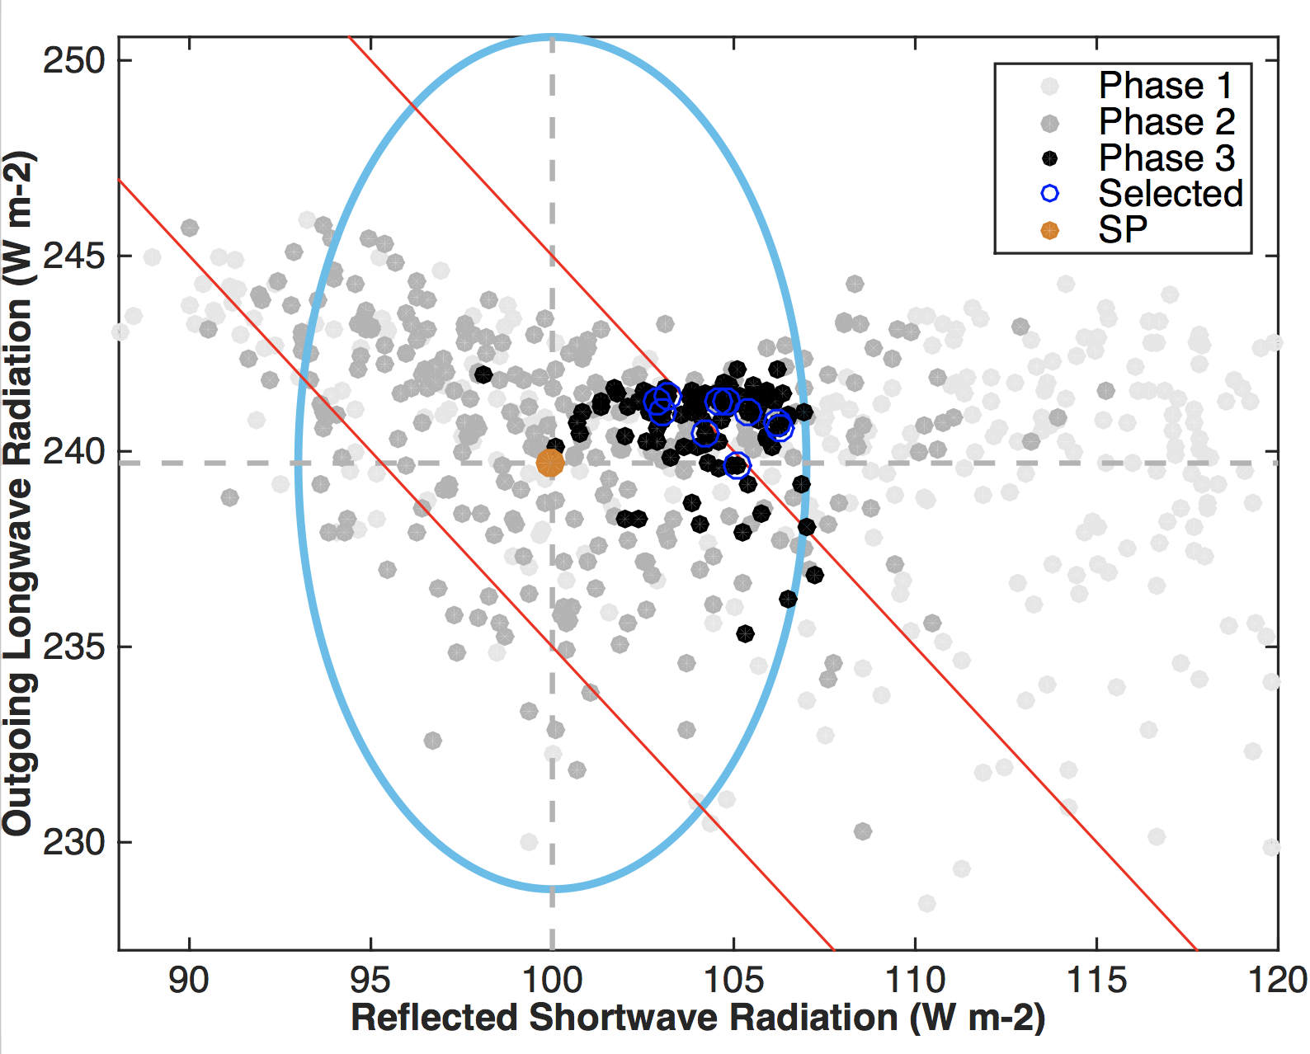
Figure 1. Global mean top-of-atmosphere (TOA) outgoing (reflected) shortwave radiation (SW) and outgoing longwave radiation (LW) from the four ensembles run through weather@home2. Horizontal and vertical dashed lines denote the reference values for SW and LW taken from Stephens et al. (2012). The filled brown circle denotes our SP. The ellipse indicates the uncertainty ranges we are willing to accept for SW and LW respectively, which includes the observational uncertainty range taken from Stephens et al. (2012), but tripled, plus the uncertainty range due to initial condition perturbations estimated from our SP reference ensemble. The red solid lines highlight net TOA energy flux of +/- 5 Wm⁻².

Figure 2. One-at-a-time sensitivity analysis of magnitude of annual cycle of temperature (MAC-T) over Northwest to each input parameter in turn, with all other parameters held at mean value of all the designed points. Heavy lines represent the emulator mean, and shaded areas represent the estimate of emulator uncertainty, at the ±1 SD level.

Figure 3. Sensitivity analysis of model output metrics in Phase 2 via the FAST algorithm of Saltelli et el. (1999).
Figure 4. Phase 3 PPE parameter inputs and summary model output metrics evaluated. 95 parameter sets are shown. The parameter values and model outputs under SP are marked in red. The horizontal and vertical red lines mark the transition from parameter inputs and model output metrics.

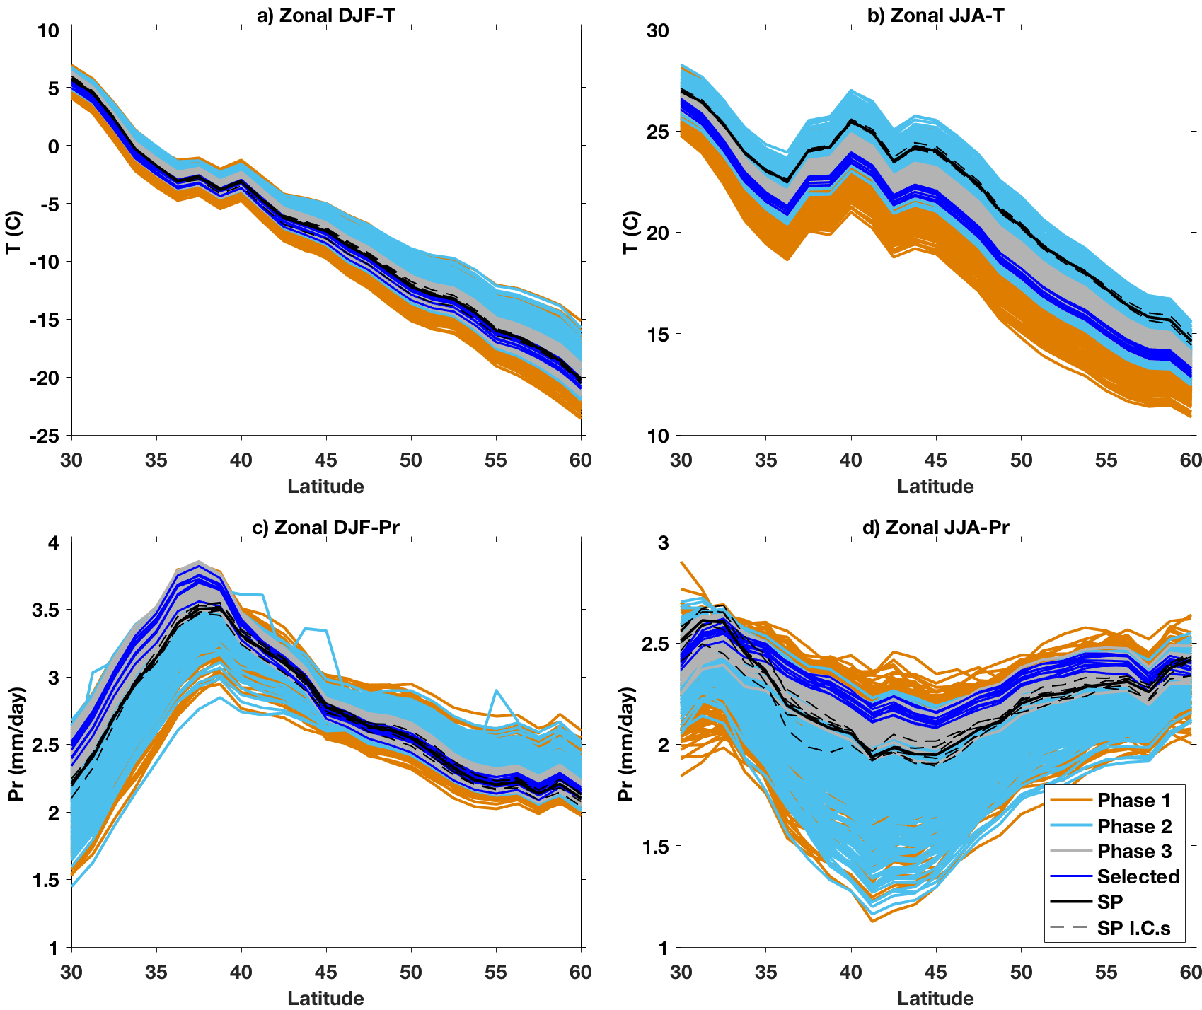
Figure 5. Comparison between three PPEs and SP zonal mean HadAM3P simulated North Hemisphere mid-latitude (30°N-60°N) a) DJF mean temperature over land, b) JJA mean temperature over land, c) DJF mean precipitation, and d) JJA mean precipitation. Output from the selected 10 parameter sets selected, based on NWUS MAC-T, are shown in blue. Note that the plotting order is the same as the legend, so most Phase 1 curves are obscured by subsequent phases. The results from different initial conditions (I.C.s) under SP are shown as black dashed lines.

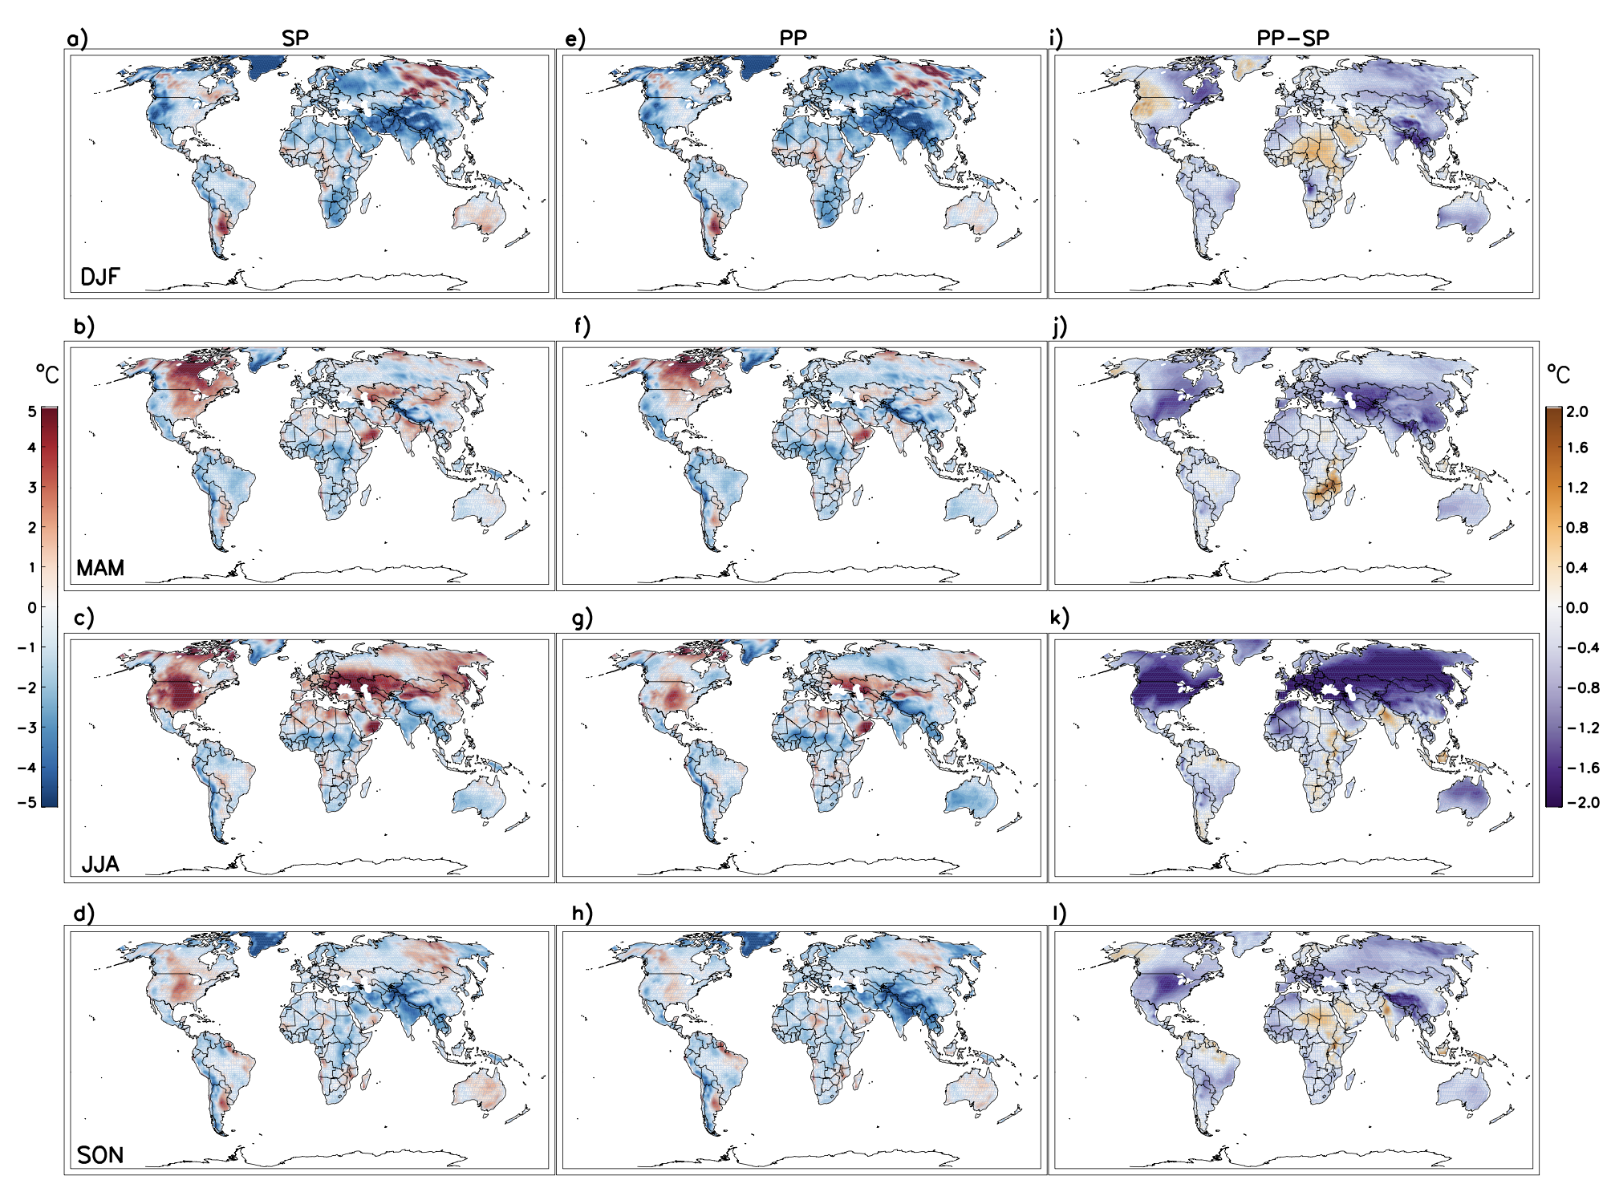
Figure 6. Biases of SP temperature over land in a) DJF, b) MAM, c) JJA, and d) SON, compared with CRU over December 1996 through November 2007. Biases of selected PP compared with CRU are shown in e)-h), while the differences between selected PP and SP, i.e. the absolute increase or decrease of biases in PP with respect to the SP values, are shown in i) - l). The PP results are the composites of the 10 selected sets, 6 IC per set.
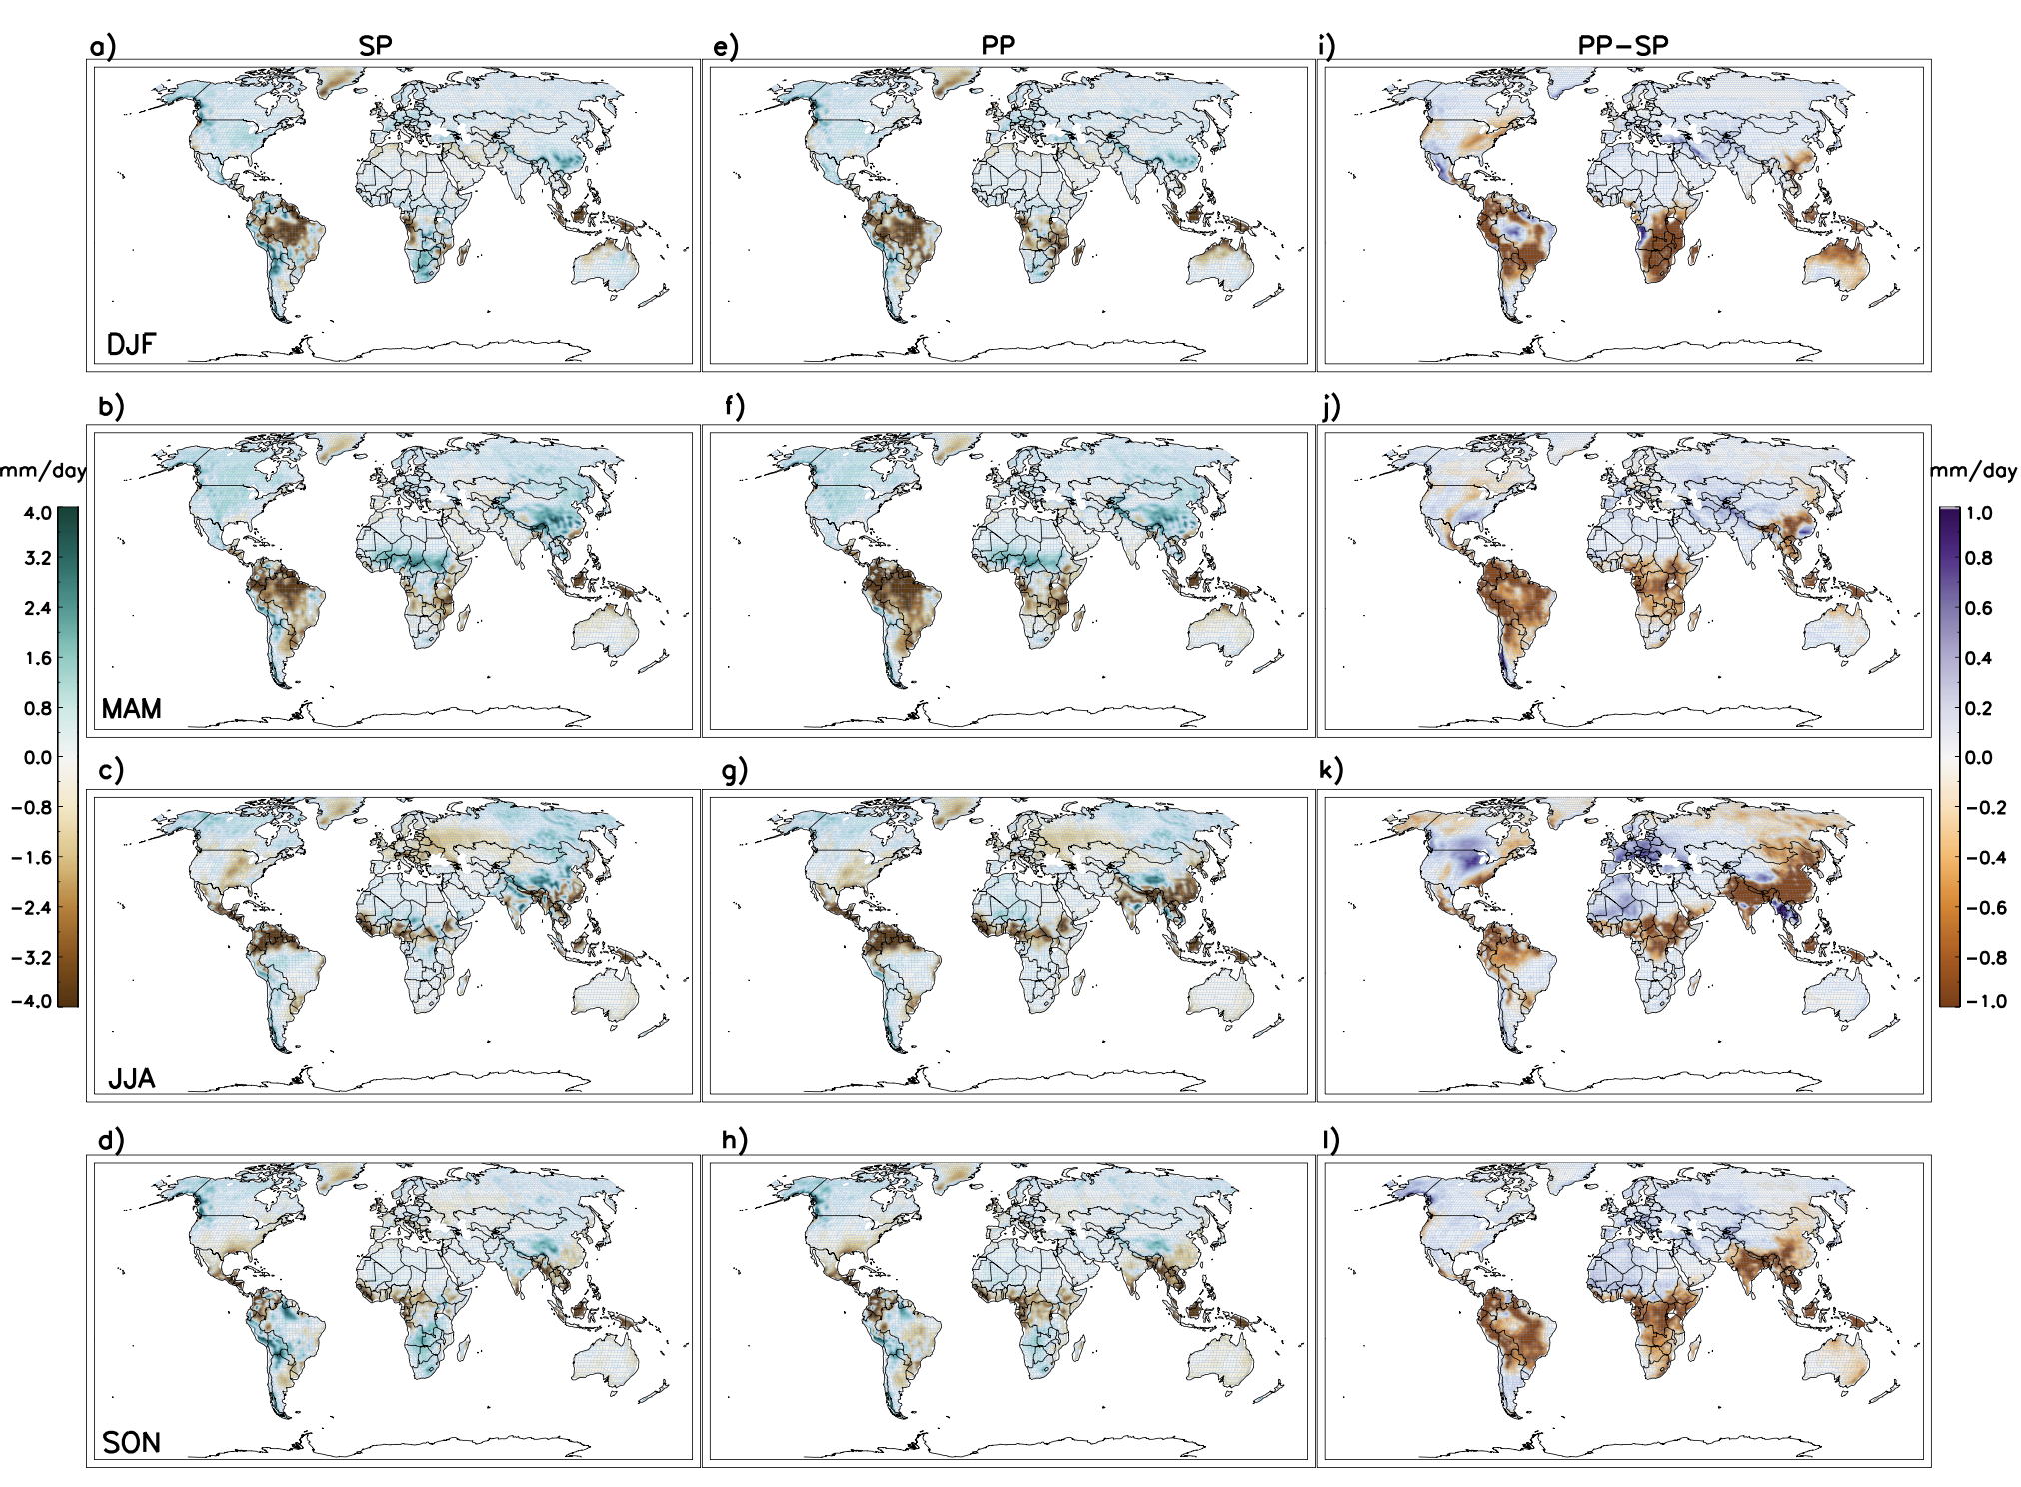
Figure 7. Same as Fig. 6, but for precipitation.
Figure 8. Annual (a,d), DJF (b,e) and JJA (c,f) meridional distributions of precipitation from Phase 3 and SP (all panels), reanalysis datasets MERRA2, JRA-55, CFSR, ERAI and 20CRv2c shown (a - c) and GCMs CanAM4-AMIP, CESM1-CAM5, and HadGEM2-A, shown in (d - f ).
Figure B1. Emulator predicted results vs. model simulated results in Phase 2 for different model output metrics based on 94 parameter sets not used to train the emulator (the 94 sets that finished after starting Phase3). The regression coefficient (regcoef) and coefficient of determination (R²) by emulated results are shown in each panel. The dashed line in each panel denotes the 1:1 line.
Figure B2. Same as Fig. B1, but for the 95 parameter sets in Phase 3. Note the ranges of x- and y-axis are set to be the same as in Fig. B1.

Table 1. Parameters perturbed in our tuning exercise with the post-culling parameters highlighted in bold.

Parameter | Default | Low | High | Description |  | Model component
CT (s⁻¹) | 6×10⁻⁴ | 0.5×10⁻⁴ | 1.2×10⁻³ | Rate at which cloud liquid water is converted to precipitation |  | Cloud
CW_SEA (kg m⁻³) | 2.0×10⁻⁵ | 0.5×10⁻⁵ | 2.0×10⁻⁴ | Threshold cloud liquid water content over sea |  | Cloud
CW_LAND (kg m⁻³) | 1.0×10⁻³ | 0.5×10⁻³ | 1.0×10⁻² | Threshold cloud liquid water content over land |  | Cloud
EACF | 0.5 | 0.5 | 0.6 | Empirically adjusted cloud fraction |  | Cloud
VF1 (m s⁻¹) | 2 | 0.5 | 4 | Ice fall speed |  | Cloud
ENTCOEF | 3 | 0.3 | 9.5 | Entrainment rate coefficient |  | Convection
ALPHAM | 0.5 | 0.45 | 0.65 | Albedo at melting point of sea ice |  | Radiation
DTICE (°C) | 10 | 2 | 11 | Temperature range over which ice albedo varies |  | Radiation
ICE_SIZE (m) | 3.0×10⁻⁵ | 2.5×10⁻⁵ | 4.0×10⁻⁵ | Ice particle size |  | Radiation
KAY_GWAVE (m) | 1.8×10⁴ | 1.0×10⁴ | 2.0×10⁴ | Surface gravity wave drag: typical wavelength |  | Dynamics
KAY_LEE_GWAVE (m^{-3/2}) | 2.7×10⁵ | 1.5×10⁵ | 3.0×10⁵ | Surface gravity wave trapped lee wave constant |  | Dynamics
START_LEVEL_GWDRAG | 3 | 3 | 5 | Lowest model level for gravity wave drag |  | Dynamics
V_CRIT_ALPHA | 0.5 | 0.01 | 0.99 | Control of photosynthesis with soil moisture |  | Land surface
ASYM_LAMBDA | 0.15 | 0.05 | 0.5 | Vertical distance over which air parcels travel before mixing with their surroundings |  | Boundary layer
CHARNOCK | 0.012 | 0.009 | 0.020 | Constant in Charnock formula for calculating roughness length for momentum transport over sea |  | Boundary layer
G0 | 10 | 5 | 20 | Used in calculation of stability function for heat, moisture, and momentum transport |  | Boundary layer
Z0FSEA (m) | 1.3×10⁻³ | 2.0×10⁻⁴ | 5×10⁻³ | Roughness length for free heat and moisture transport over the sea |  | Boundary layer

Table 2. The specifics of four ensembles used in this study.

Experiment | Start dates | Number of parameters | Number of parameter sets  in PPE | IC per parameter set per year used in the analysis
SP | 1 Dec 1995, 1996, …, 2005 | 1 | 1 | 6
PPE Phase 1 | 1 Dec 1995 | 17 | 220 | 3
PPE Phase 2 | 1 Dec 1995, 1996, …, 2005 | 17 | 264 | 3
PPE Phase 3 | 1 Dec 1995, 1996, …, 2005 | 7 | 95 | 6

Supplementary Information

Subsequent to the model tuning in this study, a large ensemble of climatology simulations (from October1988 to September2015) were run with PP set2 from the final selected 10 sets, with more than 100 simulations per year. Some initial analysis of the surface energy budget and surface radiative fluxes from this PP climatology were compared with a large ensemble of climatology simulations under SP to better understand the reduction in near surface temperature biases, shown in Fig. S16.

Table S1. Information of models used in Fig. 8, including the modelling institutions, model standard names, pertinent references, and ensemble members shown for each model.
Modeling institution | Model name | References | Ensemble member
Canadian Centre for Climate Modeling and Analysis | CanAM4 | Chylek et al. (2011) | 4
National Center for Atmospheric Research Community Earth System Model | CESM-CAM5 | Neale et al. (2010) | 2
Met Office Hadley Centre | HadGEM2-A | Martin et al. (2006)  Collins et al. (2011) | 6

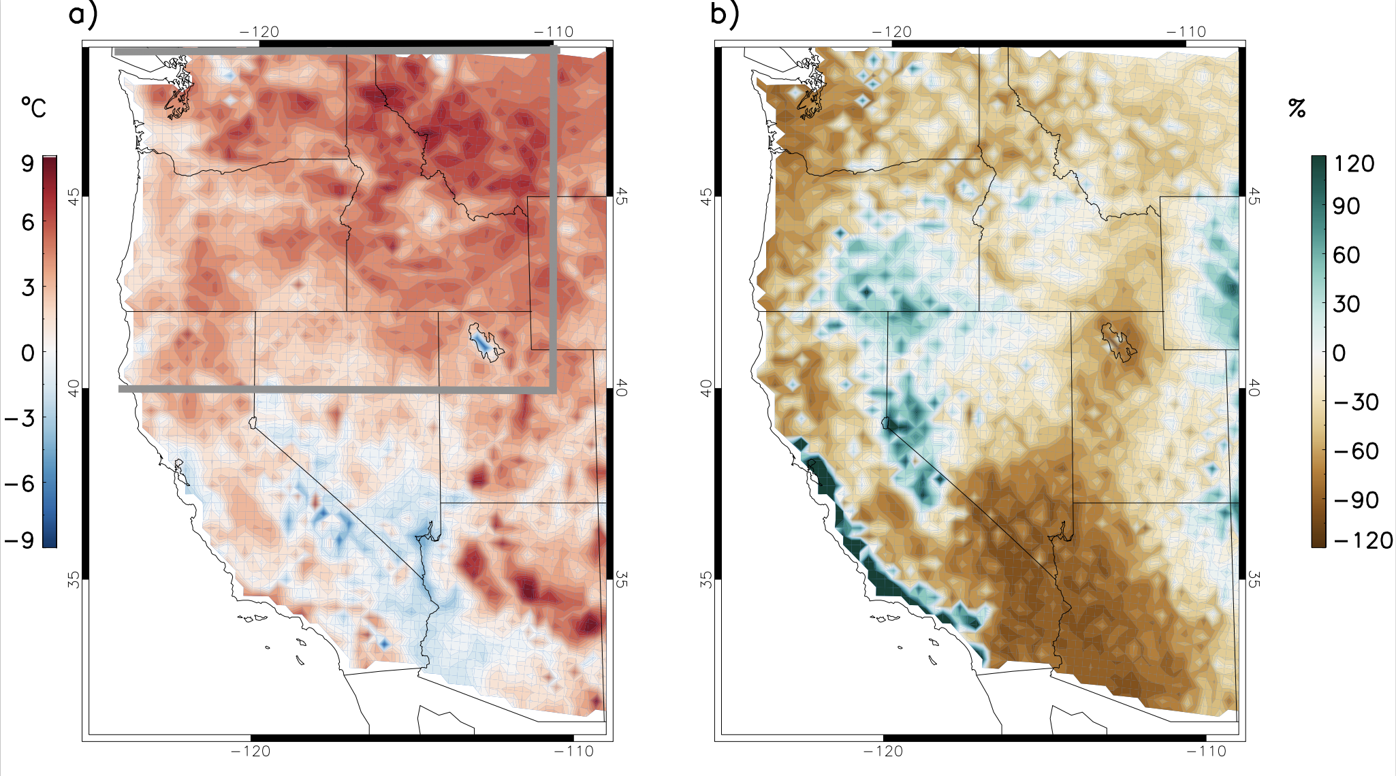
Figure S1. Biases in a) June-July-August (JJA) mean temperature (°C) , and b) precipitation (%) simulated by HadRM3P compared with PRISM over dec1996-nov 2007 under standard physics (SP) setting. The NWUS is defined as the land region bounded by the heavy grey line.
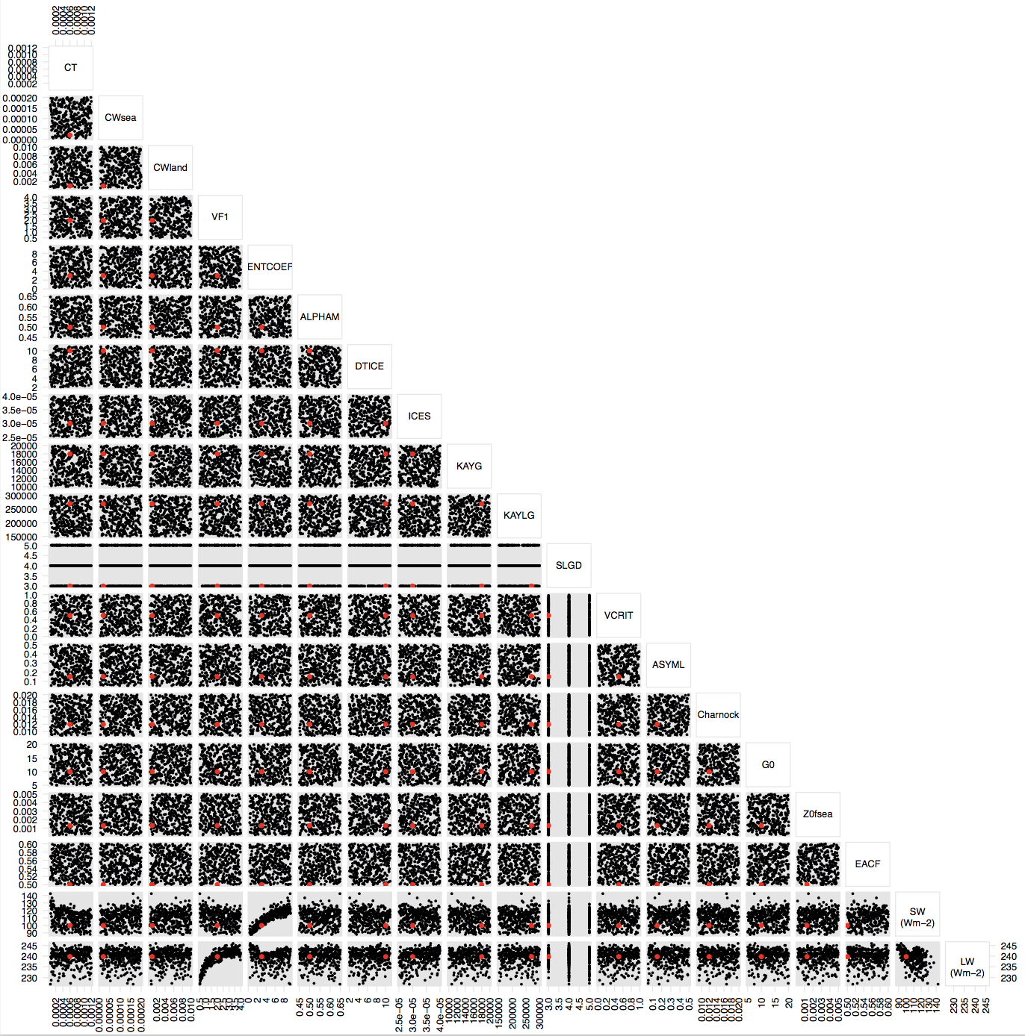
Figure S2. Phase 1 PPE parameter inputs and TOA outgoing SW and LW fluxes. 328 parameter sets are shown. The parameter values and model outputs under SP setting are marked in red.
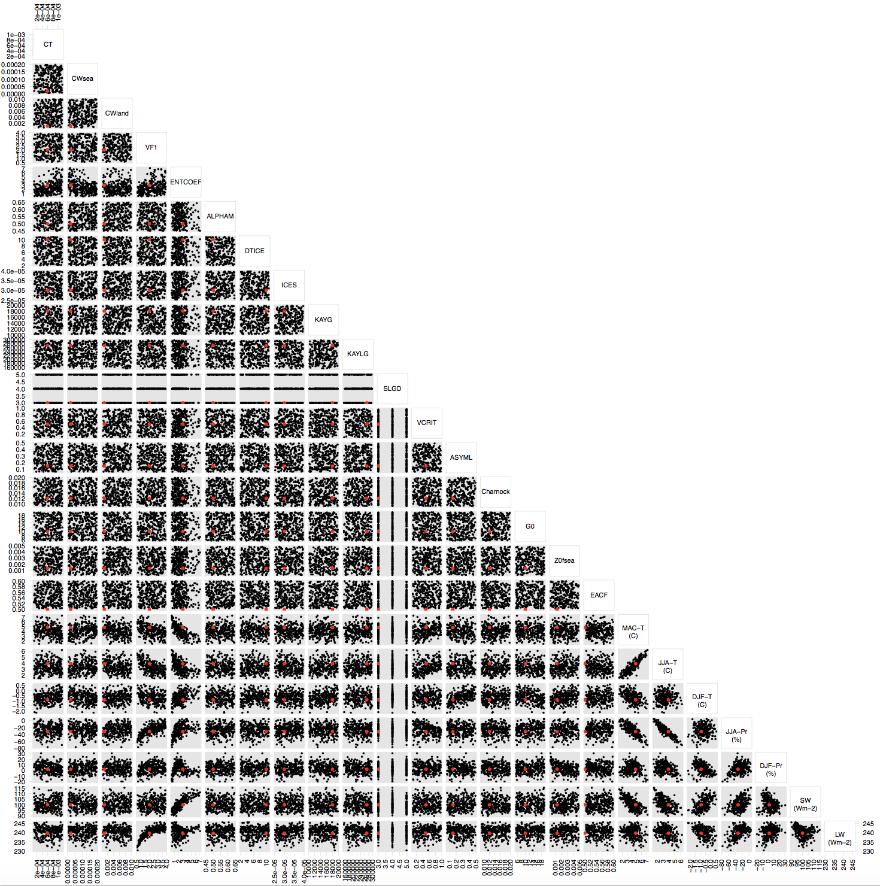
Figure S3. Same as Fig. S3, but for Phase 2 parameter inputs and summary model output metrics considered in this phase. 264 parameter sets are shown.
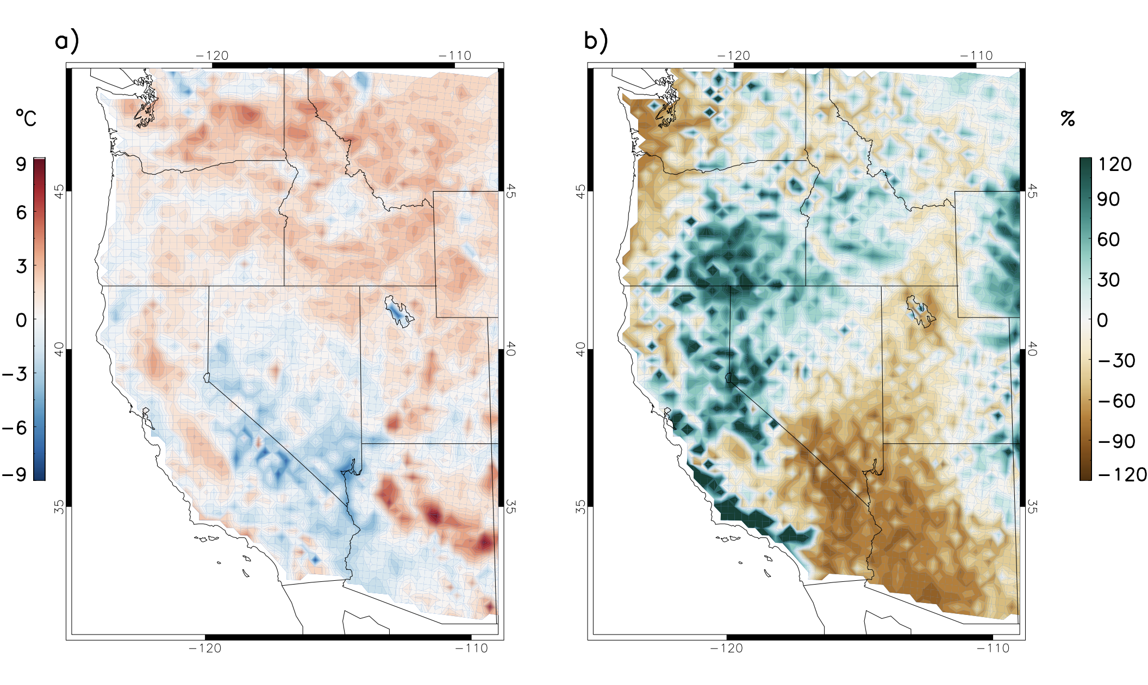
Figure S4. Biases in a) June-July-August (JJA) mean temperature (°C) , and b) precipitation (%) simulated by HadRM3P compared with PRISM over dec1996-nov 2007 under the selected PP settings, where the composite of the final 10 are taken.
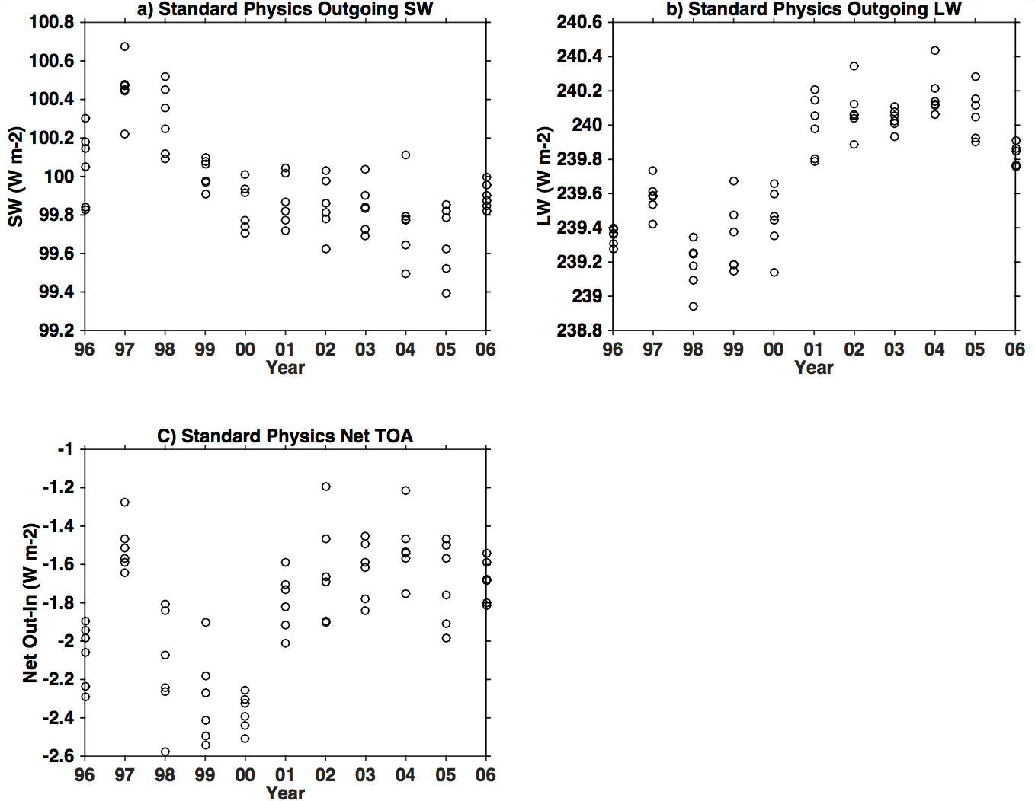
Figure S5. The range of internal variability for top-of-atmosphere a) outgoing shortwave radiation, b) outgoing longwave radiation, and c) net (outgoing minus incoming) under SP setting for each year. We rounded to the nearest Wm⁻² (±1) to account for internal variability.
Figure S6. One-at-a-time sensitivity analysis of JJA temperature bias (compared with PRISM) over Northwest to each input parameter in turn, with all other parameters held at mean value of all the designed points. Central lines represent the emulator mean, and shaded areas represent the estimate of emulator uncertainty, at the ±1 SD level.
Figure S7. Same as Fig. S6, but for DJF temperature bias.
Figure S8. Same as Fig. S6, but for JJA precipitation bias.
Figure S9. Same as Fig. S6, but for DJF precipitation bias.
Figure S10. Same as Fig. S6, but for TOA SW fluxes.
Figure S11. Same as Fig. S6, but for TOA LW fluxes.
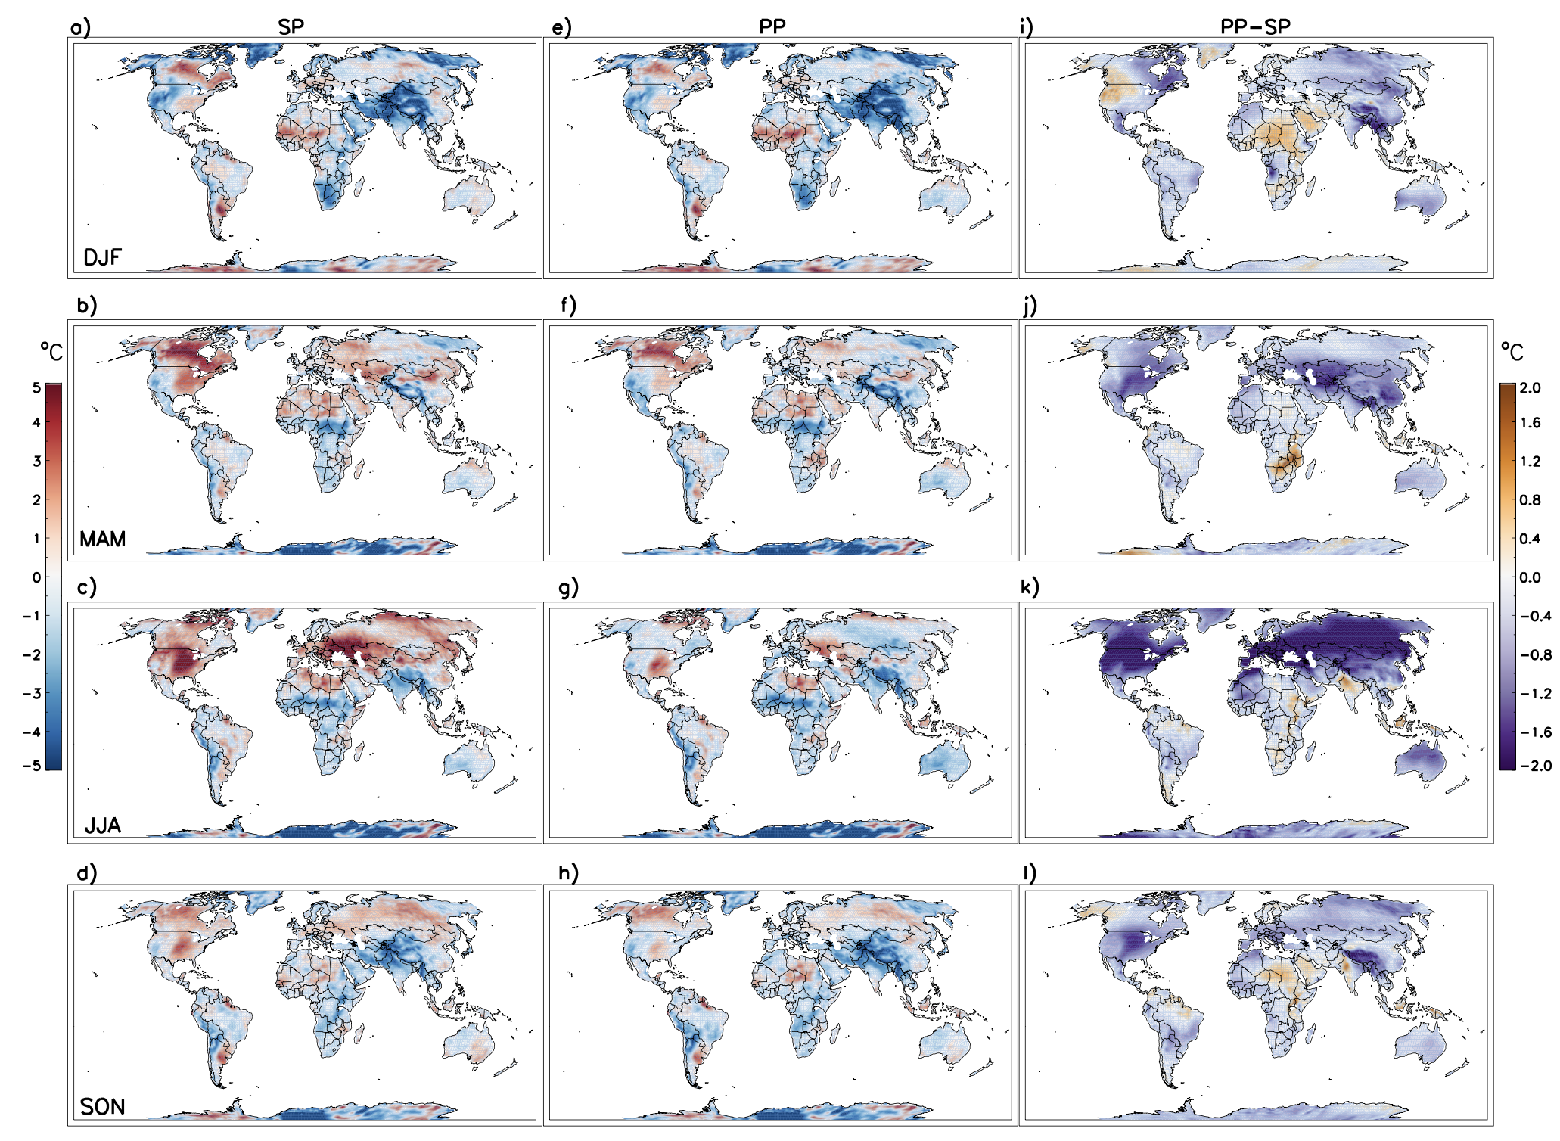
Figure S12. Biases of SP temperature over land in a) DJF, b) MAM, c) JJA, and d) SON, compared with MERRA over December 1996 through November 2007. Biases of selected PP compared with MERRA are shown in e)-h), while the differences between selected PP and SP, i.e. the absolute increase or decrease of biases in PP with respect to the SP values, are shown in i) - l). The PP results are the composites of the 10 selected sets, 6 IC per set.
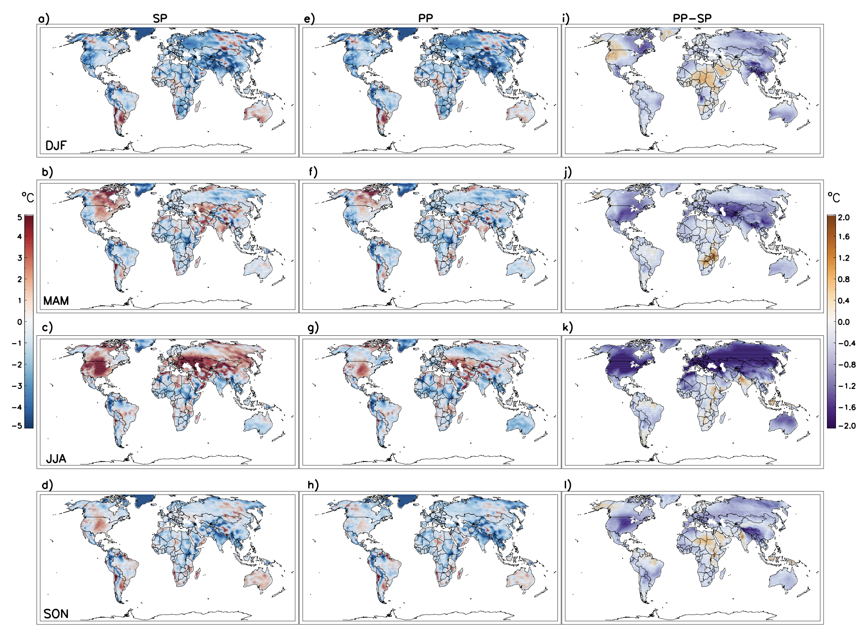
Figure S13. Same as Fig. S12, but for comparison with GHCN-CAMS.
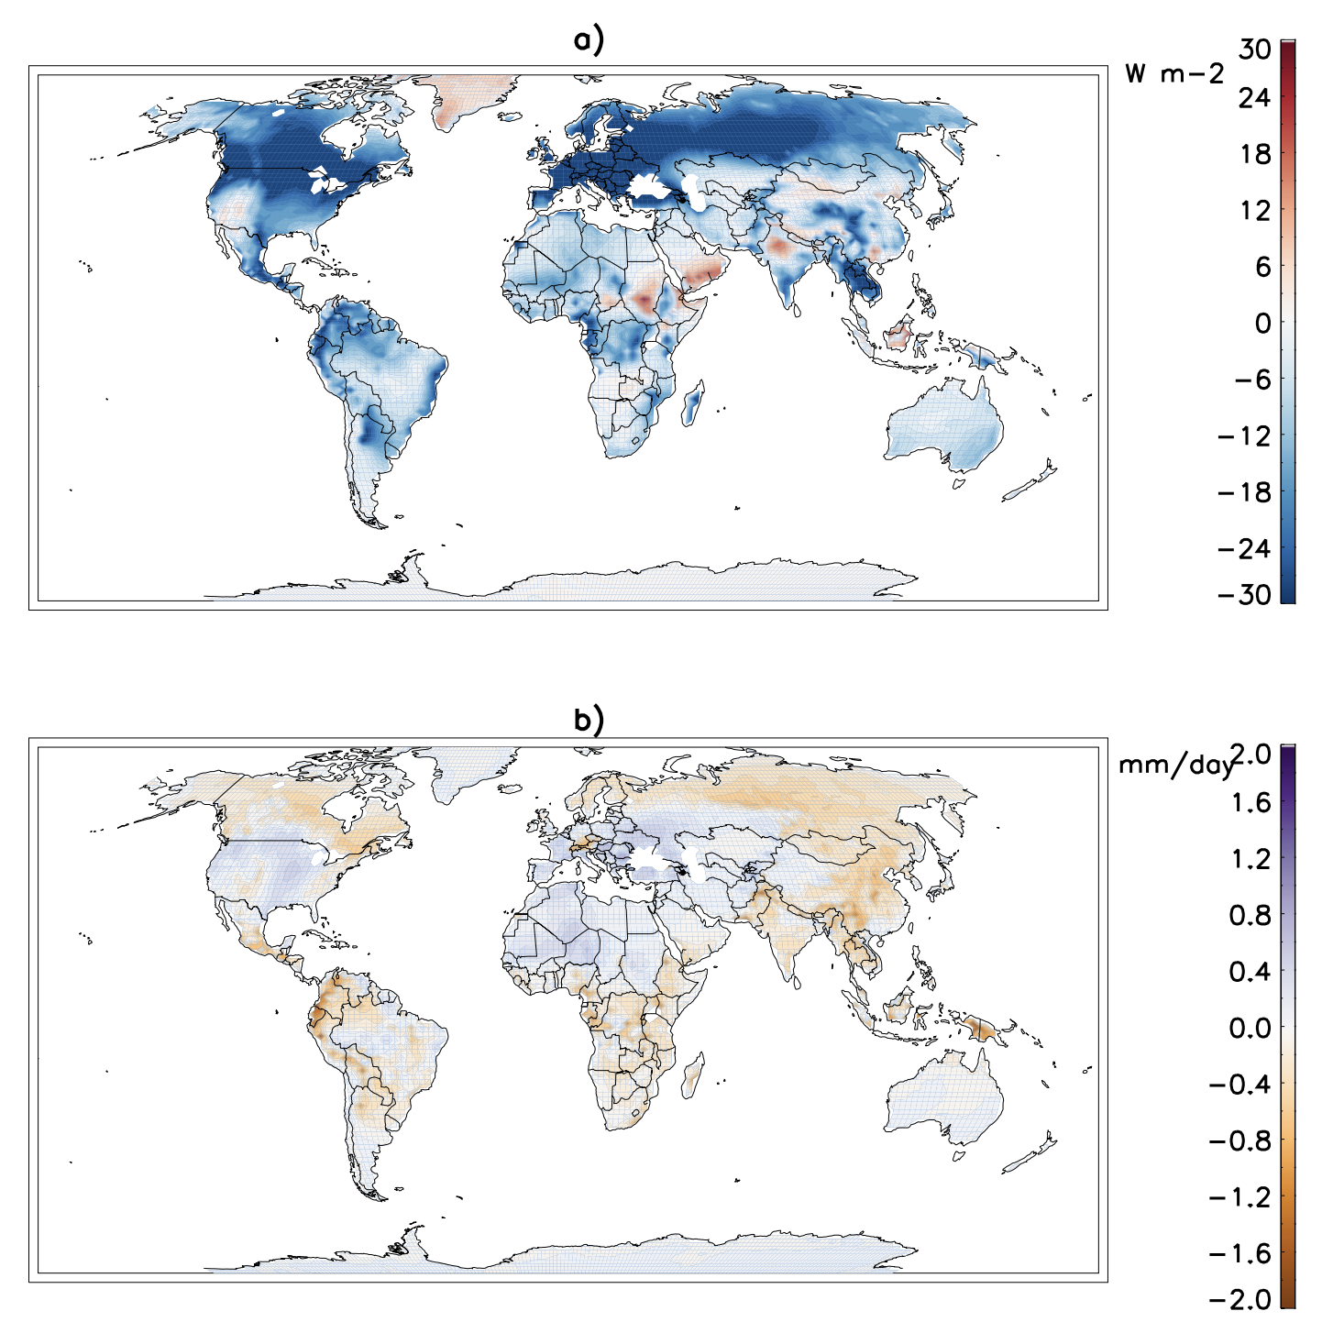
Figure S14. MEAN summer (JJA) differences between SP and PPset2 for a) total downward shortwave radiation, and b) latent heat fluxes for the period Oct1988 – Sep2015.
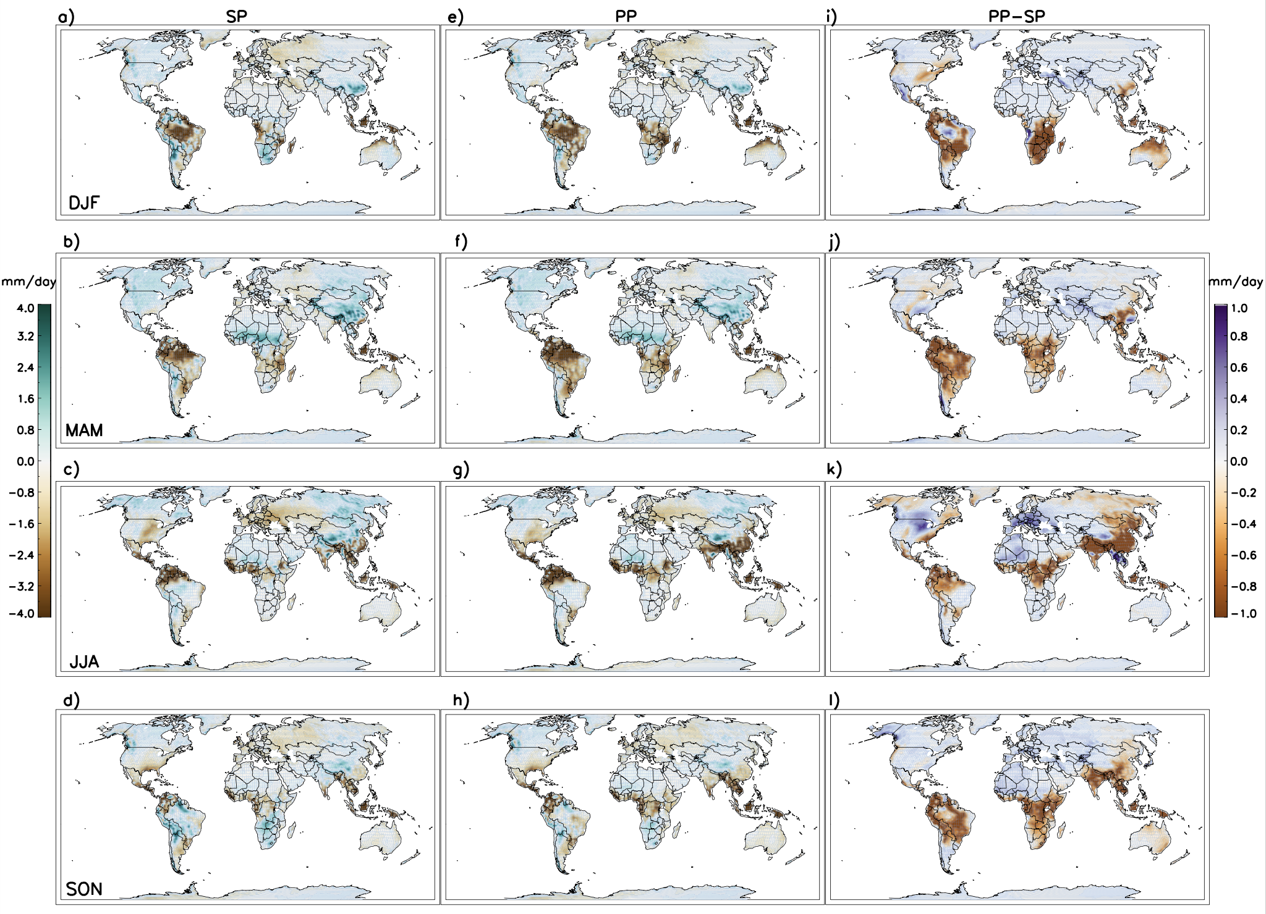
Figure S15. Biases of SP precipitation over land in a) DJF, b) MAM, c) JJA, and d) SON, compared with GPCP over December 1996 through November 2007. Biases of selected PP compared with GPCP are shown in e)-h), while the differences between selected PP and SP, i.e. the absolute increase or decrease of biases in PP with respect to the SP values, are shown in i) - l). The PP results are the composites of the 10 selected sets, 6 IC per set.
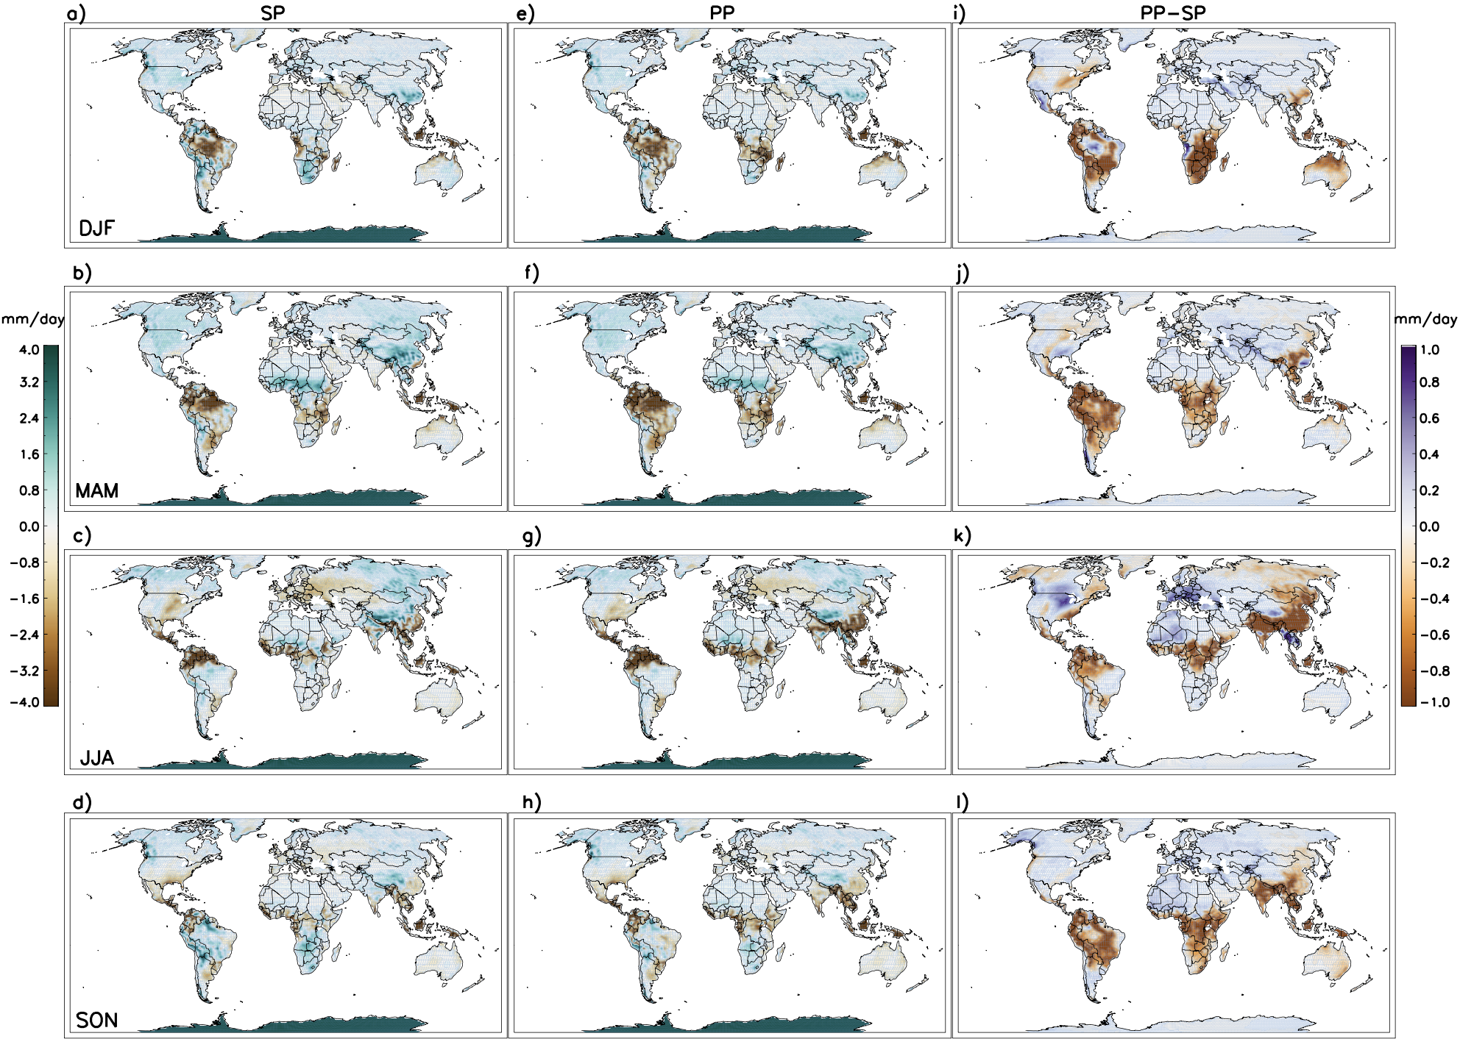
Figure S16. Same as Fig. S15, but for comparison with GPCC.
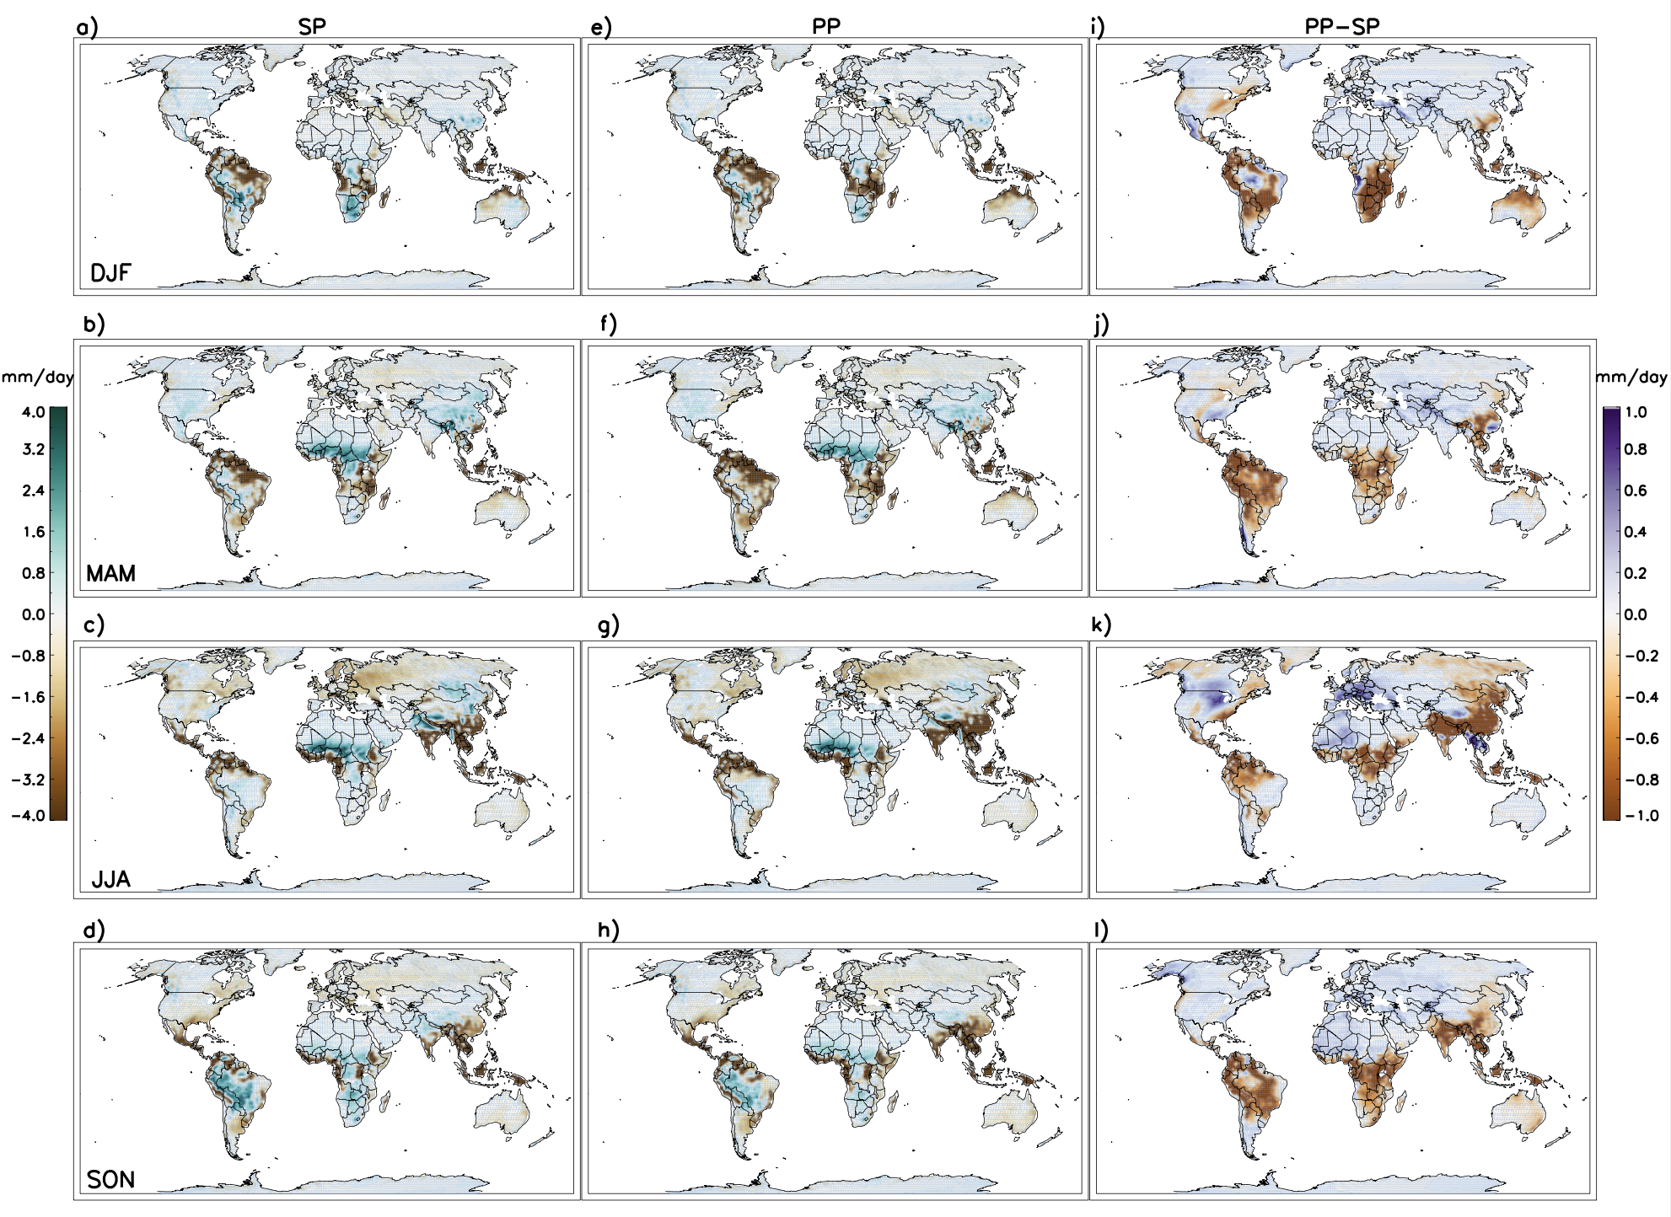
Figure S17. Same as Fig. S15, but for comparison with MERRA.
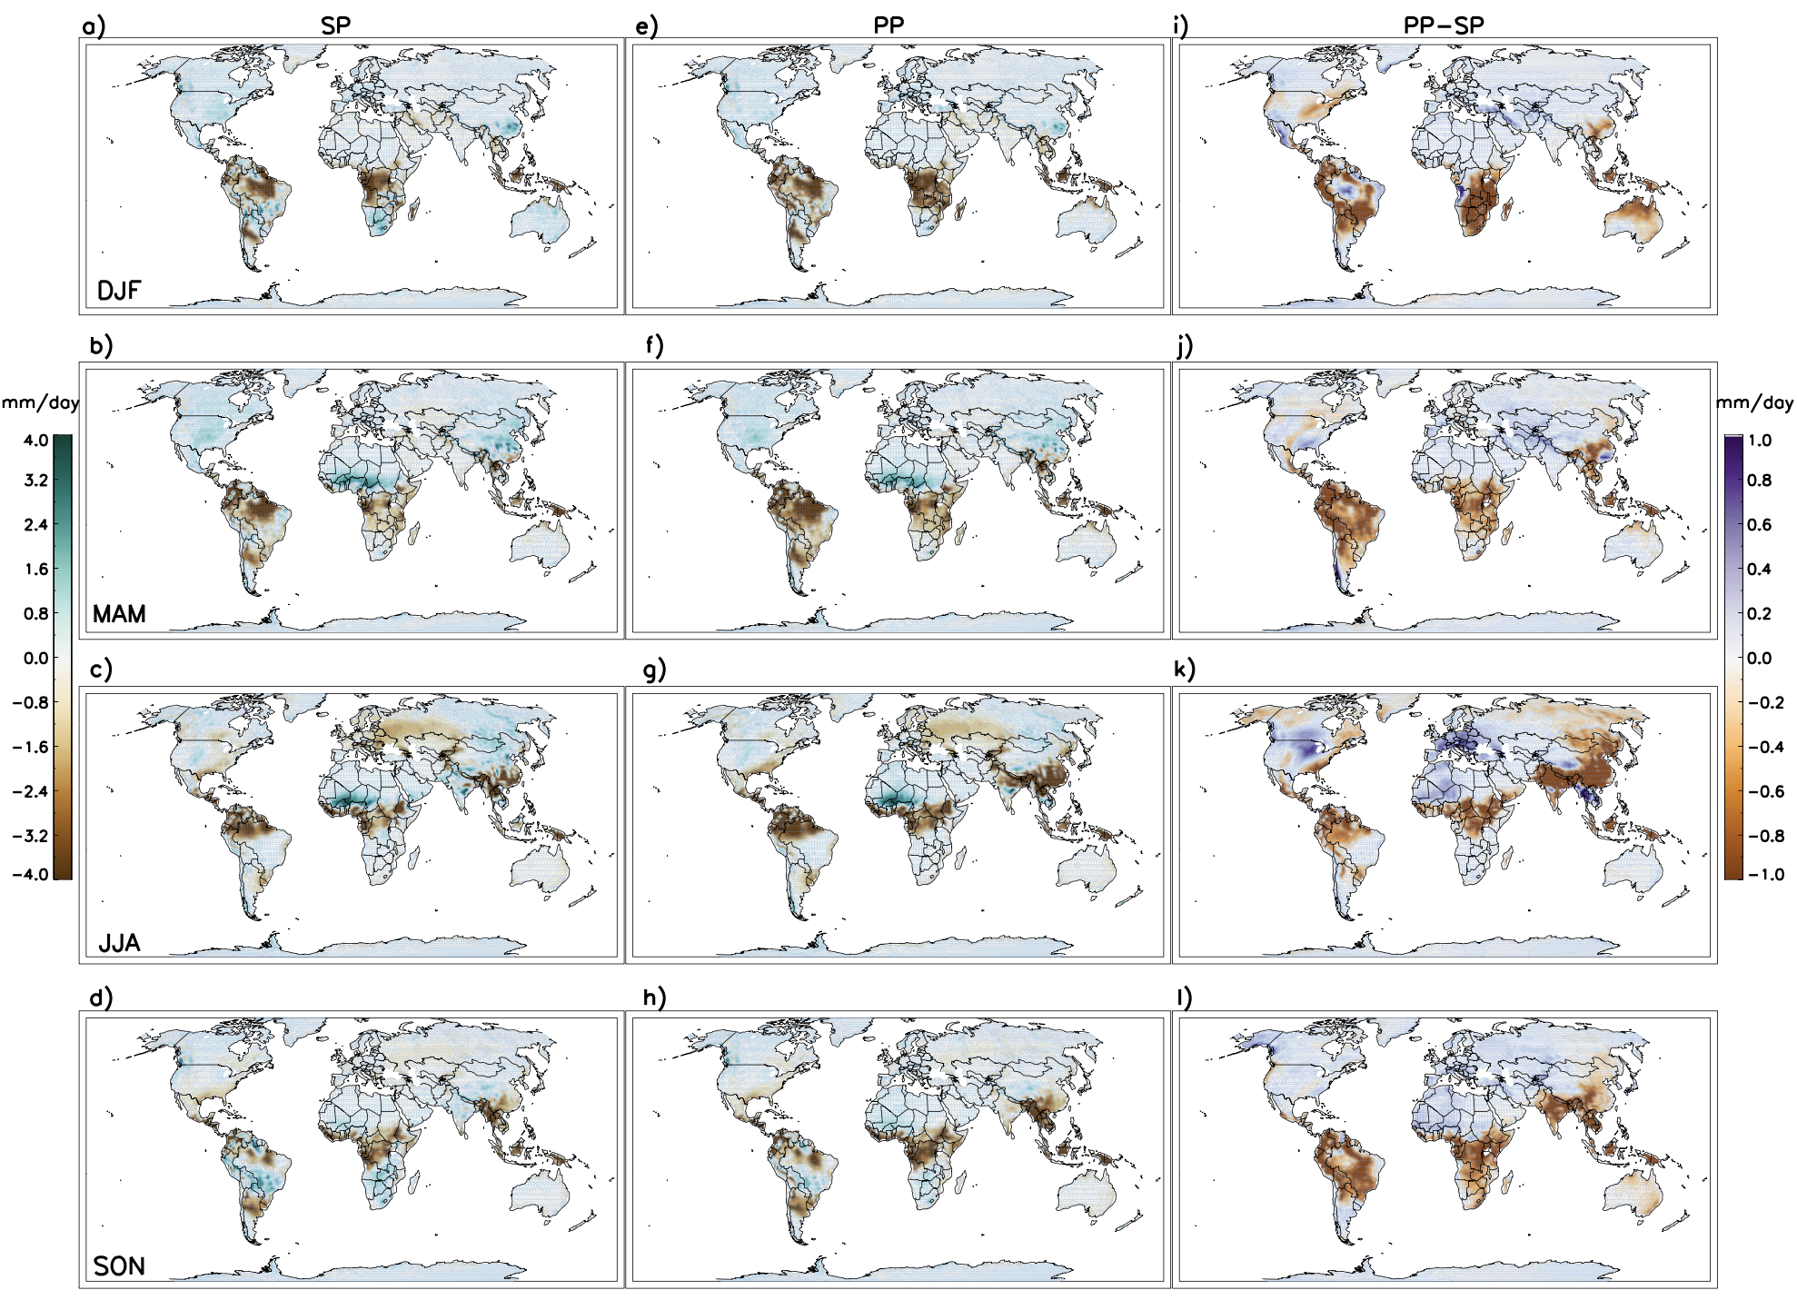
Figure S18. Same as Fig. S15, but for comparison with ERAI.
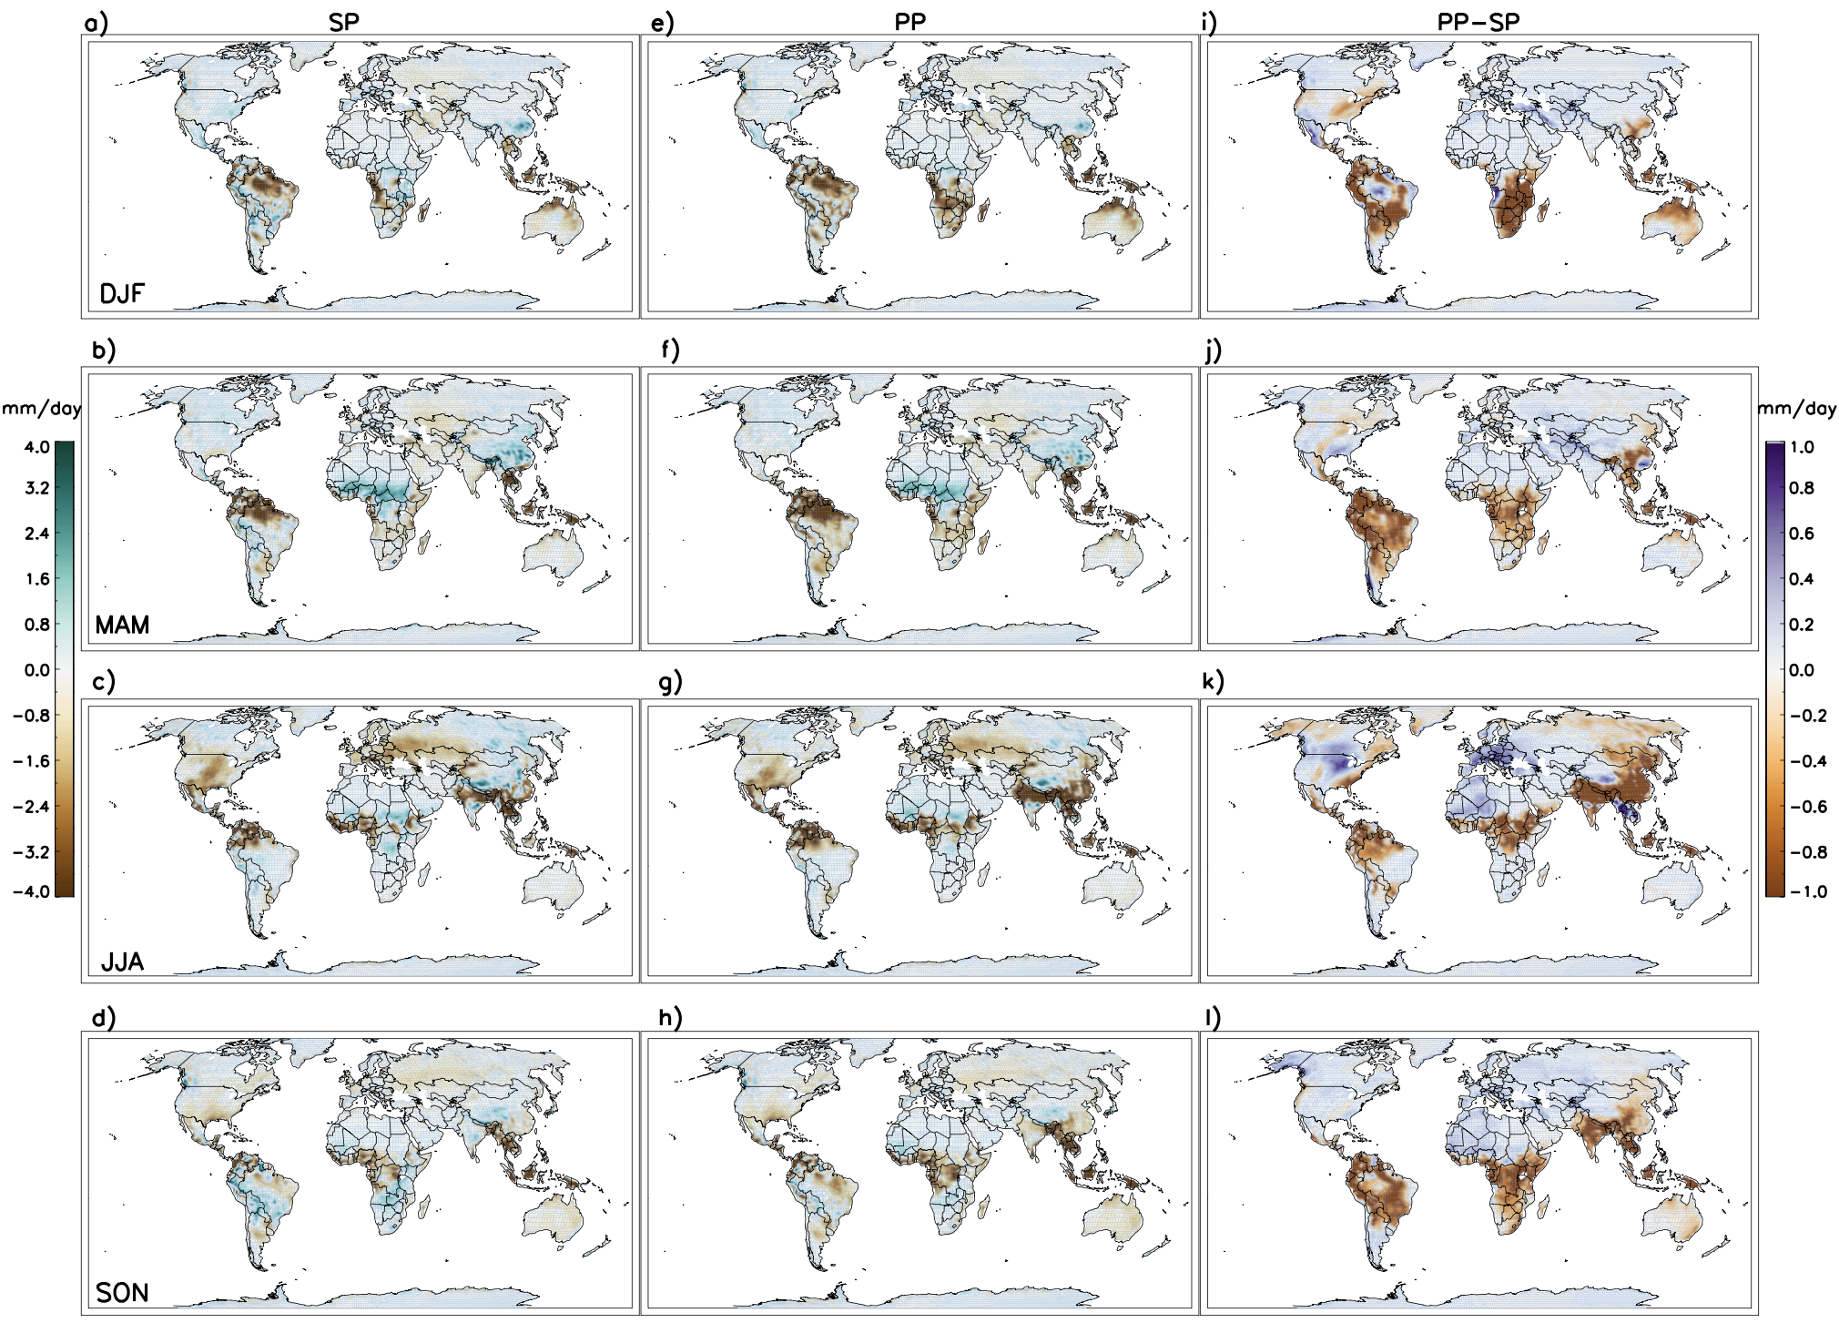
Figure S19. Same as Fig. S15, but for comparison with JRA-55.
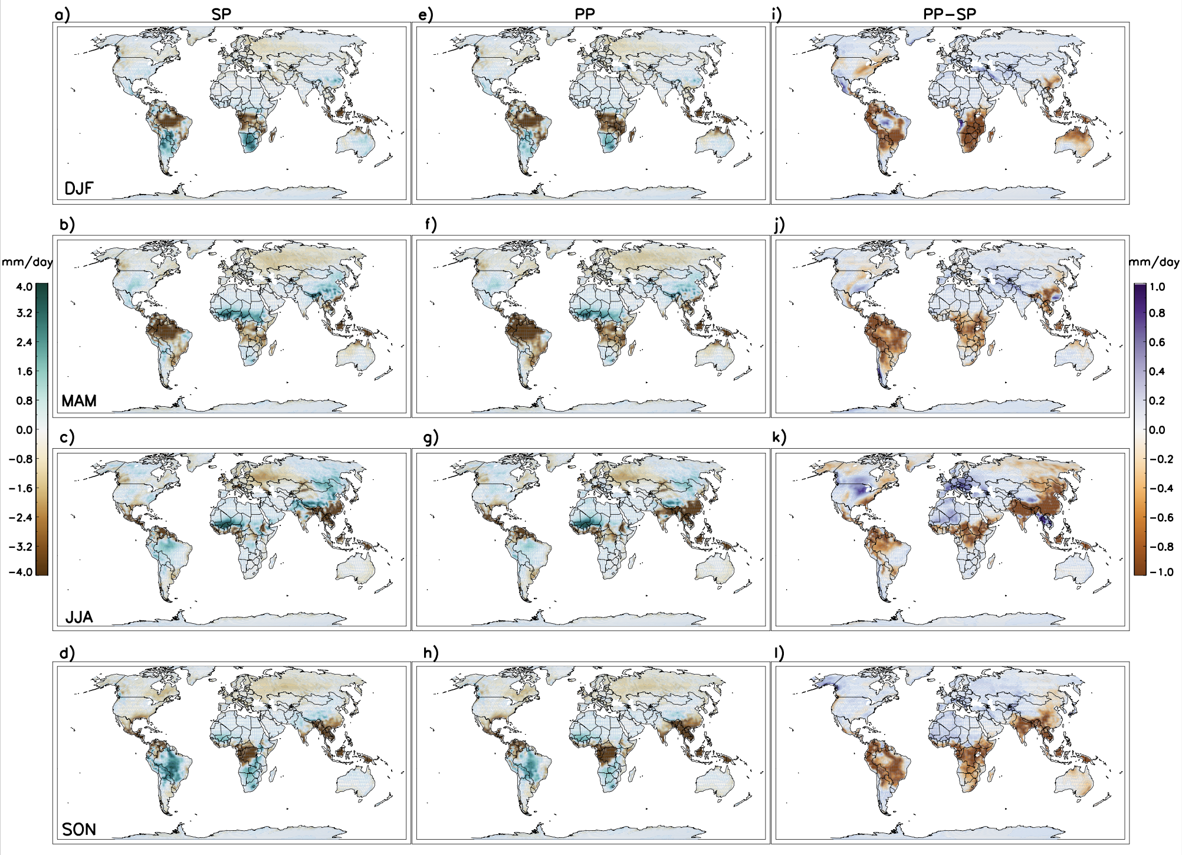
Figure S20. Same as Fig. S15, but for comparison with CFSR.
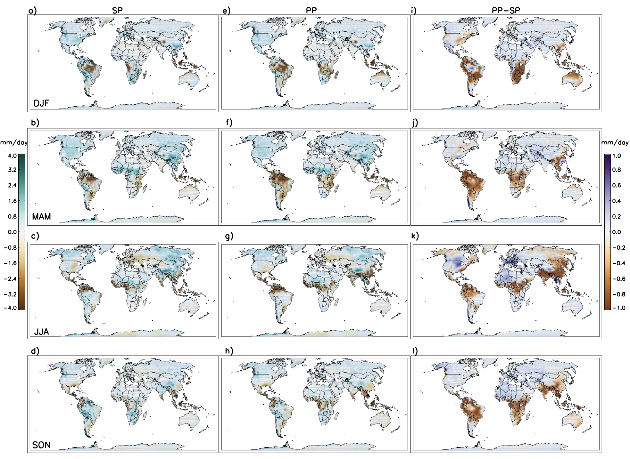
Figure S21. Same as Fig. S15, but for comparison with CMAP.
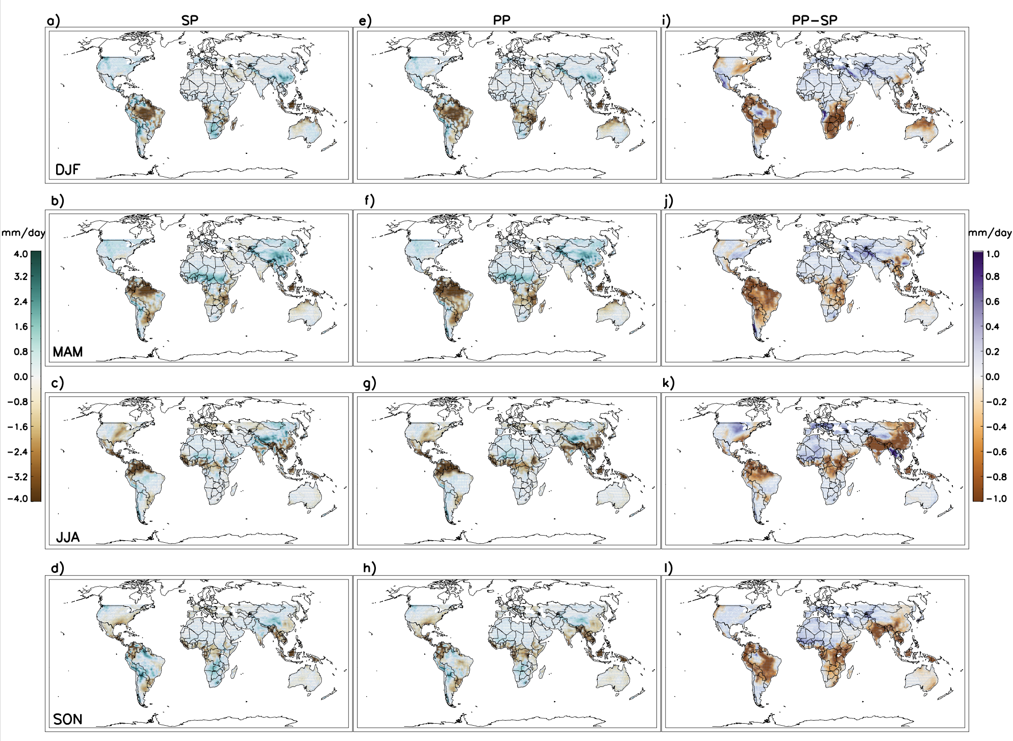
Figure S22. Same as Fig. S15, but for comparison with TRMM.
Figure S23. MAC-T biases projected into the two-dimensional spaces of each pair of input parameters using the emulator.
Figure S24. JJA-T biases projected into the two-dimensional spaces of each pair of input parameters using the emulator.
Figure S25. DJF-T biases projected into the two-dimensional spaces of each pair of input parameters using the emulator.
Figure S26. The sensitivity indices for the refined parameter space in Phase 3.

References:
Chylek, P., Li, J., Dubey, M. K., Wang, M., and Lesins, G.: Observed and model simulated 20th century Arctic temperature variability: Canadian Earth System Model CanESM2, Atmospheric Chemistry and Physics Discussions, 11(8), 22,893–22,907. https://doi.org/10.5194/ acpd-11-22893-2011, 2011.
Collins, W. J., Bellouin, N., Doutriaux-Boucher, M., Gedney, N., Halloran, P., Hinton, T., Hughes, J., Jones, C.D., Joshi, M., Liddicoat, S. and Martin, G.: Development and evaluation of an Earth- System model— HadGEM2, Geoscientific Model Development, 4(4), 1051–1075. https://doi.org/10.5194/gmd-4-1051-2011, 2011.
Martin, G. M., Ringer, M. A., Pope, V. D., Jones, A., Dearden, C., and Hinton, T. J.: The physical properties of the atmosphere in the new Hadley Centre Global Environmental Model (HadGEM1). Part I: Model description and global climatology, Journal of Climate, 19(7), 1274–1301. https://doi.org/10.1175/JCLI3636.1, 2006.
Neale, R.B., Chen, C.C., Gettelman, A., Lauritzen, P.H., Park, S., Williamson, D.L., Conley, A.J., Garcia, R., Kinnison, D., Lamarque, J.F. and Marsh, D.: . Description of the NCAR Community Atmosphere Model (CAM 5.0). Tech. Rep. NCAR/TN-486+ STR, 1(1), pp.1-12., 2010.

